Quotation for 39㎡ Prefab X house--Basic model (Qty: 1 unit)
No. | Item# | Specification | Unit | Size | Qty. | Unit Price | Total price | Remark
1 | Ⅰ | 39m2 Prefab X house basic housing cost
2 |  | 39m2 Prefab X house basic housing cost( includes the main body of the house :roof module, floor module, external wall panel, internal partition wall and internal and external decorative board, doors and windows, floor, electricity, water pipe, bathroom configurations) | set | house size： 5976*6835*2555mm  packing size：  5980*2300*2555mm(The main part of the house, no parapet, excluding optional configuration) | 1 | $13,661 | $13,661 | Packaging： | Expanded view: |  | outside view：  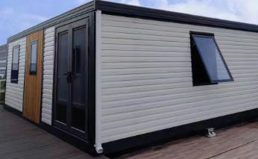
3 |  |  | pc | size： Length1265*Width430*Heigh  t450  Equipped with washbasin, faucet, drainer, countertop with lamp mirror quartz  stone or artificial stone, lower  cabinet particleboard | 1 | $136.4 | $136
4 |  |  | set | One-shaped glass shower room: length 1278, height 2000mm+shower faucet+ mixtures | 1 | $125.9 | $126
5 |  |  | pc | Toilet (hole distance 300mm.  Floor drain) | 1 | $67.1 | $67
6 |  |  | set | surface mounted bath heat lamp | 1 | $31.5 | $32
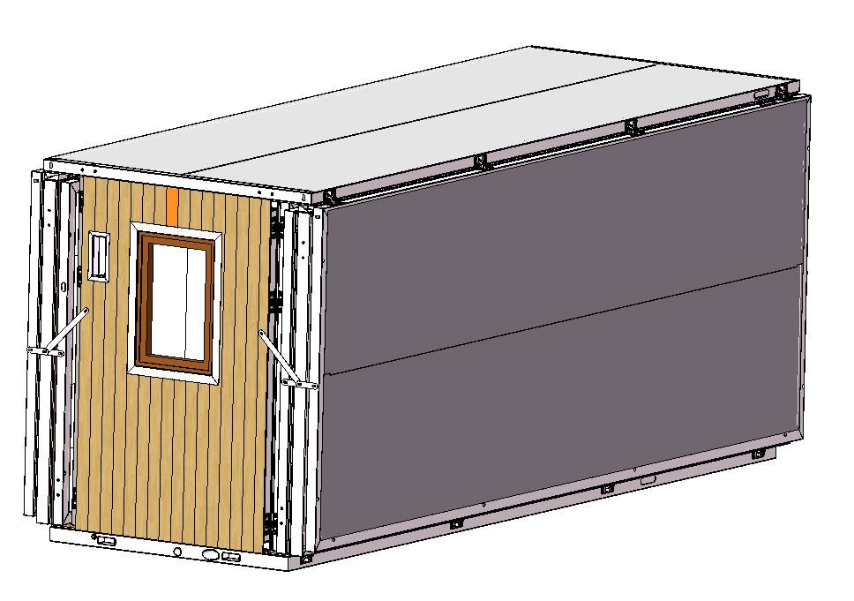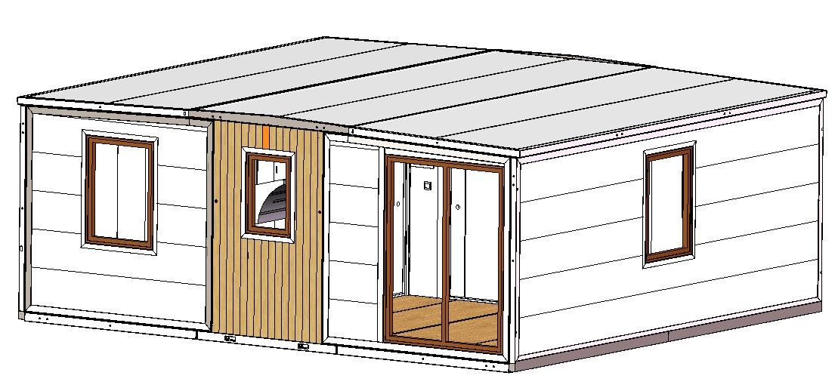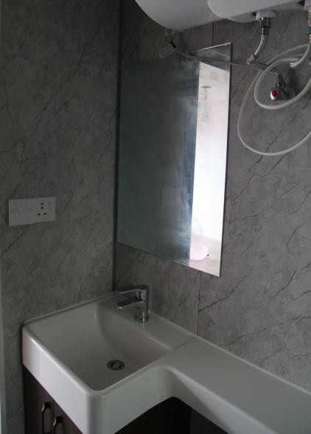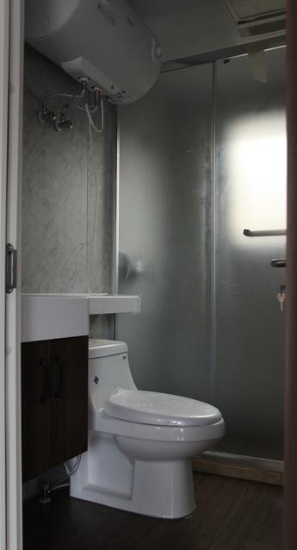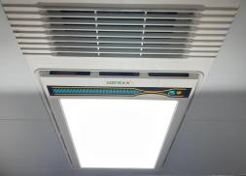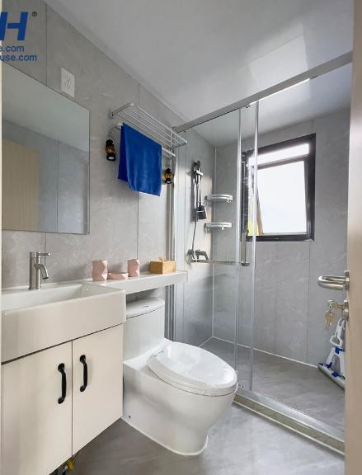

7 |  | Subtotal |  |  |  |  | $14,022
Transportation part
1 | Ⅰ | Transportation part
2 |  | 40HQ | pc | 0.50 |  | $1,140.0 | $520 | Shipping to Ningbo Port(1 x 40HQ load 2 units）
3 | Ⅱ | Subtotal |  |  |  |  | $520
Price
1 | A | 39m2 price |  | $14,122
2 | F | Total FOB price |  | $14,642
3 | Remark | 1. This quotation only includes the above-listed content (excluding assembly and optional configuration) --no parapet, cabinet, gas stove, water heater, wardrobe wall, range hood, air conditioner and other optional configurations, please be aware. .
4 |  | 2. This quotation is only valid for 7 days
5 |  | 3. Payment term: 50% deposit by TT + 50% balance before shipment.

