Quotation for 26㎡ Prefab X house--Basic model (Qty: 1 unit)
S/N | Item # | Specification | Unit | Size | Qty. | Unit Price | Total price | Remark
1 | Ⅰ | 26m2 Prefab X house basic housing cost
2 |  | 26㎡ Prefab X house basic housing cost  ( includes the main body of the house : roof module, floor module, external wall panel, internal partition wall and internal and external decorative board, doors and windows, floor, electricity, water pipe, bathroom configurations) | set | house size： 5980*4362*2555mm  packing size：  5980*2135*2555mm(The (main part of the house, no parapet, excluding optional configuration) | 1 | $9,849 | $9,849 | Packaging： Expanded view:  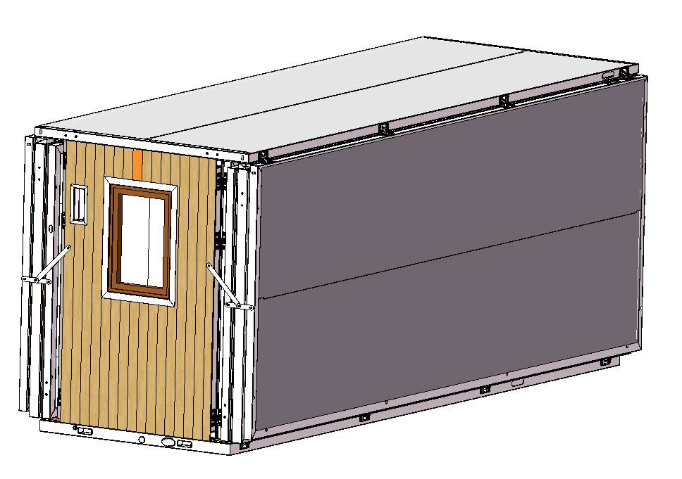
3 |  |  | pc | size:Length 1265*Width  430*Height 450 Equipped with washbasin, faucet, drainer, countertop  with lamp mirror quartz stone or artificial stone, lower cabinet particleboard | 1 | $161.4 | $161 | 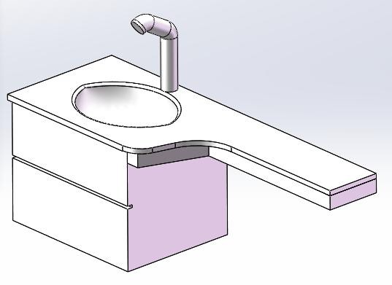
4 |  |  | set | One-shaped glass shower room: length 1278, height 2000mm+shower faucet+ mixtures | 1 | $149.0 | $149 | 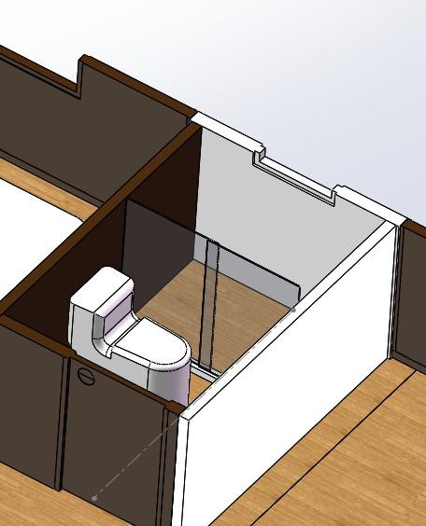
5 |  |  | pc | Toilet (hole distance 300mm.  Floor drain) | 1 | $79.4 | $79 | 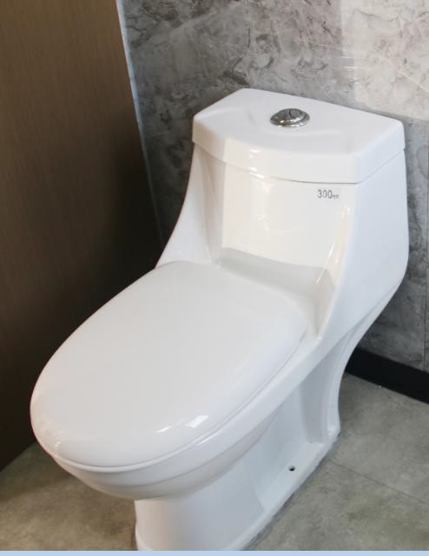
6 |  |  | set | surface mounted bath heat lamp | 1 | $49.0 | $49 | 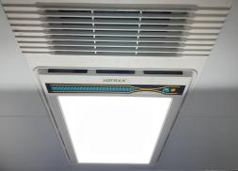
7 |  | Subtotal |  |  |  |  | $10,287
Transportation part
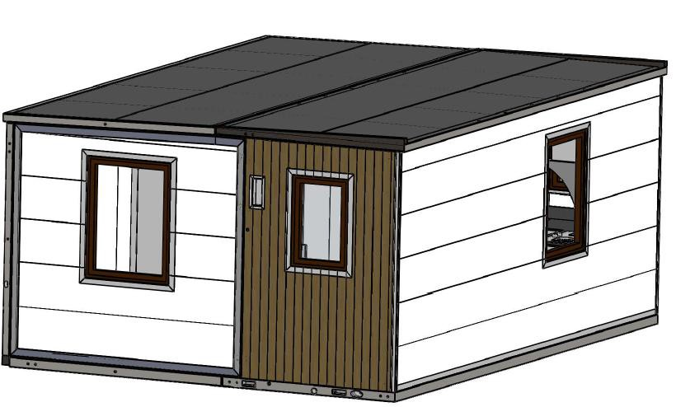

1 | Ⅰ | Transportation part
2 |  | 40HQ | pc | 0.50 | $1,040.0 | $620 | Shipping to Ningbo Port(1 x 40HQ load 2 units）
3 | Ⅱ | Subtotal |  |  |  | $620
Price
1 | F | Total FOB total price |  | $10,907
2 | Remark | 1. This quotation only includes the above-listed content (excluding assembly and optional configuration)--no parapet, cabinet, gas stove, water heater, wardrobe wall, range hood, air conditioner and other optional configurations, please be aware. .
3 |  | 2. This quotation is only valid for 7 days
4 |  | 3. Payment term: 50% deposit by TT + 50% balance before shipment.

