**Cargo Freighter Specifications**

B737-300F  
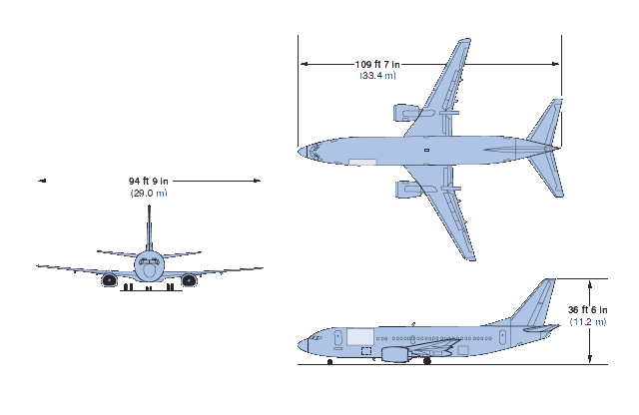  
  
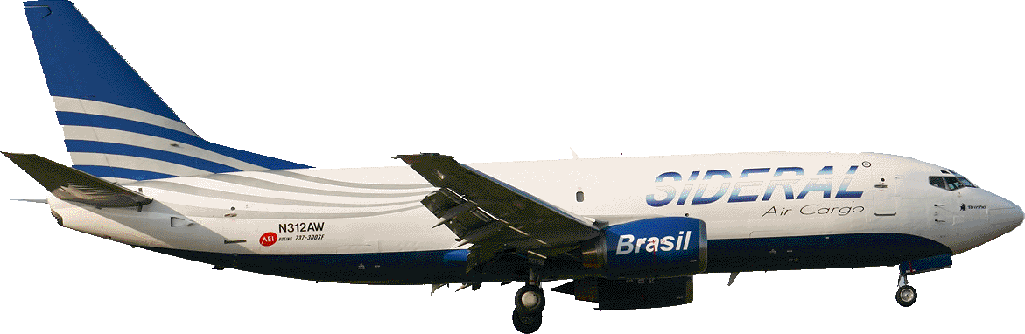  
  
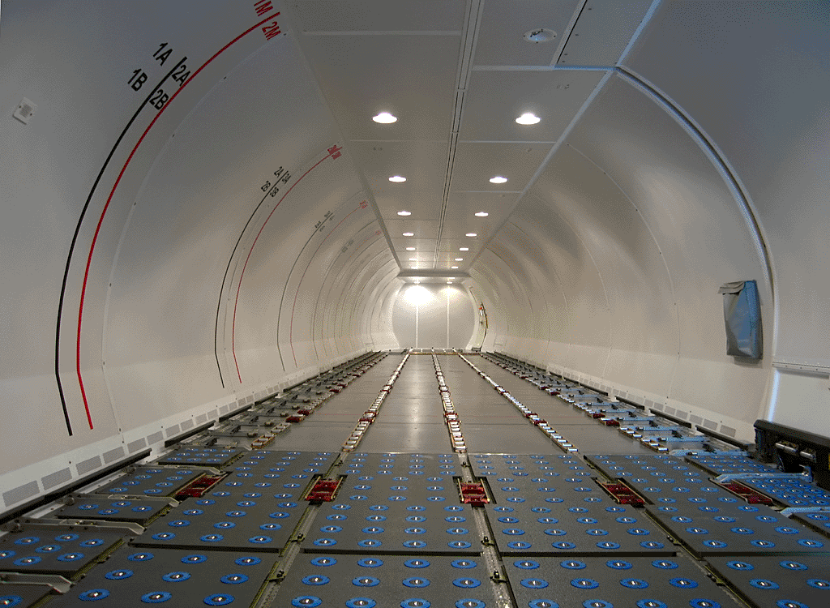  
  
Payload-Range  
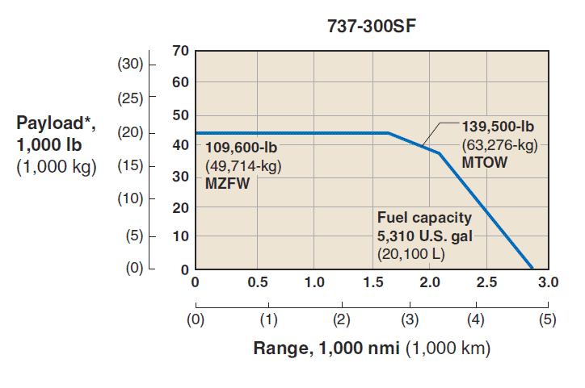  
  
Loading Specification  
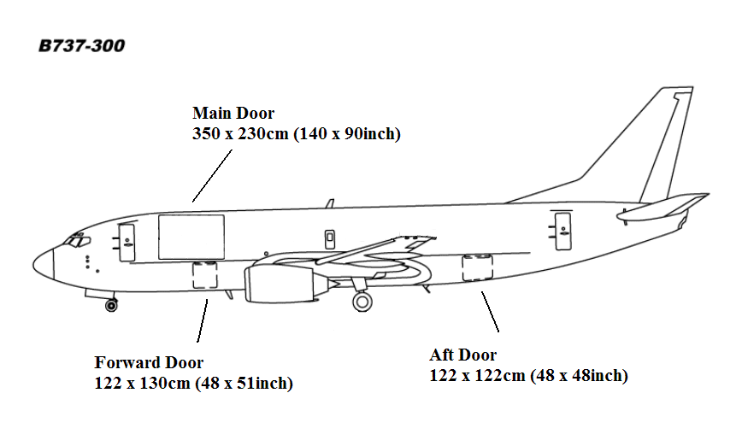  
  
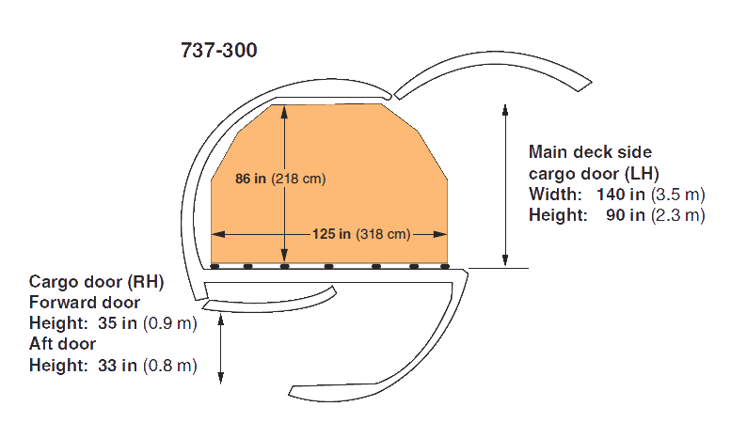  
  
Main Deck  
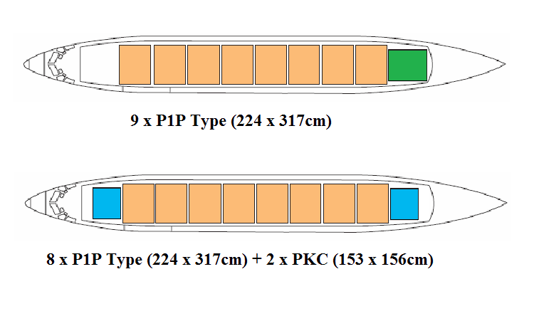  
Lower Deck  
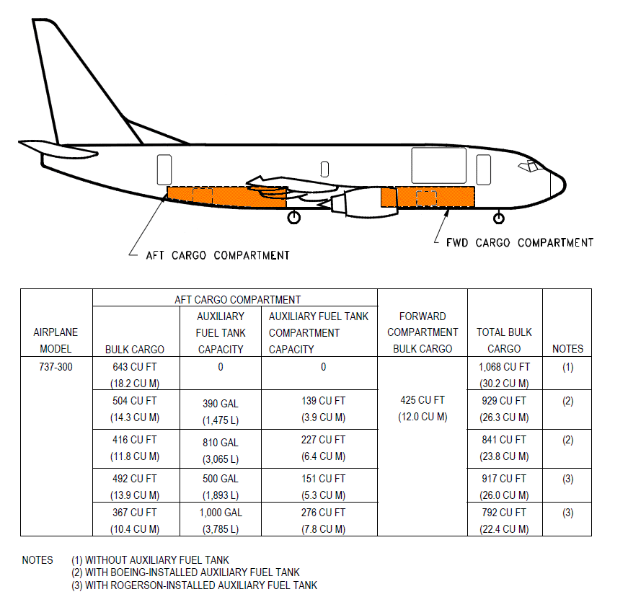  
  
ULD Reference  
  
Refer to above Main Deck (Orange Color)  
[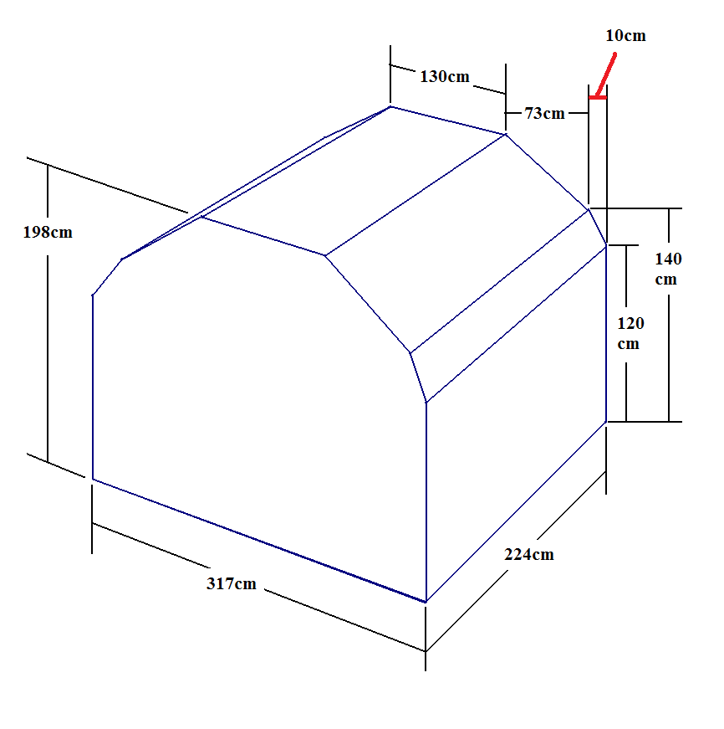](http://www.brinkley.cc/ULD/p1p_b737f_nc.htm)  
or  
[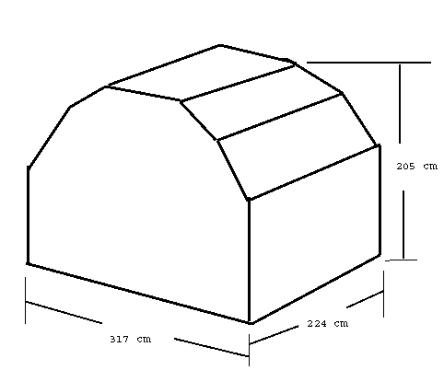](http://www.brinkley.cc/ULD/aaa.htm)  
Refer to above Main Deck (Green Color)  
[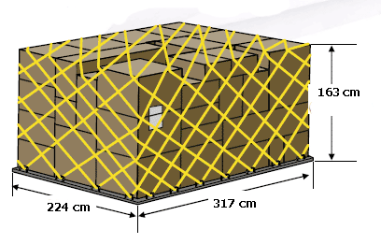](http://www.brinkley.cc/ULD/p1p_ldp.htm)  
Refer to above Main Deck (Light Blue Color)  
[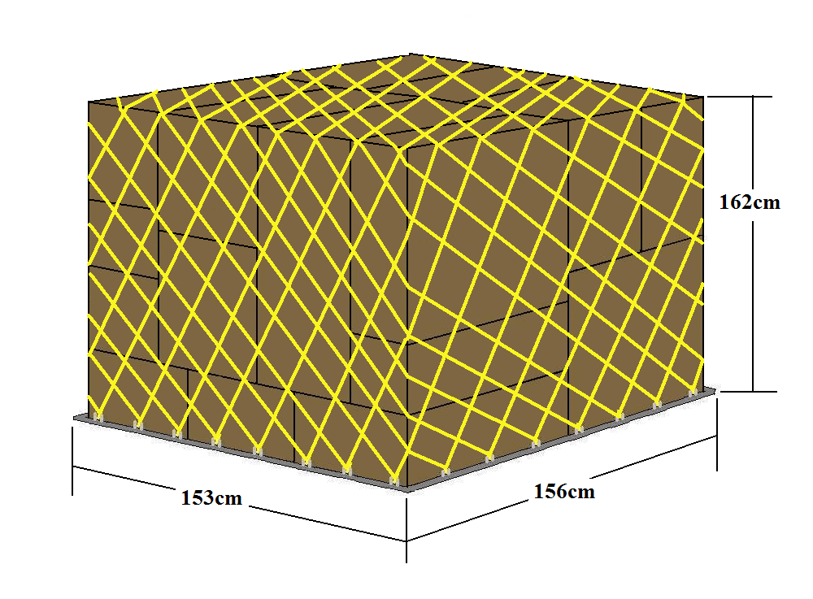](http://www.brinkley.cc/ULD/pkc_ldp.htm)  
or  
[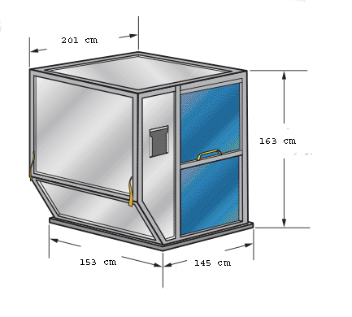](http://www.brinkley.cc/ULD/ake.htm)

|  |  |
| --- | --- |
| Payload (Tons) | 15,000 to 18,000 |
| Volume (cbm) | 130 |
| Main Door Dimension (LxH, cm) | 350x230 |
| Forward Door Dimension (LxH, cm) | 122x130 |
| After Door Dimension (LxH, cm) | 124x122 |
| Max Range (km) | 3,028 |
| Cruise speed (km/h) | 820 |
| MTOW (kg) | 63,276 |
| MZFW (kg) | 49,714 |
| Crew & Cargo Attendants | 2 |
| Max fuel capacity (kg) | 20,100 |
| Average fuel burn (tons/h) | 2.6 |
| Minimum runway (m) | 2,280 |