AIRCRAFT SPECIFICATIONS
as of 12.03.2025

PIAGGIO P180 AVANTI II
#59

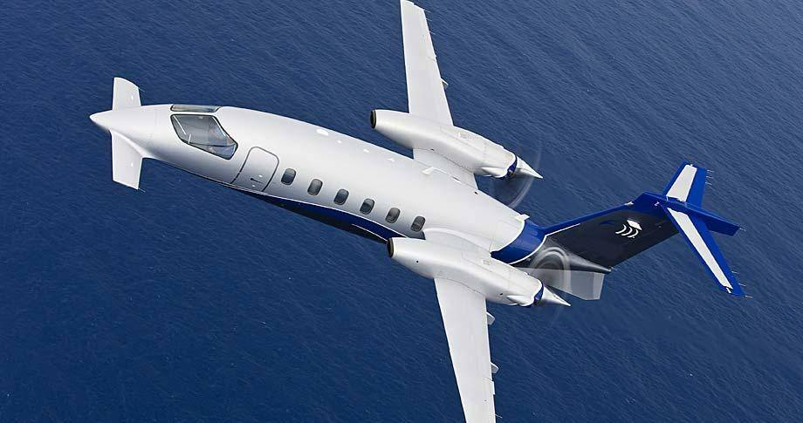

• Delivered : JUNE 2008

• Pratt & Whitney Canada PWC PT6A-66B Engines : 3 600 FH TBO

• Collins Pro Line 21 Avionics Suite

• 12 100 lbs MTOW (Increased)

• Mode-S Transponder: TDR 94D

• ADS-B out and LPV/SBAS compliant

• RVSM, Mach 0.7, Category II Landings and Steep Approach capabilities

WEIGHTS

Max Take Off Weight : 12 100 lbs
Max Zero Fuel Weight : 9 800 lbs
Max Landing Weight : 11 500 lbs
Fuel Capacity : 2 800 lbs

AIRCRAFT
Total Flight Time Since New: | 5 498 | Hours
Total Cycles Since New: | 4 359 | Cycles

ENGINES
LH ENGINE | Pratt & Whitney Canada P&WC PT6A-66B
Total Time Since New:  Total Cycles Since New: | FH 5 498  C 4 366
Hot Section Inspection: | TBHSI: 2 000 FH | Performed at: overhaul
 |  | Next HSI at: 5 500 FH
Overhaul: | TBO: 3 600 FH | Performed at: 3 596
 |  | Next OVH at: 7 196 FH
 | TSO: 1 902 FH
RH ENGINE | Pratt & Whitney Canada P&WC PT6A-66B
Total Time Since New:  Total Cycles Since New: | FH 5 498  C 4 366
Hot Section Inspection: | TBHSI: 2 000 FH | Performed at: overhaul
 |  | Next HIS at: 5 500 FH
Overhaul: | TBO: 3 600 FH | Performed at: 3 596 FH
 |  | Next OVH at: 7 196 FH
 | TSO: 1 902 FH

PROPELLERS

LH PROPELLER Hartzell HC-E5N-3A

Total Since New: | FH | 5 099
Time since overhaul: | FH | 1 503 - Overhaul 29.01.2026

RH PROPELLER Hartzell HC-E5N-3AL

Total Since New: | FH | 5 101
Time since overhaul: | FH | 1 505 – Overhaul 28.01.2026

LANDING GEAR
Total Flight Time Since New: | 5 498 | Hours
Total Cycles Since New: | 4 366 | Cycles
Total Flight Time Since overhaul: | 1 902 | Hours - Overhauled 2020
Total Cycles Since overhaul: | 1 331 | Cycles

Main Aircraft Features and Options:

1. ADS-B Out and LPV compliant
2. RVSM
3. Flight Management System FMC-3000 with GPS Sensor 4000S
4. Weather Radar with Turbulence Detection Collins
5. ELT ARTEX C406-N
6. Mode-S Transponder TDR 94D
7. Freon Cooling System
8. Single Point Pressure Refuelling
9. Overvoltage Protection
10. Provisions for Air Ambulance Kit
11. Engine Fire Extinguisher – Halon 1301
12. Propeller Synchrophaser
13. Marathon Battery
14. Max Take Off Weight (12100 lbs) and Max Zero Fuel Weight (9 800 lbs) increase
15. EASA Compliant

AVIONICS

COLLINS Pro Line 21
1 | RMS | COLLINS | RTU-4200
1 | RMS | COLLINS | CDU-3000
2 | VHF COM | COLLINS | VHF-4000
1 | VHF NAV | COLLINS | NAV-4000
1 | VHF NAV | COLLINS | NAV-4500
1 | DME | COLLINS | DME-4000
2 | Mode-S Transponder | COLLINS | TDR94 D
1 | RA | COLLINS | ALT-4000
1 | RADAR METEO | COLLINS | RTA 852
1 | TCAS I | L3 Comm | SKY899
1 | TAWS | L3 Landmark | TAWS 8000
3 | EFIS displays | COLLINS | AFD-3010
2 | DCP | COLLINS | DCP-3030
1 | CCP | COLLINS | CCP-3000
1 | FMS | COLLINS | FMC-3000
1 | CDU | COLLINS | CDU-3000
1 | GPS | COLLINS | GPS-4000S
1 | Standard audio
1 | ELT | ARTEX | C406-N

Note: Aircraft is ADS-B out, LPV/SBAS, BRNAV, 8.33KHz, FM immunity, RVSM.

INTERIORS Option 1 floorplan: (8-Place). Four single passenger seats in club arrangement, two-seat passenger side-facing divan and one forward-facing single-seat. Aft fully enclosed lavatory with flushing potty and belted aft auxiliary passenger seat, sink with hot and cold water and coat closet. Dual executive tables, forward refreshment center with coffee thermos, liquor storage, ice chest and miscellaneous storage.

Color: Grey Leather upholstering

