

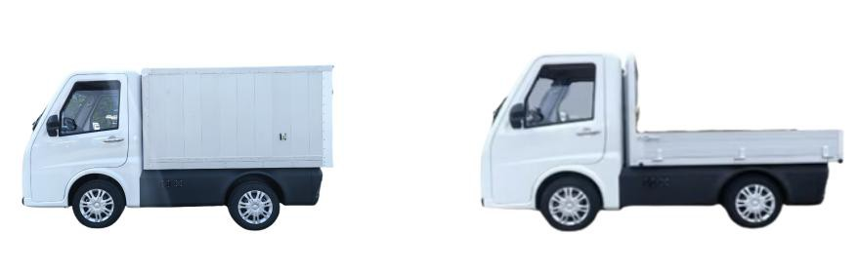

Provide Complete Delivery & Logistics Solution

 | Quotation Sheet
TO： |  |  | Date： | 2025/5/12
65km/h Standard Option |  | FOB | QTY | TOTAL
Flatbed Version  7.5KW motor，13.4KWh LFP Battery ABS+Braking energy recovery  Air-conditioner，RHD/LHD | ,  ＋ | $7,830.00 | 1 | $7,830.00
20.6KWh LFP Battery  Range: 190-220KM | ＋ | $750.00 | 0 | $0.00
27.2KWh LFP Battery  Range: 240-270KM | ＋ | $1,600.00 | 0 | $0.00
Aluminum Hopper LxWxH(mm):2085*1300*260 | 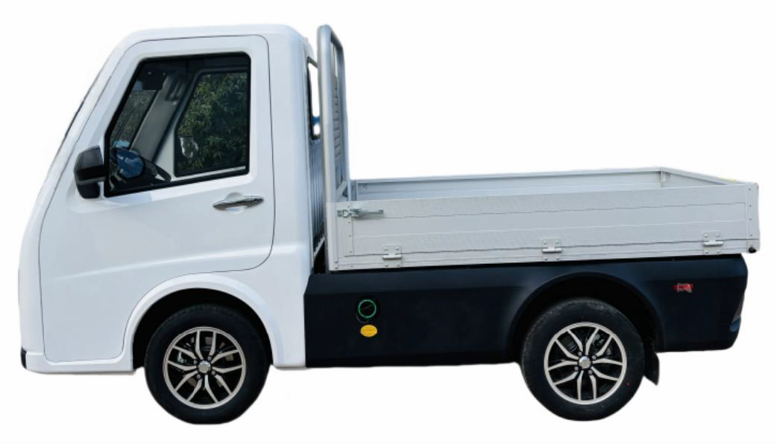 ＋ | $580.00 | 1 | $580.00
Polystyrene Resin Cargo Box LxWxH(mm):2085*1300*1200 | 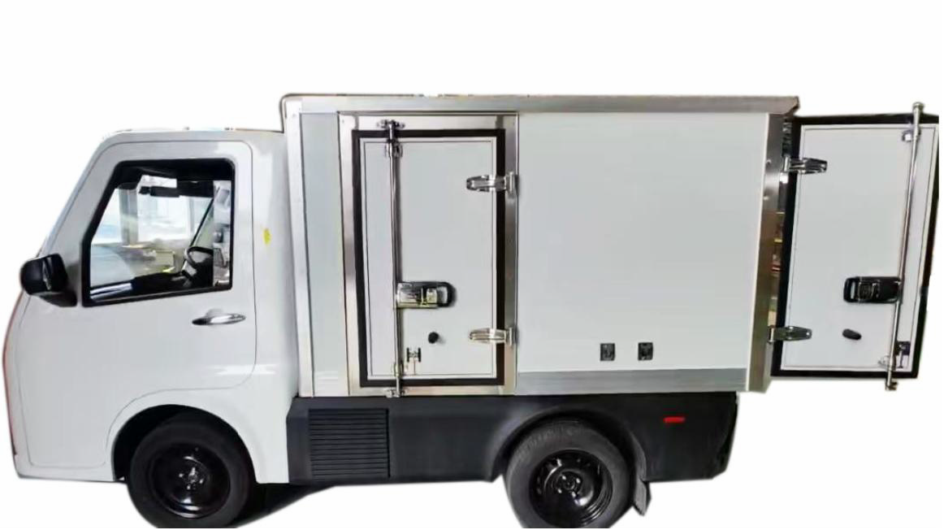 ＋ | $880.00 | 0 | $0.00
Aluminum Cargo Box LxWxH(mm):2085*1300*1200 | 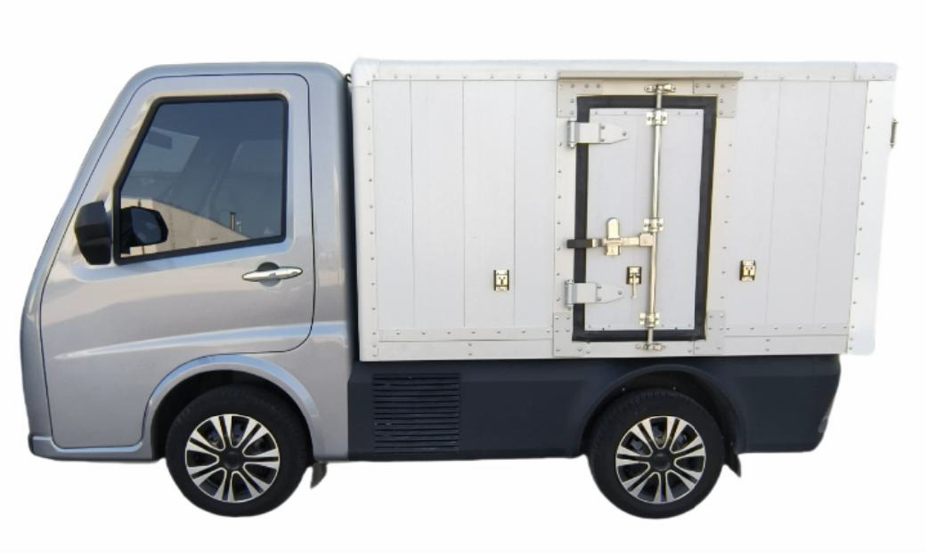 ＋ | $1,400.00 | 0 | $0.00
Glass panel & Thermoplastic panel Refrigerated Box  Cooling Temperature 0℃ — -18℃  LxWxH(mm)：2085*1300*1280 | 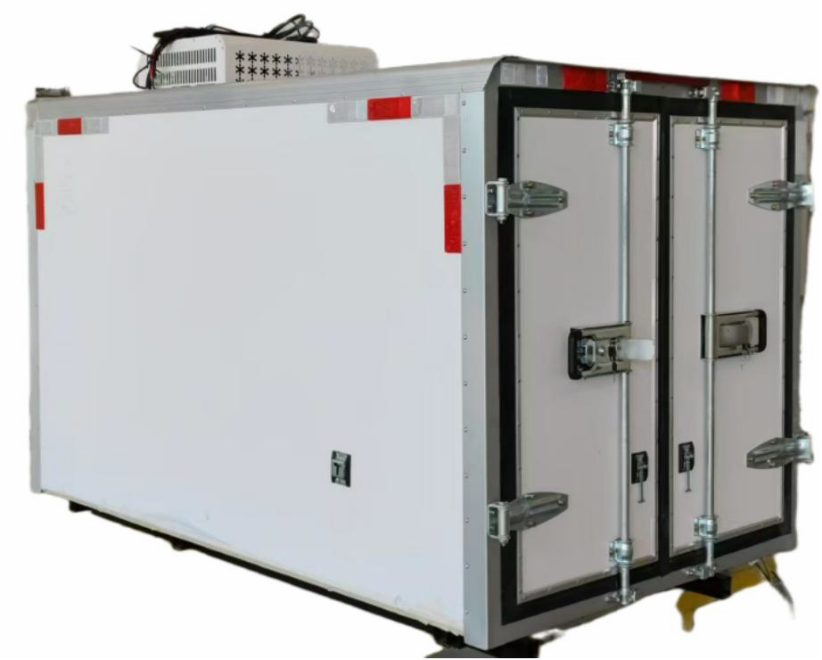 ＋ | $2,380.00 | 0 | $0.00
Trailer hook | 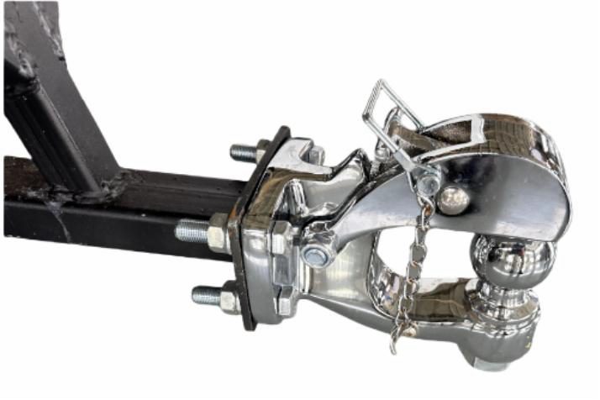 ＋ | $100.00 | 0 | $0.00
Digital Rearview Mirror | 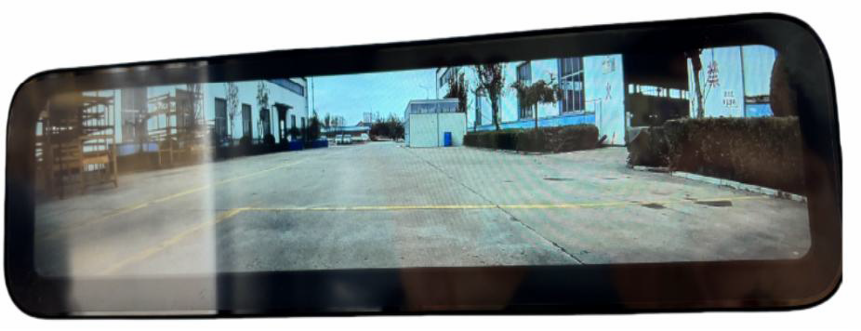 ＋ | $150.00 | 0 | $0.00
Winter tire | ＋ | $20.00 | 0 | $0.00
DG Qingdao Port Surcharge
order=1unit +800usd/uni order=2 unit +500usd/unit
order≥3 unit +300usd/unit

Remark:

$7,410.00

- 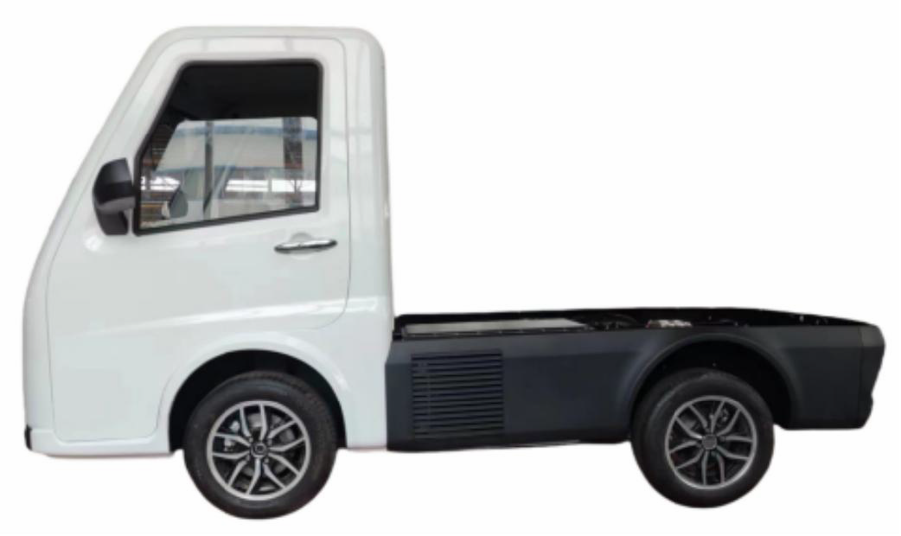Payment Term: DEMO order 100%, mass order 50% Deposit, 50% balance before shipment.

- Package : MOQ 3-4 Units for 1*40HQ

- Lead time: 40-60 work days after deposit.

- The price is valid for 1 month.

- FOB Price will be floating according the USD rate.

Quotation
TO： Date： 2025/5/12

80km/h Standard Option |  | FOB | QTY | TOTAL
Flatbed Version
15KW motor，20.6KWh LFP Battery,
ABS+Braking energy recovery  Air-conditioner，Digital Rearview Mirror | ＋ | $8,930.00 | 1 | $8,930.00
LHD/RHD
27.2KWh LFP Battery
Range: 220-250KM ＋ $880.00 0 $0.00

Aluminum Hopper
LxWxH(mm):2085*1300*260 ＋ $580.00 1 $580.00

Polystyrene Resin Cargo Box
LxWxH(mm):2085*1300*1200 ＋ $880.00 0 $0.00

Aluminum Cargo Box
LxWxH(mm):2085*1300*1200 ＋ $1,400.00 0 $0.00

Glass panel & Thermoplastic panel Refrigerated Box
Cooling Temperature 0℃ — -18℃
LxWxH(mm)：2085*1300*1280

＋ $2,380.00 0 $0.00

Trailer hook ＋ $100.00 0 $0.00

Winter tire ＋ $20.00 0 $0.00

DG Qingdao Port Surcharge order=1 unit +800usd/unit order=2 unit +500usd/unit order≥3 unit +300usd/unit

＋ $800.00 0 $0.00

Remark:
- Payment Term: DEMO order 100%, mass order 50% Deposit, 50% balance before shipment.

- Package : MOQ 3-4 Units for 1*40HQ

- Lead time: 40-60 work days after deposit.

- The price is valid for 1 month.

- FOB Price will be floating according the USD rate.

