**Aircraft Specification Report**

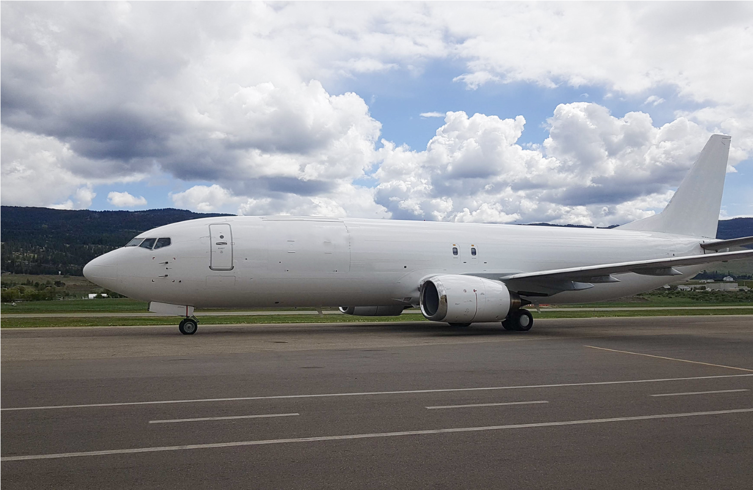

**Aircraft Type: B737-400F**

**Date of Entry into Service: 14-Aug-1991**

# 1.0 GENERAL AIRCRAFT DESCRIPTION AND SUMMARY

|  |  |  |  |  |  |  |
| --- | --- | --- | --- | --- | --- | --- |
| Manufacturer | | Boeing | | |  | |
| Model | | B737-4B3HGW | | |  | |
| MSN | | 0000000 | | |  | |
| Current Registration Mark | | 0000000 | | |  | |
| Entry into Service | | 14-Aug-1991 | | |  | |
| Time Since New (TSN) as of 1-May-2024 | | 67788:35 | | |  | |
| Cycles Since New (CSN) as of 1-May-2024 | | 33,115 | | |  | |
| Last Maintenance Visit | | December 2022 | | |  | |
| AEI Cargo Conversion Date | | October 2020 | | |  | |
| Secure Cockpit Door Fitted | | Yes | | |  | |
|  | | ***Aircraft Design Weights*** | | |  | |
| Maximum Taxi Weight | | 150,500 **lbs** | | | 68,265 **kg** | |
| Maximum Takeoff Weight | | 150,000 **lbs** | | | 68,038 **kg** | |
| Maximum Landing Weight | | 124,000 **lbs** | | | 56,245 **kg** | |
| Maximum Zero Fuel Weight | | 117,000 **lbs** | | | 53,070 **kg** | |
| Maximum Freight Weight | | 46,000 **lbs** | | | 20,865 **kg** | |
|  | | ***Aircraft Maintenance History*** | | |  | |
| **Maintenance Check** | | | **Last Done** | | **Next Due** | | |
| 1C | | | Dec 2022 | | Dec 2024 | | |
| 2C | | | Dec 2022 | | Dec 2026 | | |
| 3C | | | Oct 2020 | | Oct 2026 | | |
| 4C | | | Jun 2017 | | Jun 2025 | | |
| 5C | | | Dec 2015 | | Dec 2025 | | |
| 6C    **2.0 ENGINES** | | | Dec 2015 | | Dec 2027 | | |
| ***Engine Details*** | | | ***Position #1 (L/H)*** | | ***Position #2 (R/H)*** | | |
| Serial Number | 722346 | | | 722375 | |
| Manufacturer/Model | CFM56-3C-1 | | | CFM56-3C-1 | |
| Install Date | May 2023 | | | May 2023 | |
| Current Operating Thrust | 22k (Cat B) | | | 22k (Cat B) | |
| Time Since New (TSN) | 62092.05 | | | 74930.56 | |
| Cycles Since New (CSN) | 44328 | | | 46570 | |
| Time Since Last Shop Visit (TSLSV) | 4133.15 | | | 4133.15 | |
| Cycles Since Last Shop Visit (CSLSV) | 2502 | | | 2502 | |
| Limiter | HPT Disk (2254 cycles remaining) | | | HPC Stage 3 Disk (2217 cycles remaining) | |

# 3.0 LANDING GEAR

|  |  |  |  |  |  |  |  |
| --- | --- | --- | --- | --- | --- | --- | --- |
| ***Position*** | | ***Nose*** | | | ***Left Main*** | ***Right Main*** | |
| Part Number | | 65-73762-20 | | | 65-73761-121 | 65-73761-122 | |
| Serial Number | | XC92131 | | | 97-177054 | 97-179610 | |
| Next Overhaul Date  **4.0 APU** | | May 2027 | | | April 2028 | April 2028 | |
|  | | ***APU Details (as of May 2024)*** | | | |  | |
| Model | | | | GTCP85-129H | | | | |
| Serial Number | | | | P-200 | | | | |
| Part Number | | | | 380428-10-1 | | | | |
| Time Since New (TSN) | | | | 15113:33 | | | | |
| Cycles Since New (CSN) | | | | 8718 | | | | |
| Time Since Last Shop Visit (TSLSV) | | | | 9697.08 | | | | |
| Cycles Since Last Shop Visit (CSLSV) | | | | 5281 | | | | |
| Limiter  **5.0 NOTABLE STC/MOD LIST** | | | | N/A | | | | |
| ***STC/Mod Number Certificate Holder*** | | | | ***Description*** | | | | |
| FAA STC ST01827LA | AEI | | Main Deck Cargo Door Installation | | | |
| FAA STC ST01827LA | Ancra International LLC | | Main Deck Cargo Loading System | | | |
| FAA STC ST01806LA | Ventura Aerospace | | Installation of a 9g Cargo Barrier | | | |
| TCCA STC C-LSA11-115/D | Flair Airlines Ltd. | | Skytrak ISAT-200 Satcom System | | | |
| FAA STC ST04020NY | Kelowna Flightcraft Ltd. | | ADS-B Out | | | |
| FAA STC ST01674AT | Advanced Aircraft Extinguishers, Ltd. | | Lower Cargo Smoke Detection & Fire Suppression | | | |
| FAA STC ST01335LA | C&D Interiors | | Reinforced Cockpit Door | | | |
| FAA STC ST03354AT | ARC Avionics Corporation | | Universal Avionics Class “A” TAWS | | | |
| FAA STC ST03355AT | ARC Avionics Corporation | | Universal Avionics EFIS | | | |
| FAA STC ST03874NY | Corporation Logic Air Inc. | | Installation of 2nd FMC | | | |
| FAA STC ST03273NY | Corporation Logic Air Inc. | | Installation of Dual CMC GLS with CMA-5024  GLSSU Sensors and Dual CMC CMA-5025 Control Panels | | | |
| FAA STC ST00137AT | Collins | | TCAS II | | | |

# 6.0 PALLET CONFIGURATION FREIGHTER POSITION WEIGHTS AND CONTAINERS

|  |  |  |  |  |  |  |  |
| --- | --- | --- | --- | --- | --- | --- | --- |
| ***Main Deck Usable Volume*** | | |  | | ***Lower Deck Usable Volume*** | | |
| **10 ULD’s - 88"x125“x82”H**  1 ULD – 53”x88”x64” | **4,572 FT3**  (129 M3) | | Forward lower cargo compartment | | **582 FT3** (16.4 M3) |
| **10 Netted Pallets** 88”x125”  1 ULD 53”x88x64”H | **4,416 FT3**  (125 M3) | | Aft lower cargo compartment | | **674 FT3** (19.1 M3) |

**Standard 88’’x125’’ Main Deck Cargo Compartment Position Weights**

|  |  |  |  |  |  |  |
| --- | --- | --- | --- | --- | --- | --- |
| Netted Pallet  Dimensions  Container Dimensions | **P1**  88”x125” 80"H  88”x125”  82"H | **P2**  88”x125” 80"H  88”x125”  82"H | **P3**  88”x125” 80"H  88”x125”  82"H | **P4**  88”x125” 80"H  88”x125”  82"H | **P5**  88”x125” 80"H  88”x125”  82"H | **P6**  88”x125”  80"H  88”x125”  82"H |
| Container Type | AAA  AAC  AAY | AAA  AAC  AAY | AAA  AAC  AAY | AAA  AAC  AAY | AAA  AAC  AAY | AAA  AAC  AAY |
| Position Weight Limit | 4,000 LB  1,814 KG | 6,500 LB  2,948 KG | 6,500 LB  2,948 KG | 6,500 LB  2,948 KG | 8,000 LB  3,628 KG | 8,000 LB  3,628 KG |
|  | **P7** | **P8** | **P9** | **P10** | **P11** |  |
| Netted Pallet  Dimensions | 88”x125”  80"H | 88”x125”  80"H | 88”x125”  80"H | 88”x125”  80"H | 53”x88”  64"H |  |
| Container Dimensions | 88”x125”  82"H | 88”x125”  82"H | 88”x125”  82"H | 88”x125”  82"H | 53”x88”  64"H |  |
| Container Type | AAA AAC  AAY | AAA AAC  AAY | AAA AAC  AAY | AAA AAC  AAY | LD3  AEP  AEH |  |
| Position Weight Limit | 6,500 LB  2,948 KG | 6,500 LB  2,948 KG | 6,500 LB  2,948 KG | 3,750 LB  1,700 KG | 2,500 LB  1,133KG |  |

IATA ULD type codes are provided for reference and are based upon standard contours and dimensions. Variations in contour or dimensions may exist between various ULD manufacturers. KF Aerospace does not guarantee that all described ULDs from all manufacturers will fit within the aircraft and the aircraft operator must confirm the ULDs it plans to use will fit within the internal contour of the aircraft.

