**SPECIFICATION SUMMARY**

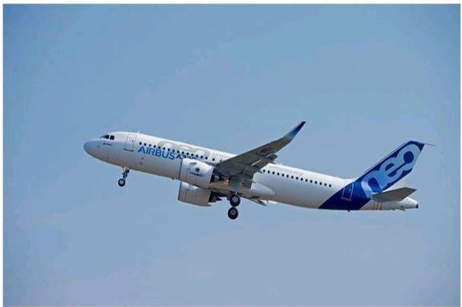

## AIRBUS A320-251 NEO

### AIRCRAFT IDENTIFICATION

**Aircraft Model Airbus A320-251N Manufacturer Serial Number TBA**

**Manufacture Date 2024 Aircraft Registration TBA**

**Engines Model CFMI LEAP-1A26 Sharklets YES**

**Noise Abatement Compliance Stage IV law. ICAO Annex 16, Volume 1 Approach Category CAT 1118 Capable**

**ETOPS 120 min to be certified by EASA Over Water None**

### WEIGHTS, OPERATIONAL

**Maximum Taxi Weight (MTW) Maximum Take Off Weight (MTOW) Maximum Landing Weight (MLW) Maximum Zero Fuel Weight (MZFW) Aircraft Basic Empty Weight (BEW) Maximum Usable Fuel Capacity Auxiliary Fuel Capacity**

**European 77'400 (kg)**

**77'000 (kg)**

**6T400(kg)**

**64'300 (kg)**

**40'300 (kg)**

**19'087 (kg)**

**None**

**•wvos3**

### AIRFRAME STATUS

**Total Airframe Hours 0:00**

**Total Cycles 0**

**Status Date 06 Dec 2023**

### MAINTENANCE STATUS

**Base HM-check interval 7'500 FH & 5'000 FH & 24 MO A· Check interval 7S0 FH & 750 FC & 121 Days**

**Last HM Check performed N/A**

**Next HM Maintenance Check in 7'500 FH & 5'000 FH & 24 MO Status Date 06 Dec 2023**

**A320-251N Page 2 of 9**

#### ENGINE/ APU DETAILS

**Manufacturer**

**Model**

**Engine 1 Engine 2 APU**

**CFMI CFMI Honeywell CFMI LEAP-1A26 CFMI LEAP-1A26 GTCP Bl-9A**

|  |  |  |  |
| --- | --- | --- | --- |
| **ENGINE/ APU STATUS** | **Engine 1** | **Engine 2** | **APU** |
| **Serial Number** | **TBA** | **TBA** | **TBA** |
| **Thrust Rate** | **26.600 Lbs** | **26'600 Lbs** |  |
| **Total Time Since New** | **0:00** | **0:00** | **0:00** |
| **Total Cycles Since New** | **0** | **0** | **0** |
| **Last Shop Visit** | **None** | **None** | **None** |
| **Last Overhaul** | **None** | **None** | **None** |
| **Hours Since Last Shop Visit** | **N/A** | **N/A** | **N/A** |
| **Cycles Since Last Shop Visit** | **N/A** | **N/A** | **N/A** |
| **First Limiter** | **15'000** | **15'000** | **30'000** |
| **Status Date** | **06 Dec 2023** | **06 Dec 2023** | **06 Dec 2023** |

|  |  |  |  |
| --- | --- | --- | --- |
| **LDG DETAILS** | **NLG** | **LH MLG** | **RH MLG** |
| **Part Number** | **NA31001-0003** | **10-450101-101** | **10-450201-101** |
| **Serial Number** | **TBA** | **TBA** | **TBA** |
| **Position** | **NLG** | **LH MLG** | **RH MLG** |
| **Cycles Since New** | **0** | **0** | **0** |
| **Status Date** | **06 Dec 2023** | **06 Dec 2023** | **06 Dec 2023** |
| **Last Overhaul Date** | **N/A** | **N/A** | **N/A** |
| **Cycles Since Overhaul** | **N/A** | **N/A** | **N/A** |

**Overhaul Interval**

**1s·ooocvc 21·ooocYc 21·ooocvc**

**or 10 Years or 10 Years or 10 Years**

**A320-251N Page 3 of 9**

#### MAJOR AVIONICS EQUIPMENT

|  |  |  |  |
| --- | --- | --- | --- |
| **Description** | **Manufacturer** | **Part Number** | **QTY** |
| **ATA 22 • Automatic Flight Controls** |  |  |  |
| **Flight Augmentation Computer** | **Thales Avionics** | **C13206AA00** | **2** |
| **Flight Management Guidance Computer** | **Thales Avionics** | **C13207CA00** | **2** |
| **ATA 23-Communication** |  |  |  |
| **Radio Management Panel** | **Thales Avionics** | **Cl2848CB01** | **2** |
| **Audio Management Unit** | **Team** | **AMU4031SA140204** | **1** |
| **Audio Control Panel** | **Team** | **ACP2788AD01** | **3** |
| **Transceiver VHF/COMM Transceiver HF/COMM** | **Honeywell**  **N/A** | **965-1696-051** | **3** |
| **ATA 31- Indication and Recording System** |  |  |  |
| **Solid State Flight Data Recorder** | **Honeywell** | **980-4750-002** | **1** |
| **Solid State Cockpit Voice Recorder** | **Honeywell** | **980-6032-023** | **1** |
| **Flight Warning Computer** | **AIRBUS** | **3S0E0S3021414** | **2** |
| **FDIMU (Flight Oita Interface Management Unit)** | **Teledyne** | **2234320-02-02** | **1** |
| **SFDIU** | **Thales Avionics** | **C12860AA04** | **1** |
| **ATA 34- Navigation** |  |  |  |
| **MMR- Multi Mode Receiver ILS/GPS** | **Honeywell** | **822-1152-122** | **2** |
| **ADIRU (Air Data Inertial Reference Unit)** | **Honeywell** | **HG2030BE04** | **3** |
| **Weather Radar (WRX)** | **Honeywell** | **930-1005-002** | **1** |
| **TCAS 117.1Computer** | **Honeywell** | **940-0351-001** | **1** |
| **ATC-Mode STransponder** | **Honeywell** | **066-01127-1402** | **2** |
| **Radio Altimeter Transceiver (RA)** | **Honeywell** | **066-50007-0432** | **2** |
| **EGPW5** | **Honeywell** | **69000942-151** | **1** |
| **VOR Receiver** | **Honeywell** | **69001410-200** | **2** |
| **DME Interrogator** | **Honeywell** | **066-50013-1222** | **2** |
| **ADF Receiver** | **N/A** |  |  |

**A320-251N Page 4 of 9**

## INTERIOR CONFIGURATION

|  |  |  |  |
| --- | --- | --- | --- |
| **Galleys** | **2 (Gl; G4B)** | **Catering Standard** | **ATLAS** |
| **Lavatories** | **3** | **Cargo Configuration** | **All Bulk+ No CLS** |
| **Attendant Seats** | **s** | **Cockpit Configuration** | **Standard** |
| **In Flight Entertainment** | **None** |  |  |
| **Seats** |  | **Manufacturer** | **Part Number** |
| **Economy** | **186** | **TBA** | **TBA** |

**NOTE: Seats not Installed. Customers may Install its own BFE, or ask for specific PNs.**

**Lead time and costs shall be considered.**

**A320-251N Page 5 of 9**

**A Otlh SUlndlltd SpaoflCt1llon RehJ'MCft WO 000 02000N/ I :. 01*I* Rev, 01**

|  |  |  |  |  |  |  |  |  |  |  |  |  |  |  |  |  |  |  |  |
| --- | --- | --- | --- | --- | --- | --- | --- | --- | --- | --- | --- | --- | --- | --- | --- | --- | --- | --- | --- |
| **SCN**  **MSCN EPACTDU** TITLE  **MISC** . | | | | | | | | | | | | | | | | | | | |
| **ATA 02 CERTIFICATION EXTERNAL LIVERY** | | | | | | | | | | | | | | | | | | | |
| SCN | CN02.10.!20/01 | | | | 15 knou tollwlnd certification at Take-Off | | | | | | | | | | | | | | |
| SCN | CN02.12.J29/0i | | | | CenI0ca1Ion of A320 increased seating capacItv up to 186 seau | | | | | | | | | | | | | | |
| SCN | CN02.40,J16/01 | | | | C.ternal lIverv | | | | | | | | | | | | | | |
| SCN | CN02 | | 10..l ll/OI | | Compliance w,th EASA type ceniflcation requlremen11 (A319/A320/A3211 | | | | | | | | | | | | | | |
| **ATA 03 MISCELLANEOUS** | | | | | | | | | | | | | | | | | | | |
| SCN | CNQ3 | | 20 | ,55 l/53 | A32Q.251N des,gn weights lncrea,ed MTOW 10 77 t, MLW to 67 | | | | | | | | | | | 4 MlrW to 64 | | | 3 t (WV 0531 |
| ATA U **PLACARDS AND MARKINGS** • **GENERAL** | | | | | | | | | | | | | | | | | | | |
| SCN | CNll.00.124/03 | | | | **ln tallauon of leasing Identification platesan LH door frame** | | | | | | | | | | | | | | |
| SCN | CNU.00.124/09 | | | | lnsuillatlon or leasingldent1flcatl0n platesoo engjne, | | | | | | | | | | | | | | |
| SCN | CNU.30.122/46 | | | | in,t.illatlon of placard ro, cabin •ccess reswwon | | | | | | | | | | | | | | |
| SCN | CNll.30.110/04 | | | | Passenger placards andsigns alternate marking | | | | | | | English ontv | | | | | | | |
| SCN | CNll,00.123/02 | | | | Alrcrah certlr,catlon holdersIn rllght compartment andcabin | | | | | | | | | | | | | | |
| SCN |  | CNll.30.131/0S | | | Installa11on of we,ght placard on each ovcrwing hate!> | | | | | | | | | | | | | | |
| SCN | CNll.20,125/05 | | | | Red RVSM markings around mtic ports | | | | | | | | | | | | | | |
| SCN | CNll.20,J19/13 | | | | External livery Nose landll\& **gear** towing anglemarklnas | | | | | | | | | | | | | | |
| SCN | CNIJ.30.J11/32 | | | | Monolln&ual EEPMS exit Identifier | | | | * English onlv (vertlal arrangement) AIRSIGNA | | | | | | | | | | |
| **ATA 21 AIR** CONDITIONING - **GENERAL** | | | | | | | | | | | | | | | | | | | |
| SCN | CN21.SO..l00/0J | | | | **lns,allatlon of an if ulation cover ror o,one conv@11ers.** | | | | | | | | | | | | | | |
| SCN | CN2l.70.J09/07 | | | | lnstall•Uon of ozone catalytic con•eners • | | | | | BASF CORPORATION, **PN.20499006** | | | | | | | | | |
| MSCN | CN2J.61.000/0i | | | | Introduce Improved Air Conditionin | | | | g Sv,,Ien1Conuoller **P/N**180380000,03 | | | | | | | | | | |
| MSCN | CN2l.6l.000/02 | | | | introduce Improved Air Conditioning System Conuoller **P/N** 180380000**04** | | | | | | | | | | | | | | |
| **ATA 23 COMMUNICATIONS** - **GENERAL** | | | | | | | | | | | | | | | | | | | |
| SCN | CN23.00.132/44 | | | | Auto progr | , ELT (406 AfN) assoc. wtthremote conttol panel In cockpit w/o AIM | | | | | | | | | | | | HDNEl'WELL (BFE) | |
| SCN | '307300100E | | | | ,rici dcs,  . Callchime **via** allC/A station and pa,senaer compartment loudspeakers EVAC command push button at add1tlonal attendant panel  Guard ror EVAC command button at additional attendant panel  Customer provided (picture) screensaver | | | | | | | | | | | | | | |
| SCN | CN23.12,130/16 | | | | VHFData Radio (VDR) alternate equIp,nent, capable VOL mode 2 HONEYWELL | | | | | | | | | | | | | | |
| SCN | CN23.51.136/27 | | | | Boomsets alternote equipment TELEX COMMUNICATIONS, PN64300-210 | | | | | | | | | | | | | | |
| SCN | CN23.7J,!03/21 | | | | SSCVR alte1nate equipment HONEYWELL, PN980·6032-023 (90 davsULS) | | | | | | | | | | | | | | |
| SCN | CN23.71.JJ0/01 | | | | Reco1der Independent Power Supply (RIPS) 28VOC power supply for CVR | | | | | | | | | | | | | | |
| SCN | CN23.71120/01 | | | | Synem provision for CVRcapable ol datalink recotdln& | | | | | | | | | | | | | | |
| MSCN | CN23 | | 7100J/04 | | 1n11oduce CAMOMS8 fo, EDl12 mandate | | | | | compliance | | | | | | | | | |
| ATA 24 ELECTRICAL POWER • GENERAL | | | | | | | | | | | | | | | | | | | |
| MSCN | CN24.22 | | | 000/06 | Introduce GCUP/N 767584M | | | | | | | | | | | | | | |
| **ATA ZS EQUIPMENT/FURNISHINGS· GENERAL** | | | | | | | | | | | | | | | | | | | |
| SCN | CN2S | | 1l | 208/0S | lnstallotlon or fourth occupant seat In cockpit (without oxygen muk) | | | | | | | | | | | | STELIA AEROSPACE | | |
| SCN | 2SDS000100E | | | | CARGO HOLD CONFIGURATION  I-nc-lud-e<:  Installation of rubber sealproliles for lloor panels In FWD and AH cargo holds  S.slc runbulk configuration wlihout ACT provi,;ion | | | | | | | | | | | | | | |
| R;,inlorced floor panels tn fWO& AFTcargo hold; | | | | | | | | | * with full bulkconOguratlon | | | | | |
| SCN | CN2S.65 | | | l96/72 | Installation of provision for emeraencv equipment | | | | | | | | | | | | | | |
| SCN | CN2S | | 33 619/0J | | Installation or wet galley at loc | | | IVB | * 3 FS and 2 HStrolleys | | | | * Space-Fie• Ralleys (SFE) | | | | | | |
| SCN | GNJS.43,470/03 | | | | Space-Ft.x lavatDrv modul• F,/G1In comb | | | | | . withgall•v loc.IVB | | | | | all of oft lH Pf>:1./crew/ltrvice door | | | | |
| SCN | CN2S | | 3S131/20 | | Installation orMinimum non | | electr,cal galley catering oqulpmenl (BFEI | | | | | | | | | | | | |
| SCN | CN25 | | 33 639/08 | | lnstallauon orspec1fIc options ongalley at loc. IVB | | | | | | | | | | | | | | |
| SCN | GN25.22,212/0l | | | | Single wall- | mounted C/A seat (16G) at loc. 62 | | | | | * on favatorv door at ah Pf>:1./Crew/Servlce door area | | | | | | | | |
| SCN | CN2S | | .43 | .47J/08 | lnstallatlM oroptions on Space.flex lavato11es fs and Gs | | | | | | | | | | | | | | |
| SCN | 2SD3000100E | | | | Gallev and Aallev catering definition | | | | | | | | | | | | | | |
| SCN | CN25 | | ]2 002/22 | | 1n,1allat1on or 16G cabin a11,ndan1se•t nxx SCRICS•• **por** amomlud cabin layout | | | | | | | | | | | | | | |
| SCN | CN2s.21 IOS/42 | | | | Non-Installation of Passenger Seats | | | | | | | | | | | | | | |
| SCN | CN25 | | .26133/04 | | **Provls,ons rorcurtalns** | | | | | | | | | | | | | | |
| SCN | CNZS | | .26.201/04 | | Installation of J6G full-height partition ror double C/Aseat FWO of alt RH PAX/Crew/Service door | | | | | | | | | | | | | | |
| SCN | CNlS. | | 26 | 140/54 | Installation orcranked windscreen (SFEJ LH | | | | | | | | | | | | | | |
| SCN | 2502000200E | | | | CABIN LAYOUT DEFINITION  I-n-c-ludes:  C.bin Layout ,ef.320·25.42492 Rev **82** J86pax (186 Y/C) (•J  Including:  Door l I SFE Lav l GI WET SFE Gailey Cluster I (4T) 2 Sf£Partitions· 2 SFE CAS   * Door 2.*1* $FE Spate flex V2 Uvatoues • I SfE SG4I WETSpace Fie• V2Galley (G4S w/ 8HS/l) • 2 SFEPartitloni 3 SFECAS | | | | | | | | | | | | | | |

**.**

**. . ,**

**•**

**.**

**.**

**.**

**. . .**

**.**

**. .**

**•**

**, -**

**.**

**,**

**.**

**A320-251N Page 6 of 9**

**SCN SCN**

**SCN**

**SCN SCN SCN SCN SCN SCN MSCN MSCN**

**CNZS.20.001/01 ZSOOOOOlOOE**

**CNZS.23.500/01**

**CN2S.3S.132/06 CNZS.28.103/02 CN25.28.200/75 CN2S.62.l02/l 7 CN25.62.105/07 CN25.6S.002/l2 CN2S.62.090/07 CN25.65.001/32**

**1•Iseats notInstalled at time of delivery**

**Add,uonal sealing for gaps closureIn Galleys, Lavaiorles andentrance areas**

**CABINEMERGENCY EQUIPMENT**

**Emergency Equipment drawing rel, 320.S0.19045 rev 84 Interior colour scheme deAnluon**

**ICSrof. ICS 15/071 Issue 4**

**NonInstallation of non,electrlcal R•lley cate11nBfloo,e equipment (8FE)**

**tn51l!llallon of double-sided adhesive tape lor carpel**

**NTF selection (SfE standard I}- SCHNELLER AerFuslon eco. 9SR**

**tnstallallon of slide nits atFWD andAfT PAX/Crew/Service doors(SFE) • AIR CRUISERS(A320) Su,v,vai luls (4) selecIlon (SFE) • AIR CRUISERS, PN60128-301**

**Cockpit flashlights alternate l!Qulpment (SFEI OME CORPORATION P2-07-001S 002 Install additional w,apper for FWD and ah door slide,,**

**Install crash axe P/N EI576014-IOOOO**

##### ATA 26 FIRE PROTECTION • GENERAL

**MSCN I CN26.10.000/07 Install rou Meggln P/N 909012-02-01 (engine & APU) MSCN I CN26.24,100/05 SLandardlze portable nre extinguisher TOTAl 74-20 In cockpit**

**ATA 27 FLIGHT CONTROLS • GENERAL**

**MSCN I CN27.40.000/09 Introduce T!lrnmablc 1-torlzontal Stablll,er (THS) actuate, P/N 47145-26S**

##### ATA 28 FUEL· GENERAL

**MSCN I CN28.42.100/17 A319 Noa/ A320 N•o • tntroduco common fu•Igauglns**

**ATA 29 HYDRAULIC POWER • GENERAL**

**MSCN I CN2910 ll0/0 Introduce Improved EDP Eaton P/N3031863-002**

##### ATA 31 INOICATING/RECOROING SYSTEMS • GENERAL

**SCN SCN SCN MSCN MSCN MSCN MSCN**

**CN31.00.107/14 CN3J.36.107/03 CN31.33.200/23 CN3I .36.100/0S CN31.S3.100/14 CN31.53.100/16 CN31.60.000/1J**

**Imperial units for 1ndlutors and labels**

**Fullprovl,lon far WirelessGround Link DAR (WGL-OAR) (ARINC 591/600) SSFDR alternate equipment (1024 w/s capable)· HONEYWELL \90 days ULB)**

**Introduce Flight Dal• Interface & Management Unit (FOIMU) P/N 2234320·02-02 Introduce FWC H2f8 P/N 350E05302.1414**

**Introduce FWC H2F9C Introduce £I52-513,l ,oftware**

##### ATA 32 LANDING GEAR - GENERAL

**SCN SCN SCN SCN MSCN MSCN MSCN**

**CN32.40.113/32 CN32.4S.200/12**

**CN32.4l,lll/25 CN32.41.120/12 CN32.ll.001/10 CN32.2l.100/l0 CN32.42.105/10**

**Wheels and brakes alternate equipment (OURACAR8) - GOODRICH**

**InstaliaIlon or universal brake cool,ng la,uon Bf·GOODRICH wheels andbrakes MIGtires selection · BRIDGESTONE (46Xl7 R20 radial ores)**

**NLG tires selection BRtOGESTONE (30X8.8 RJ5 radial tires)**

**Opllmlze corrosion protec11on on theMIG main fitting Introduce "EV2" NLG**

**Introduce escuL4.10 P/N t21327007**

**ATA 33 LIGKTS • GENERAL**

**SCN SCN MSCN MSCN MSCN MSCN MSCN**

**CN33.50.118/0 I CN33.S0.122/16 CN33.10.106/03 CN33.l2.109/06 CN33.40.J03/06 CN33.40.103/08 CN33.48.101/02**

**lnstallallon ol floor,mounted EEPMS LUFTHANSA TECHNIK 1000 / Elclt Identifier -AIRSIGNA lnstdllatlon ol Titanium Grev floor-mounted EEPMS LUFTHANSA TECIINIK •1000 - whole cabin Introduce UD Integrallighting sv11em units**

**Introduce llD technologv In the cockpit**

**Introduce LEO technology eateinal light<**

**Introduce lCO technology wing t,p li&hts - Sharklels Introduce Sharklet sttobe lights wIIh shutter concept**

##### ATA 34 NAVIGATION • GENERAL

**SCN SCN SCN SCN SCN SCN SCN SCN SCN SCN SCN SCN**

**CN34.00.300/02 CN34,43.204/0l CN34.42,117/0l CN34.S3.121/01 CN34.S8.313/22 CN34.20.203/02 CN34.41.302/07 CN34.42.10I/19 CN34.43.290/0l CN34.51.IOJ/13 CN34.S2.117/02 CN34.55,102/t4**

**RNP AR/ SMAR capablllty (STEP3)**

**TCAS change 7.1• HONEYWELL TPA-100B/ ATC XPDR. HONEYWELL (•1402)**

**Radio altitude automallc all outs NonInstallation or ADF ,vstem**

**MMR alternole equloment provIdlns ILS (FMImmunity) and GPS O functions• HONEYWELL I5IS optional function BARO setting**

**AlternaI0 full,Ingle WXR (ARINC 708A) with weather ahead HONEYWELLROR-4000 *V2***

**Radio alllmeters alternate equipment I•ONEYWELL, PN066-50007-0432 Wlr1ng prov,slon for A>rcra11 Traffic Sltuat,on Awareness (ATSAW)**

**OME Interrogator> alternate equipment HONEYWELL, PN066 50013-1222**

**Compliance wllh ADS-8 OUT regulation for NRA**

**VOR/MIIRKER receivers alternate equipment HONEYWELL, PN69001410·200**

##### ATA 3S OXYGEN• GENERAL

**SCN SCN SCN MSCN**

**CN35.32.S00/49 CN35.20.0l0/0J. CN3S.20.115/0l CN3S.IO.OOO/oS**

**tnstallallon orP8E In cabin (BFE) ESSEX, PN MR10049NA tnstallauon or rour o,ygen masks per bOx**

**AlternaI0 lavatory gaseous oxygen supptv (15 min)**

**lnlrodur. cockpit oxygen segregation for neo rt/c**

##### ATA 38 WATER/WASTE- GENERAL

**SCN CN38.10,102/04 Provide acompliance staIemen1 with USPH5 handbook onsanitation SCN CN38.31.I ll/0I lnsIallatlor1 or,n Improved toilet auembty**

**SCN CN38.12.119/03 Lavatory water faucet flow time adjustment to S1econds**

**A320-200 NEO Page 7 of 9**

**.**

|  |  |  |  |  |  |  |  |
| --- | --- | --- | --- | --- | --- | --- | --- |
| **ATA 46 INFORMATION SYSTEMS** - **GENERAL** | | | | | | | |
| SCN | CN46 21 | | 102/16 | AIRBUS standa,d AOC software Iron, HONEYW(Ll withuniuIn lbs | | | |
| **ATA 49 AIRBORNE AUXILIARY POWER** • **GENERAL** | | | | | | | |
| SCN CN49 | | .00.105/21 I APU anemate equipment HONEYWELL. GTCP131·9A | | | | | |
| MSCN CN49 00 | | | 106/ 10 I Introduce A320Neo entry Into seivlce APU ECB st•nd•rd | | | | |
| ATA 51 STANDARD PRACTICES AND STRUCTURES • GENERAL | | | | | | | |
| SCN | CNSl. | 22 | 510/ LB | PPGMan clear coat btlow front cockpit windows | | | |
| SCN | CNS! 22.705/02 | | | Alternate paint system (CF primer | | | , Bose Coal/Clear Co;it) on fuselaM & vert uablllzer ANAC |
| SCN | CNSl | 22.705/04 | | Alterna1e pa,nt system (Cf primer | | | , B»e Coal/Clear Coat) on nacelles ANAC |
| SCN | CNSl | 22.260/50 | | D<!tor.>tlve •dheslvc Mm (SFEI | | | |
| **ATA SS STABILIZERS** - **GENERAL** | | | | | | | |
| SCN | CNSS 30 | | .101/01 I lnstallailon ore,oslon protection onvertical stabilizer leading **edge•** s1atnless s1eel | | | | |
| **ATA S6 WINDOWS** • **GENERAL** | | | | | | | |
| SCN CN56 10 | | | .102/23 I Alte,naic lateral window, SAINT-GOBAIN SULLY | | | | |
| SCN | CN56 10 | | .102/32 I Altemaie front wmdows • SAINT | | | -GOBAIN SULLY | |
| **ATA S7 WINGS** - **GENERAL** | | | | | | | |
| SCN | CN57 | .49.101/01 I wins leading edge access p;,nels **removal of seal•nt** | | | | | |
| **ATA** 71 **POWER PLANT** • **GENERAL** | | | | | | | |
| SCN | CN7102 | | .100/02 I lnstalla1lon ol an lnte,phone lack on CFM nacelles | | | | |
| **ATA 72 ENGINE** • **GENERAL** | | | | | | | |
| SCN | CN72 00 | | 220/01 I CFM engines | | CFM LEAP-LA26 a1**.a** thrust rating of 26 600 Lbl (A321HSJNI | | |

**.**

**.**

**.**

**.**

**. ·**

**A320-251N Page 8 of 9**

#### BFE LIST

**ATA Item Description Deflnitlonremarks Supplier Part Number**

TheAircrafthas InstalledpartialBFE.

TheFull Un of theBFE to be established andInstalledbeforeaircraft delrvery.

**A320-251N Page 9 of 9**

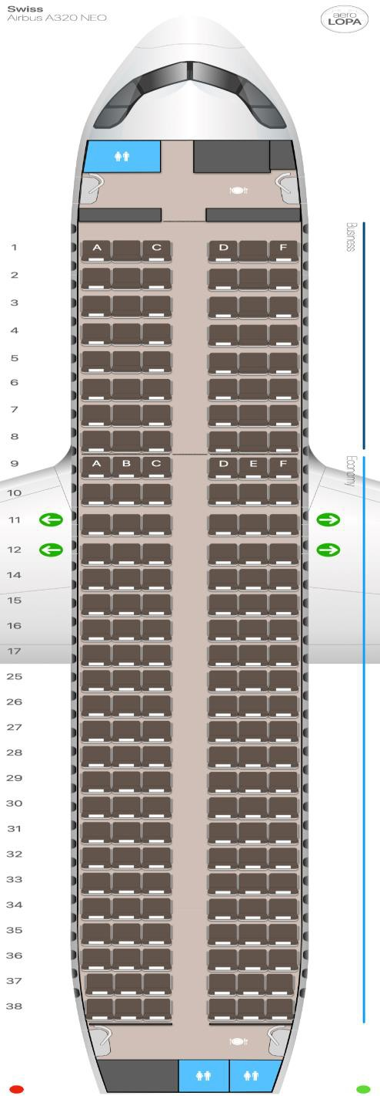

# **Option 1**

**All Economy**

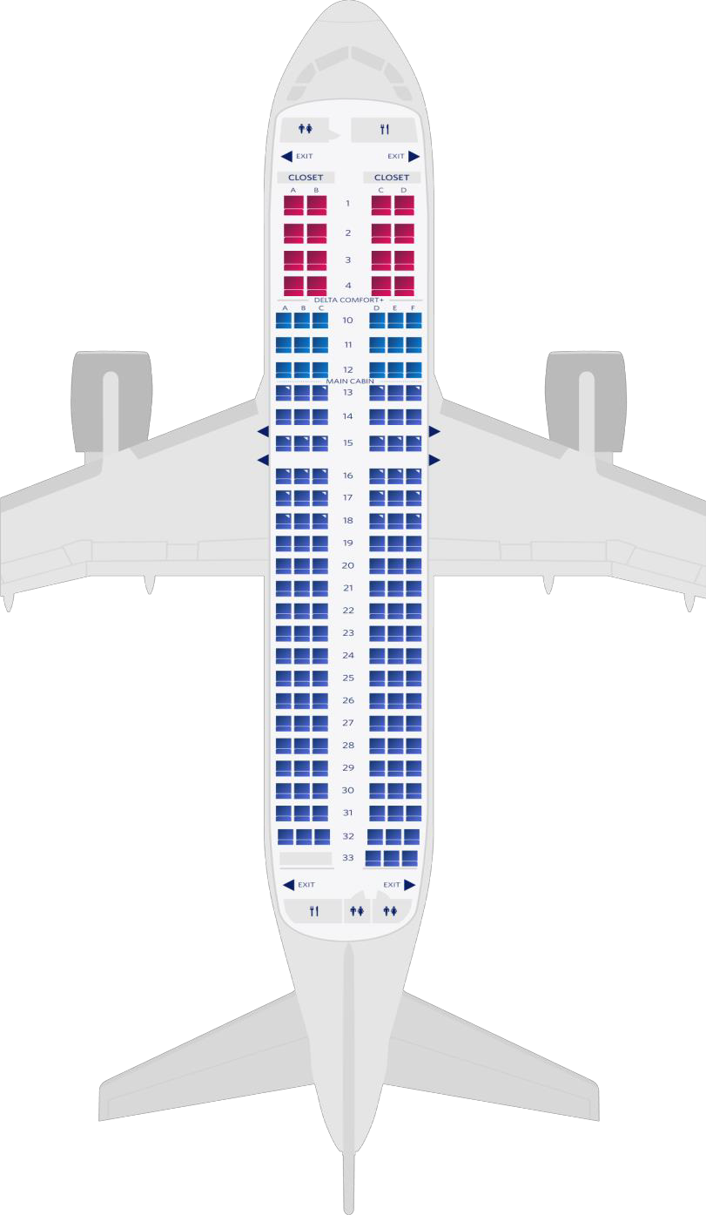

# **Option 2**

**Economy and Business Class**

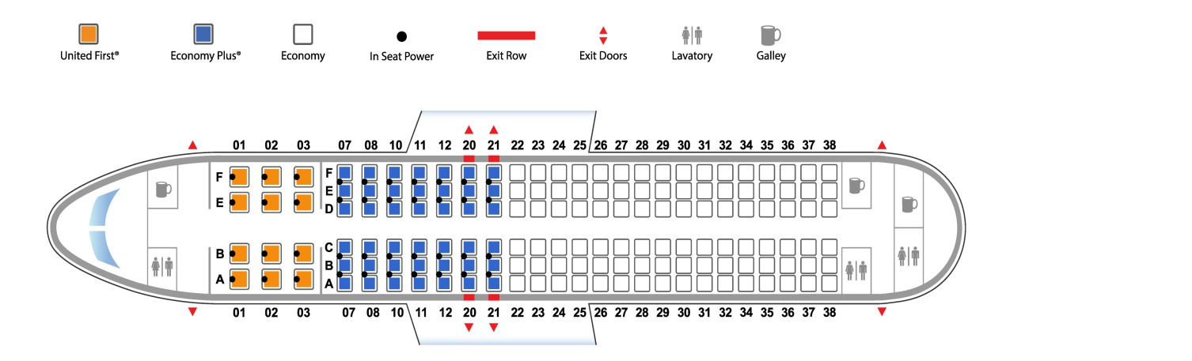

# **Option 3**

**Economy, Business and First Class**