INVENTORY FOR IMMEDIATE DELI VERY

# G ENERATOR SE TS

|  |  |
| --- | --- |
|  | Two (2) Surplus never used or installed, Caterpillar 3512B, 1200 kW, 600v, 50 Hz. Land Drilling Diesel Generator sets.  Price per unit: US $475,000 EXW South America |
|  | |
|  | One (1) Surplus, never used or installed, Caterpillar 3512C, 1045 kW, 600v. 60 Hz. 1200 RPM, Land Drilling Diesel Generator set.  Price: US $495,500 EXW South America |

Nine (9) NEW Caterpillar G3516H, 2500 kVA, 2000kW, Continuous, 400v. 50 Hz. Natural Gas generator set, with Warranty.

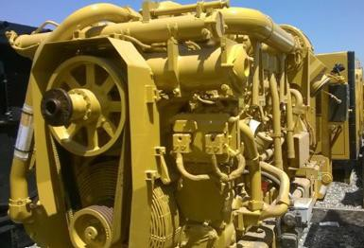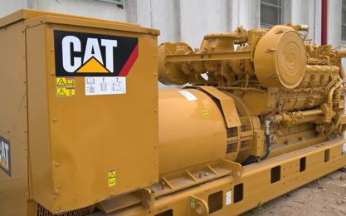

Price Per Unit: US $929,500 EXW Southeast Asia

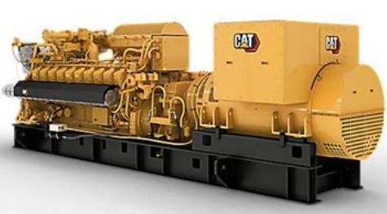

Twelve (12) NEW Caterpillar G3520H, 3125 kVA, 2500 kW Continuous, 400v. 50 Hz. Natural Gas Generator set, with Warranty.

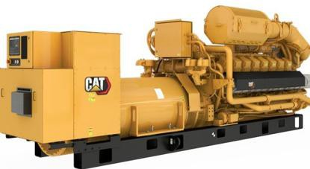

Price per unit: US $1,100,000 EXW Southeast Asia

One (1) New Caterpillar G20CM34, 10MW, 13,800v. 60 Hz. Natural Gas Generator set. Complete unit with cooling system , exhaust system and auxiliaries.

Price: US $8.950,000 EXW North America

Fifteen (15) New/surplus Caterpillar C175-20, 3620 kW Standby, 3300 kW Prime, 480v. 60 Hz. Open Skids, Tier II, no radiator, zero hour with Caterpillar Warranty, ready for delivery.

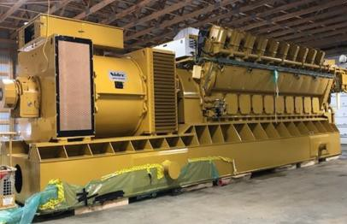

Price per unit: US $2,240,000 EXW North America

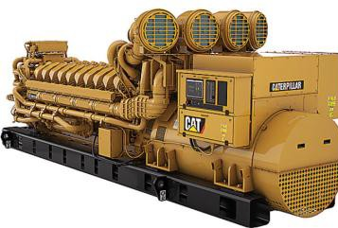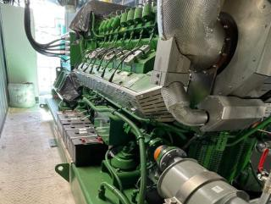

One (1) New Enclosed MWN 3016, 800 kW, 400v. 50 Hz. With for CHP applications. Full Warranty.

Price: US $925,500 EXW Europe

One Surplus/New Jenbacher, 2000 kW, 480v. 60 Hz. Natural Gas Generator Set, ready for delivery

Ask for more information

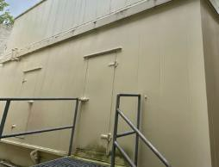

Two (2) CAT 3512, 1000kW Prime, 480v. 60 Hz. Diesel Generator sets and all the Switchgear and UPS Systems, Power Plant.

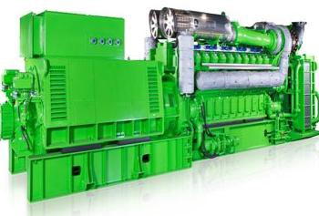

Ask for more information

# TURBINE- GENERATORS

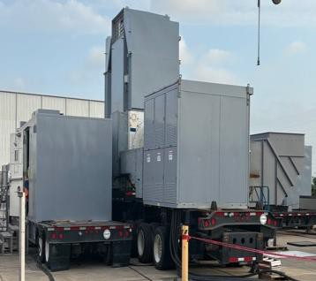

Two (2) GE TM2500 Gen 4, 22 MW (ISO), Overhaul, zero hours, dual fuel, dual frequency, mobile natural gas turbine, ready for delivery.

Price: US $38,000,00 EXW North America

Two (2) Solar Mars 100 15000SAN with SoLoNOx, 10 MW, 60 Hz. Natural Gas Turbine generators and one (1) steam turbogenerator 10 MW, 60 Hz. 40,000 hours of use since new, year of manufacturing

2011.

Price per unit: US $2,700,000 EXW South America Ask for more information

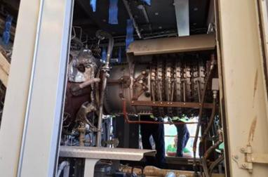

Two (2) New Siemens SGT A05, 6300 kVA, 4160v. 60 Hz. Mobile Natural Gas Turbine, ready for delivery with full warranty.

Price: US $6,950,000 EXW North America Please email for more information

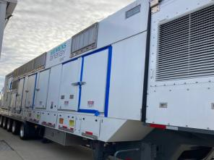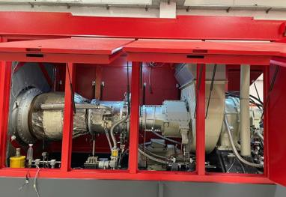

Four (4) Fully Rebuilt Solar Taurus 60, 5200 kW, 6300v, 50 Hz. Enclosed Natural Gas Turbine-Generator.

Price per unit: US $3,195,00 EXW Eastern Europe

Six (6) Quality Use Solar Taurus 60, 5200 kW, 50 Hz. Enclosed Natural Gas turbines with between 12,000 to 15,000 hours of use since last overhaul.

Price per unit: US $2,550,000 EXW Easter Europe Please email for more information

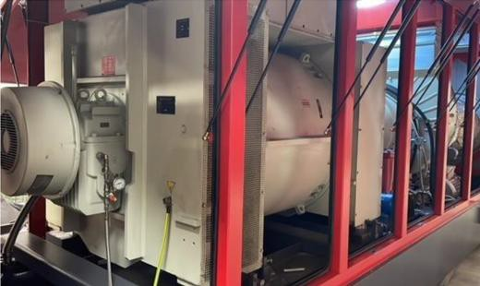

# NATURAL GAS COMPRESSORS

Four (4) Surplus never used or installed 400 HP electric driven natural gas compressor set, with Ariel JGJ/2, ready to ship.

Price per unit: US $695,000 EXW North America Ask for more information

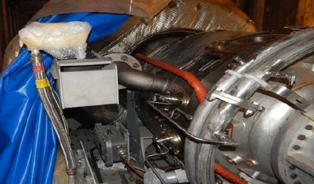

One (1) Surplus Solar C50 (Centaur 50) Natural Gas Compressor Set Price: US $2,995,000 EXW North America

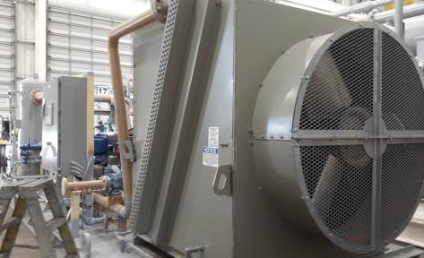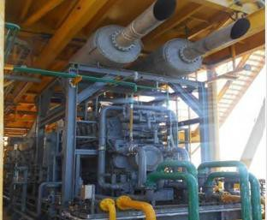

One (1) Surplus never used or installed, 5000 PSI, 10 MMSCFD, with Caterpillar G3612, Ariel JGD/6, Murphy Control, Cooler, complete natural gas compressor set, recently inspected by manufacturer, ready to ship.

Price: US $2,750,000 EXW South America

# SUBSTATIONS

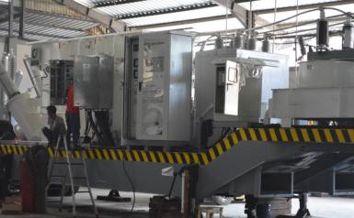

Two (2) Surplus/Never used Mobile Substations, 30 MVA, 115 kV –

13.8 kV, 60 Hz. 3 phase, YNd1 Connection, low bed chassis trailer, HV Surge arrester, High Capacitive Voltage Transformer, 145 kV Hybrid Switchgear, Outdoor Circuit Breaker Roof Bushing, Control and protection panel and all auxiliaries.

Price per unit: US $ 2,150,000 EXW South America