6X 2MW MWM Gas Engine TCG2020V20 400V Freq 50Hz Natural Gas Containerized

Engine type : Containerized TCG 2020 V20
Engine Serial No. : 220 9998
Generator type : Marelli MJB 560 LA4 B20
Generator Serial No. : MZ15736
Installed Capacity : 2,000 (kW)

Name Plat Missing | 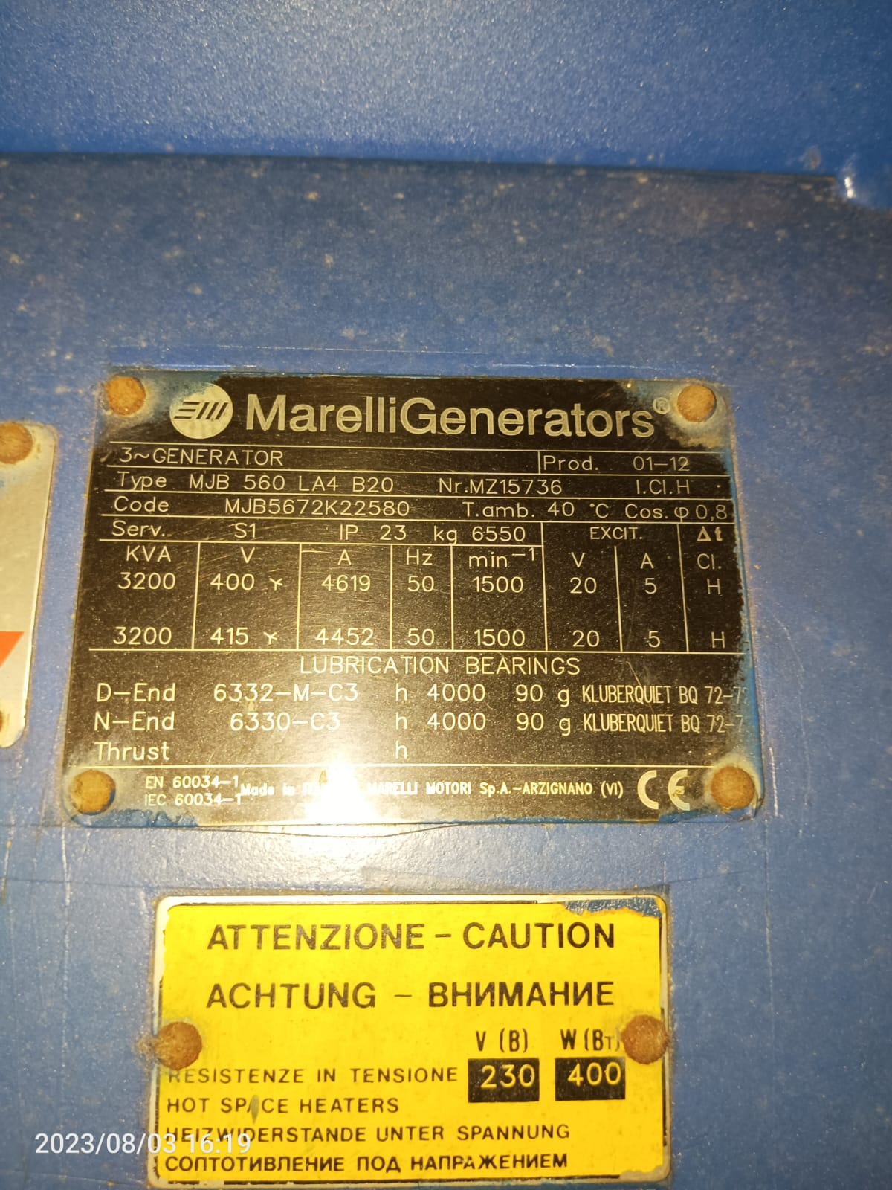 | 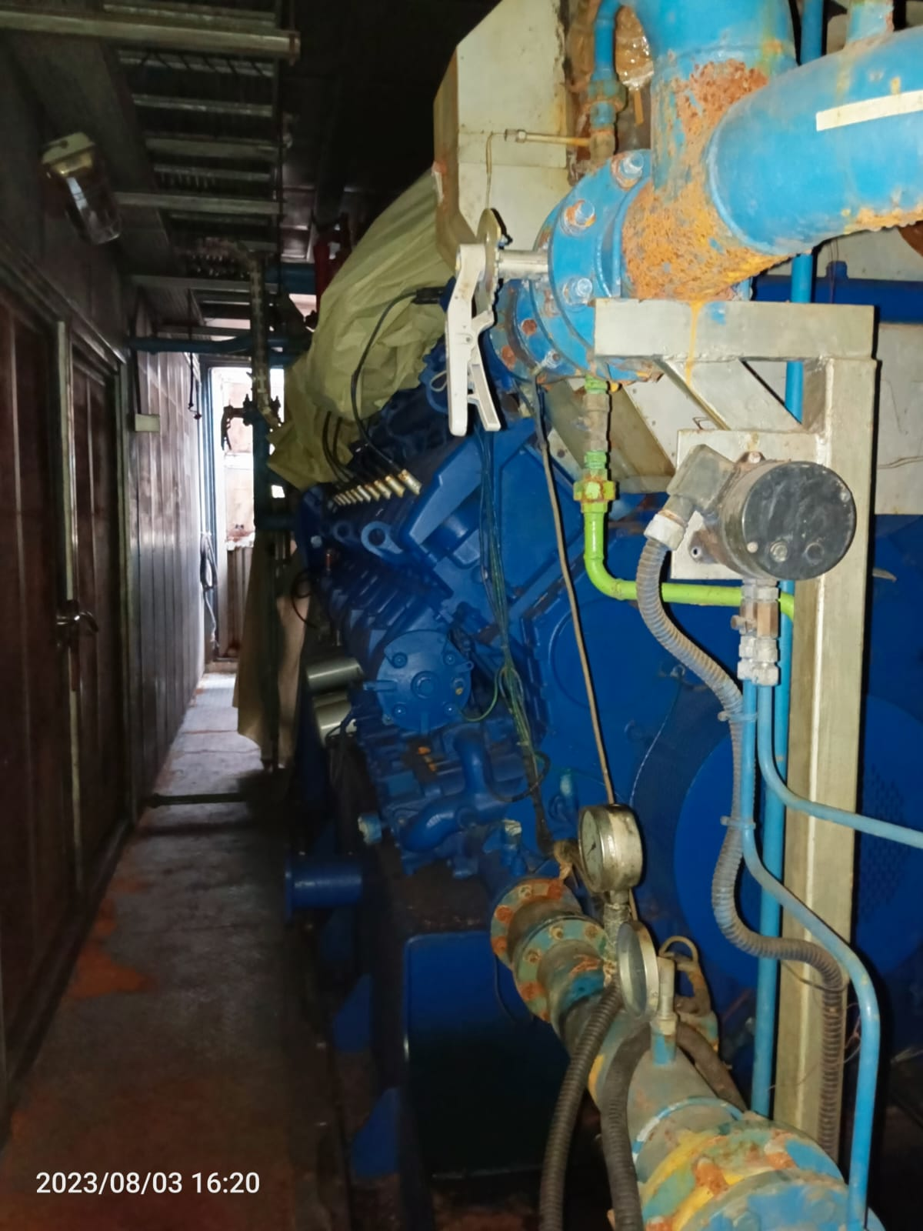

Engine type : Containerized TCG 2020 V20
Engine Serial No. : 220 9929
Generator type : Marelli MJB 560 LA4 B20
Generator Serial No. : MZ15187
Installed Capacity : 2,000 (kW)

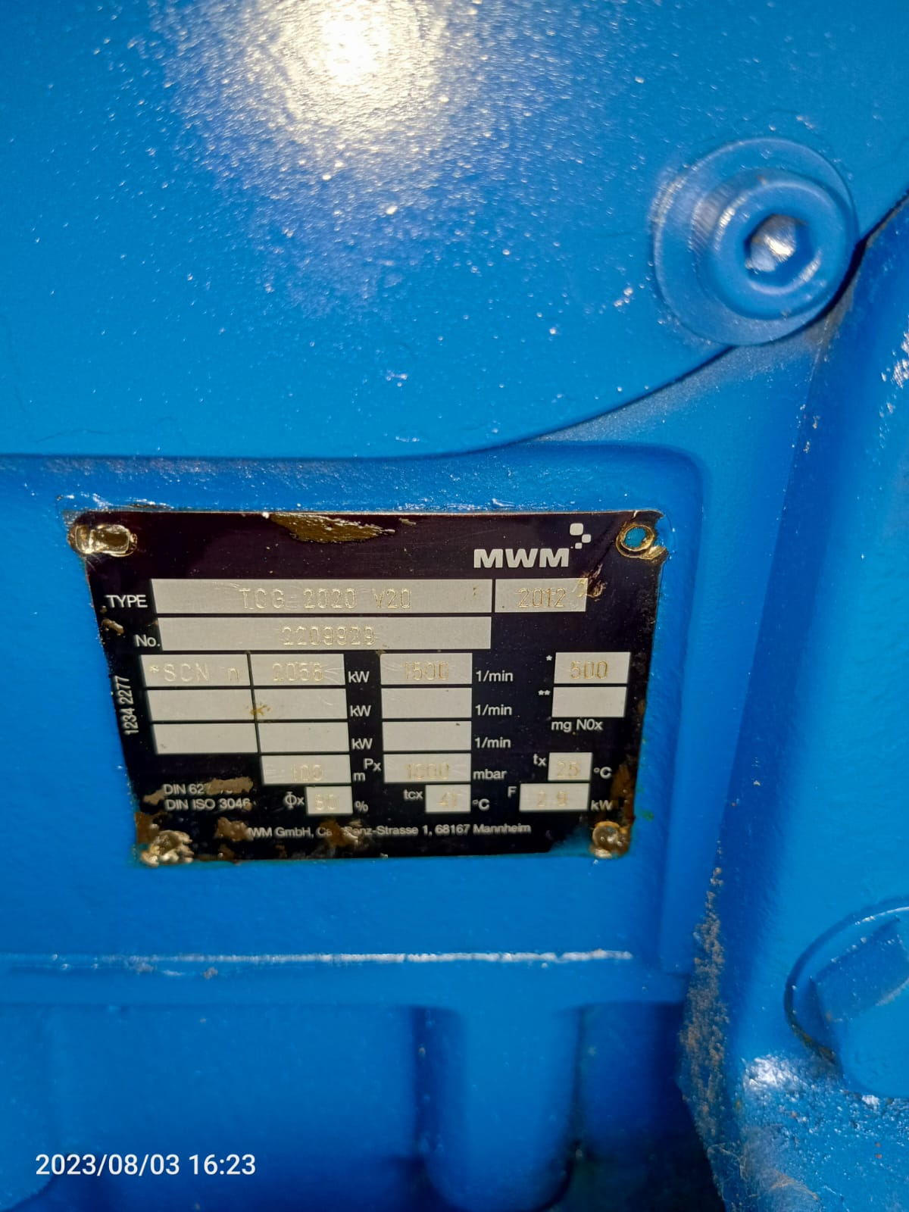 | 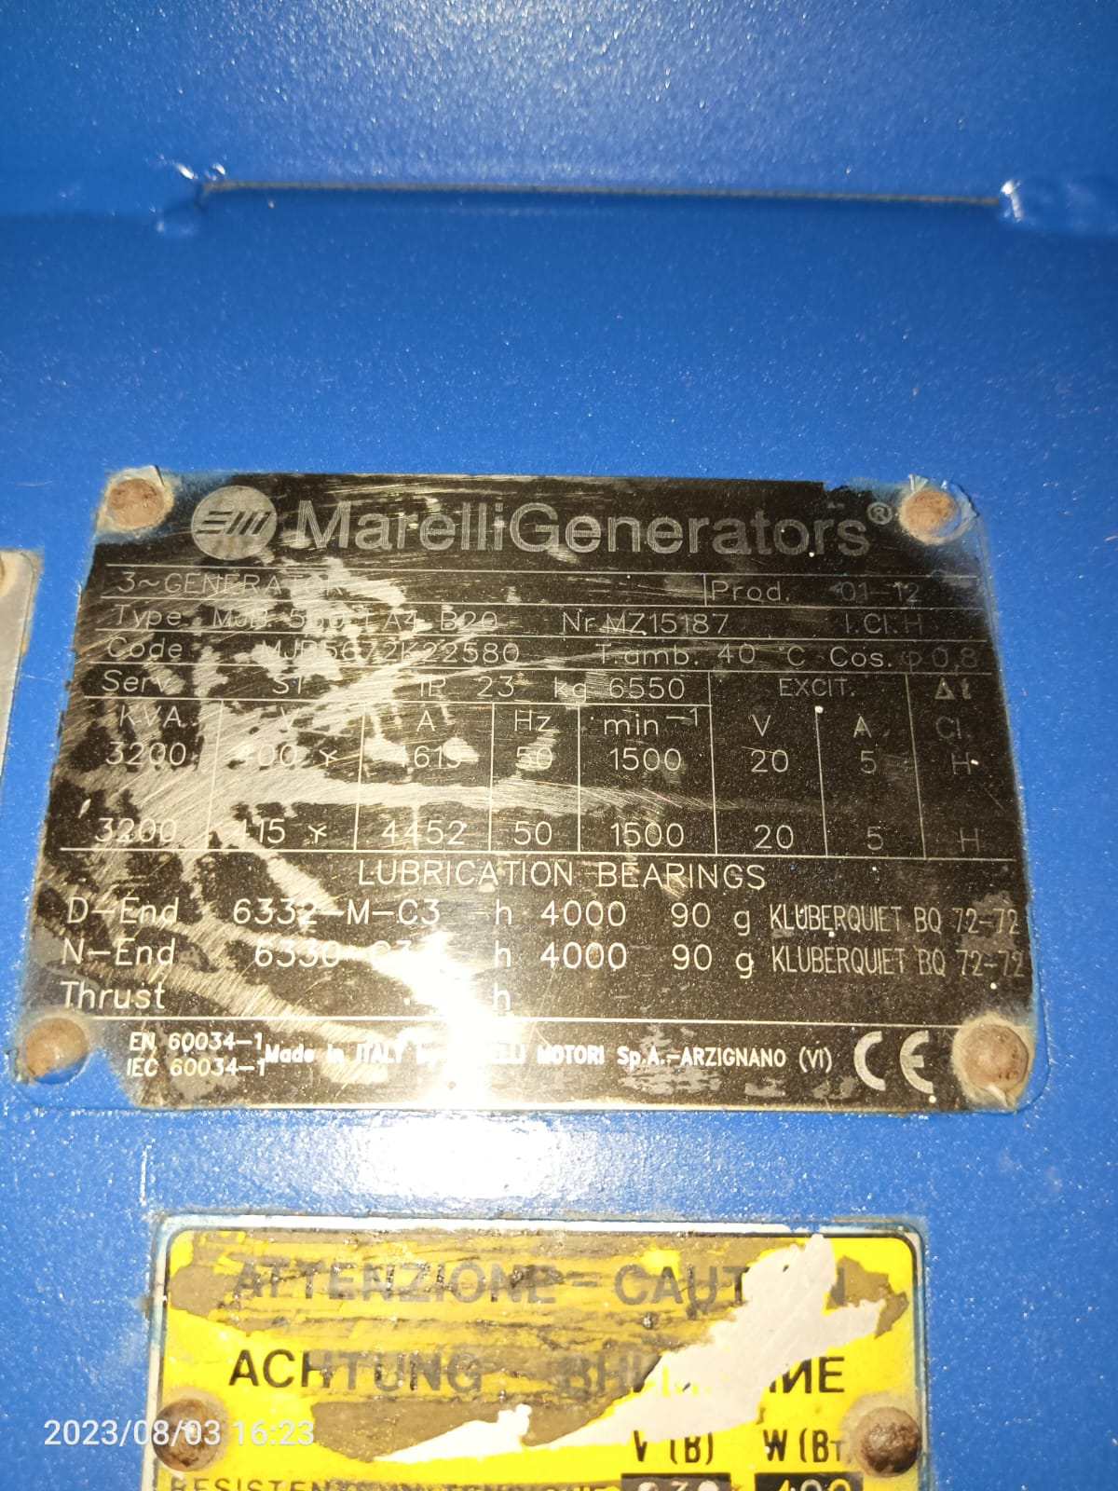 | 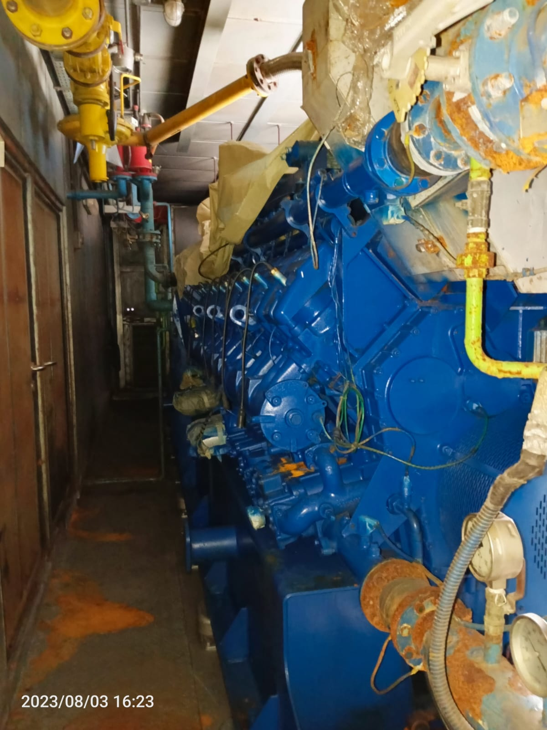

Engine type : Containerized TCG 2020 V20
Engine Serial No. : 220 9972
Generator type : Marelli MJB 560 LA4 B20
Generator Serial No. : MZ16007
Installed Capacity : 2,000 (kW)

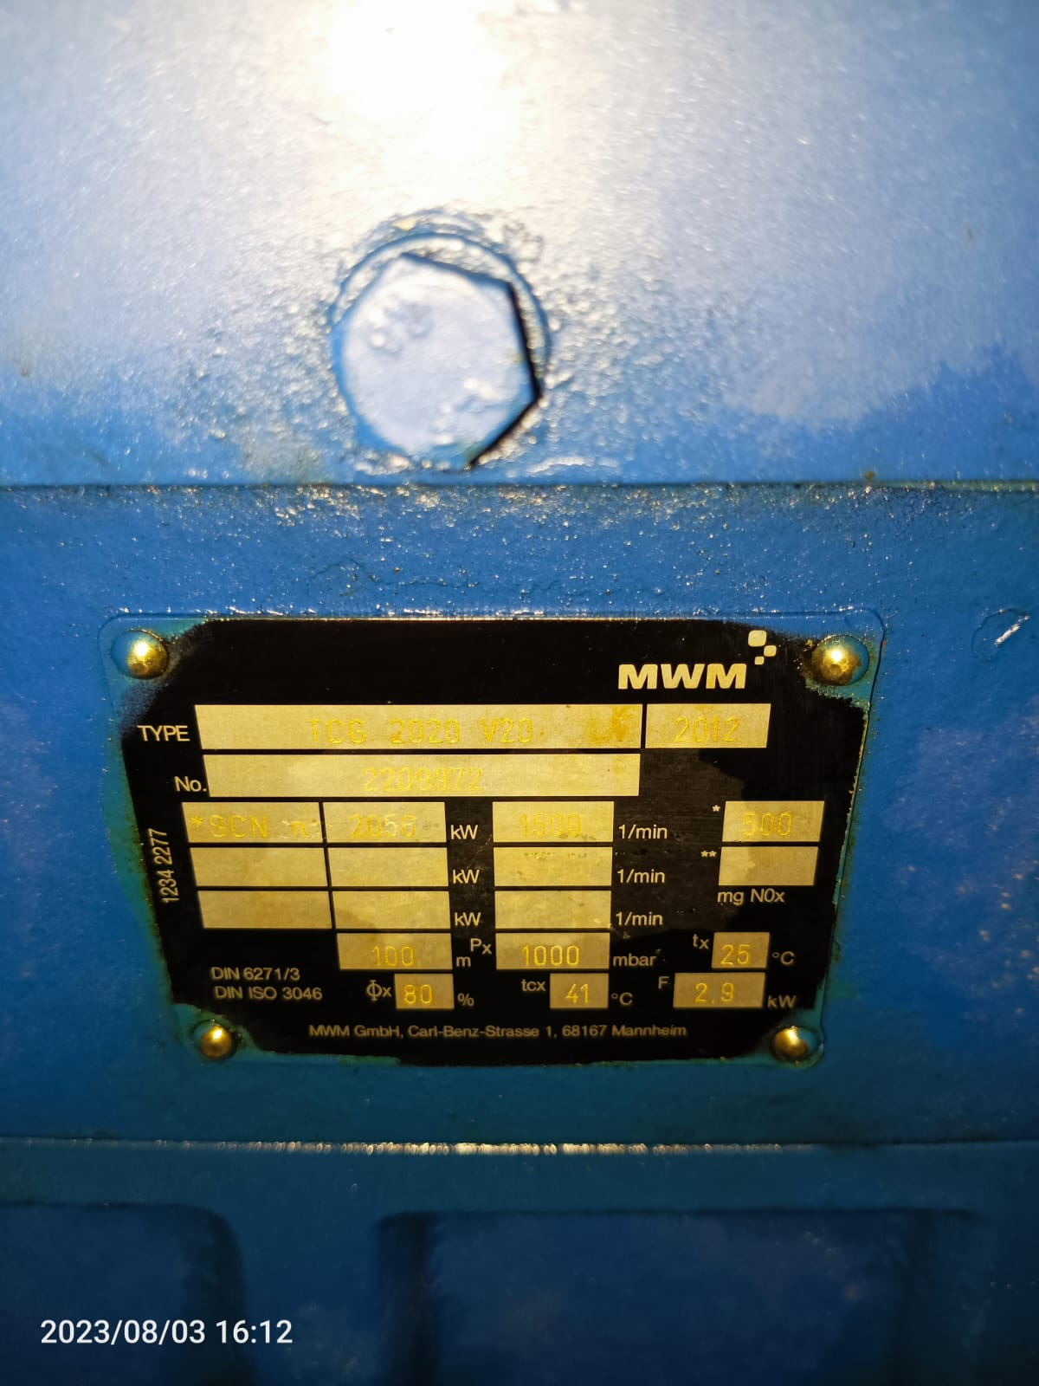 | 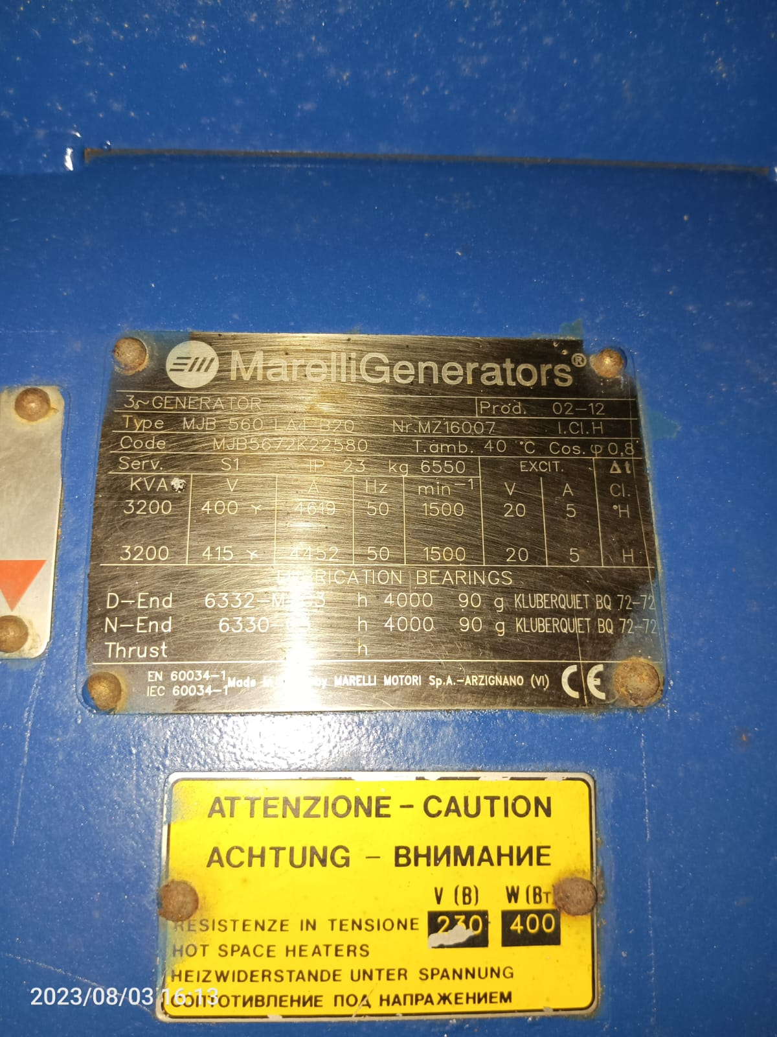 | 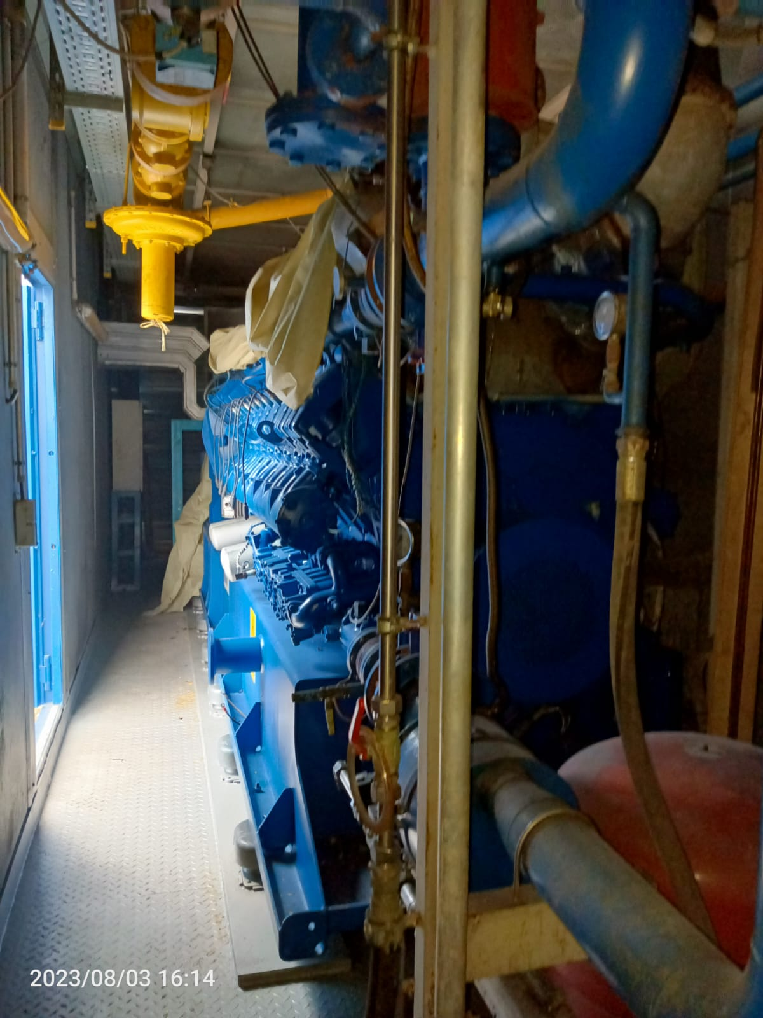

Engine type : Containerized TCG 2020 V20
Engine Serial No. : 220 9971
Generator type : Marelli MJB 560 LA4 B20
Generator Serial No. : MZ16006
Installed Capacity : 2,000 (kW)

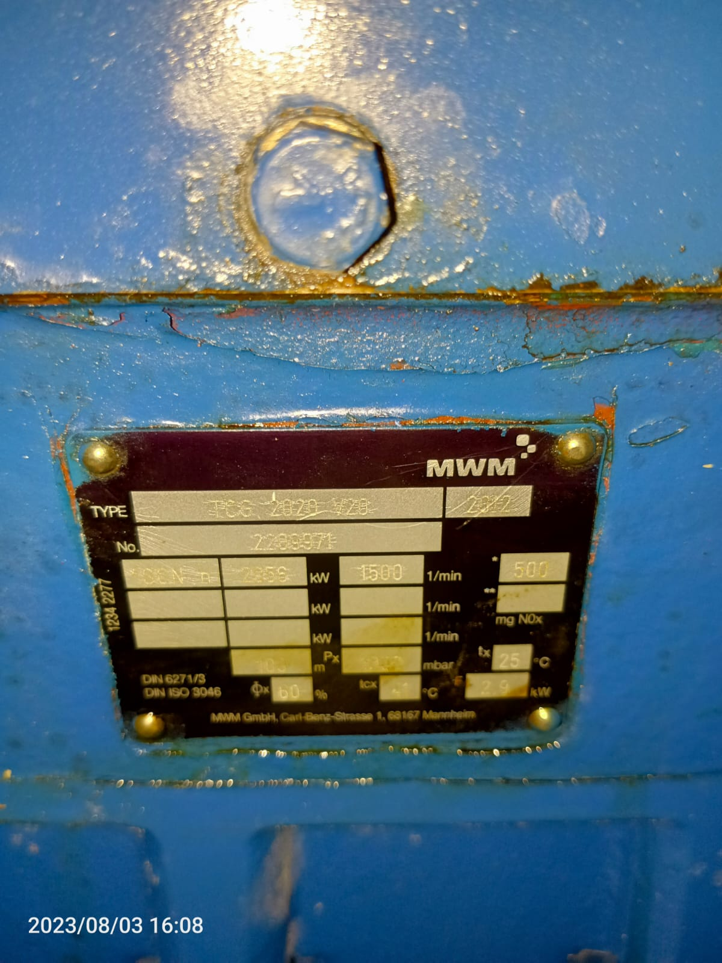 | 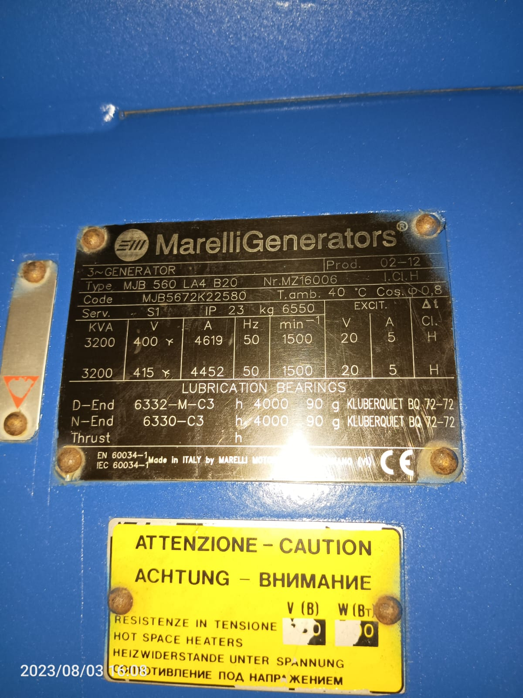 | 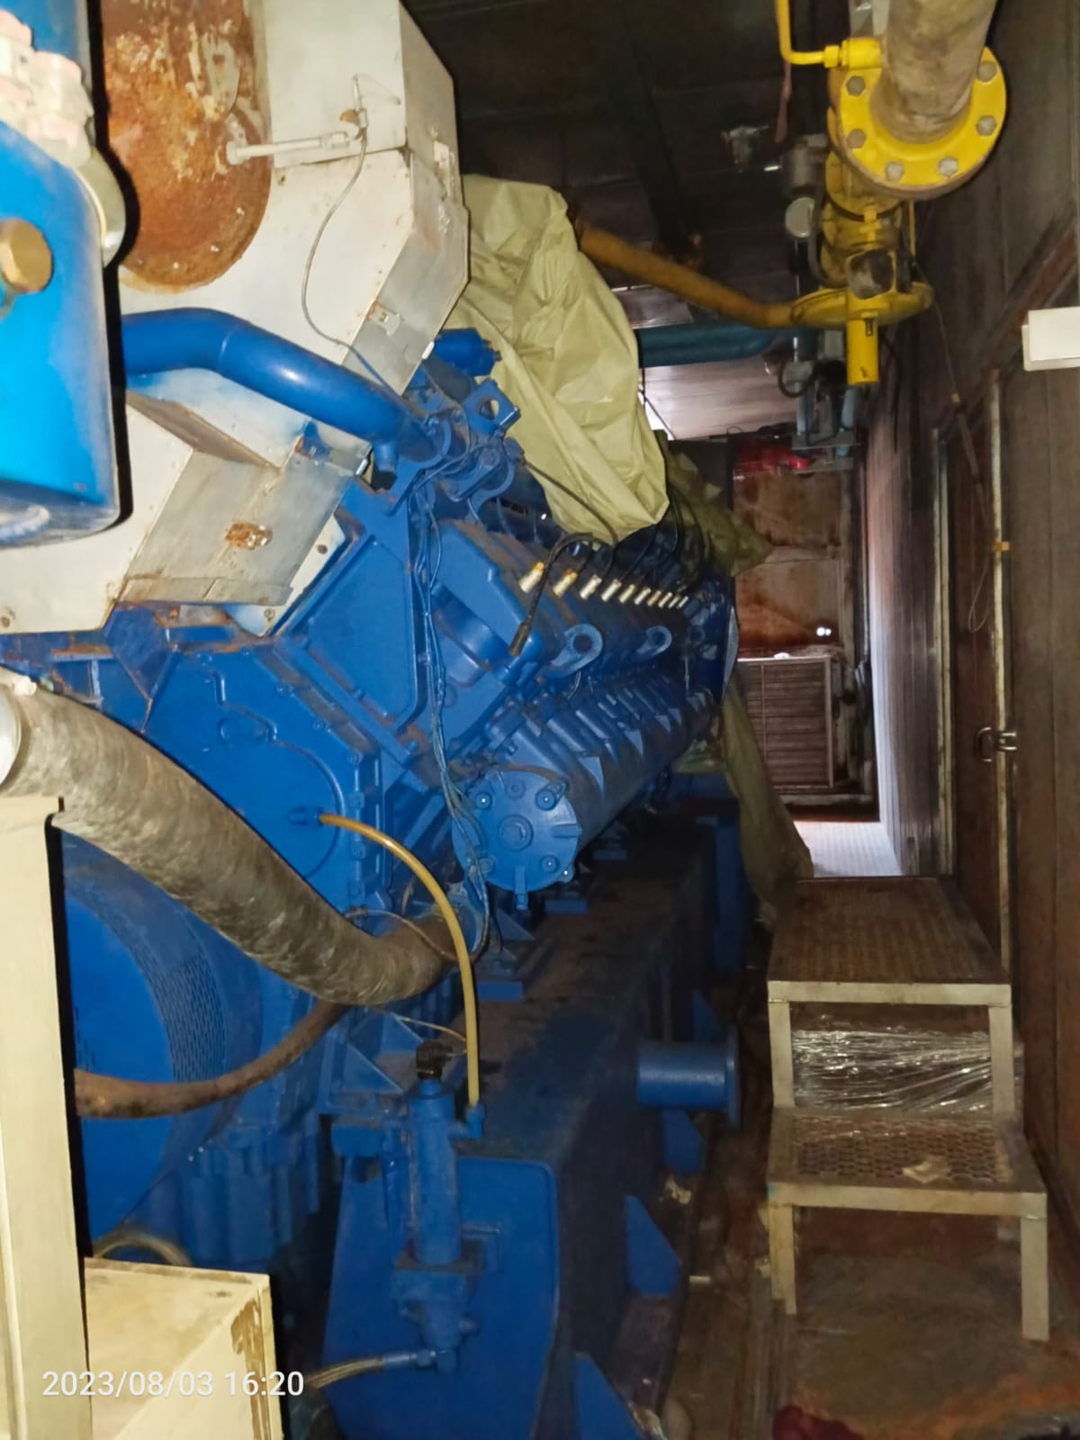

Engine type : Containerized TCG 2020 V20
Engine Serial No. : 220 9289
Generator type : Marelli MJB 560 LA4 B20
Generator Serial No. : MX26620
Installed Capacity : 2,000 (kW)

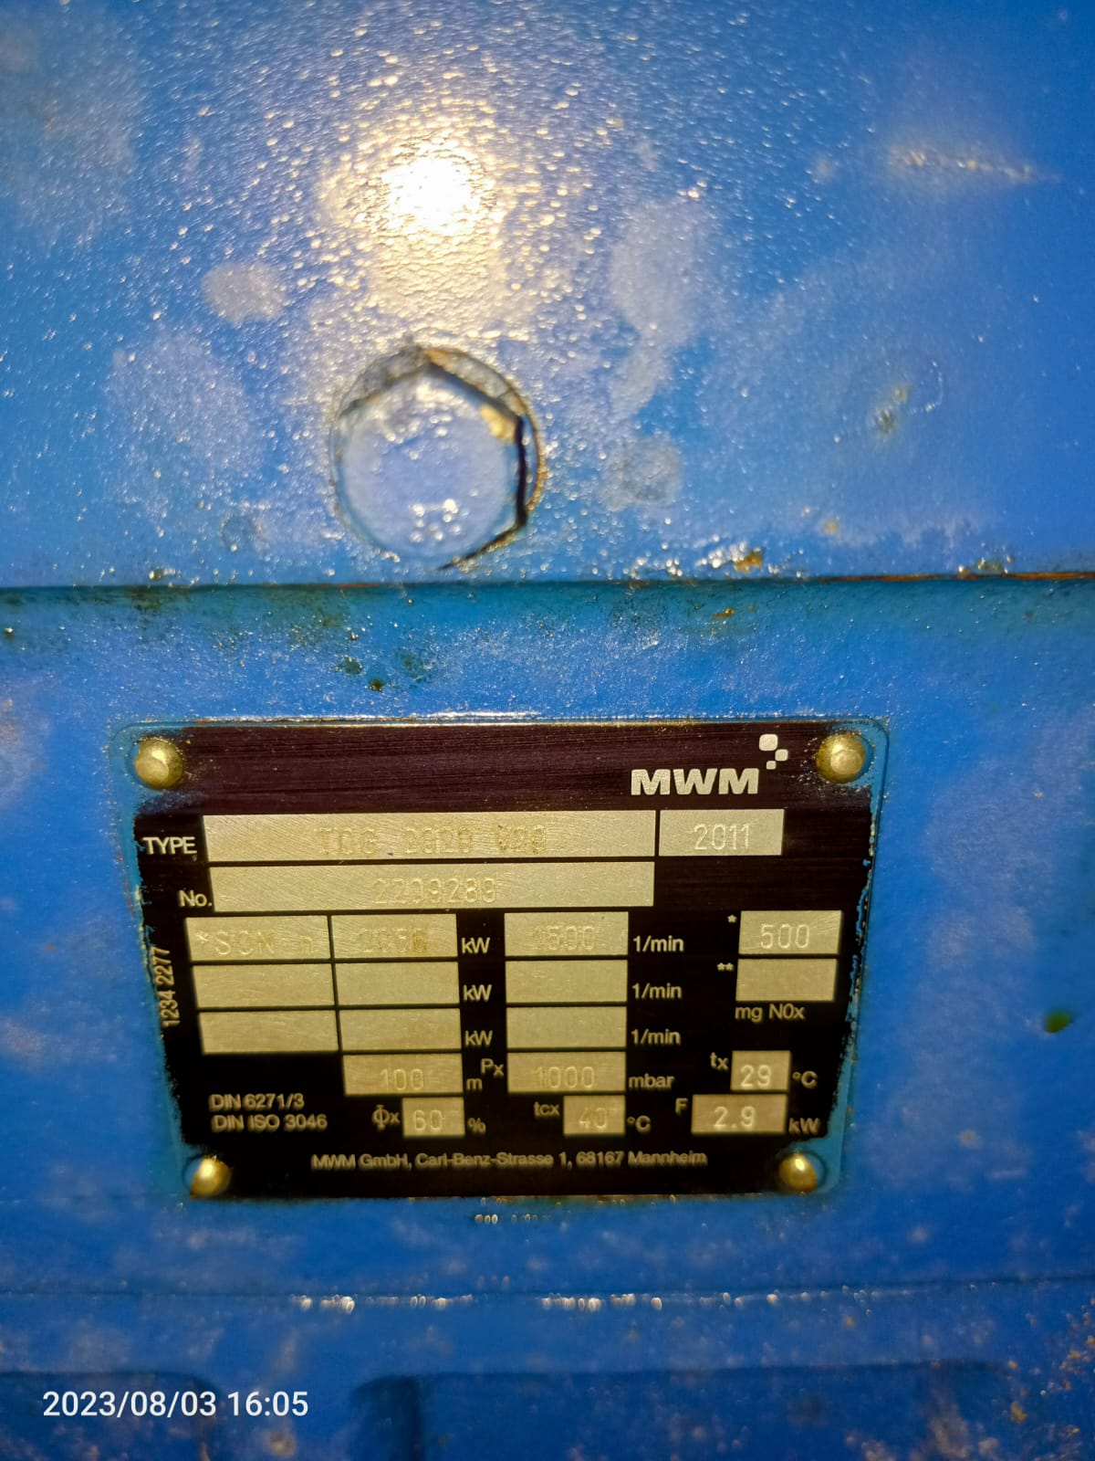 | 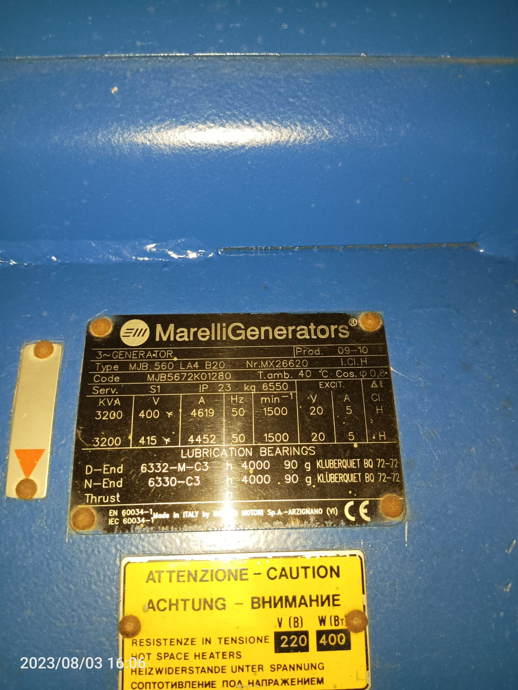 | 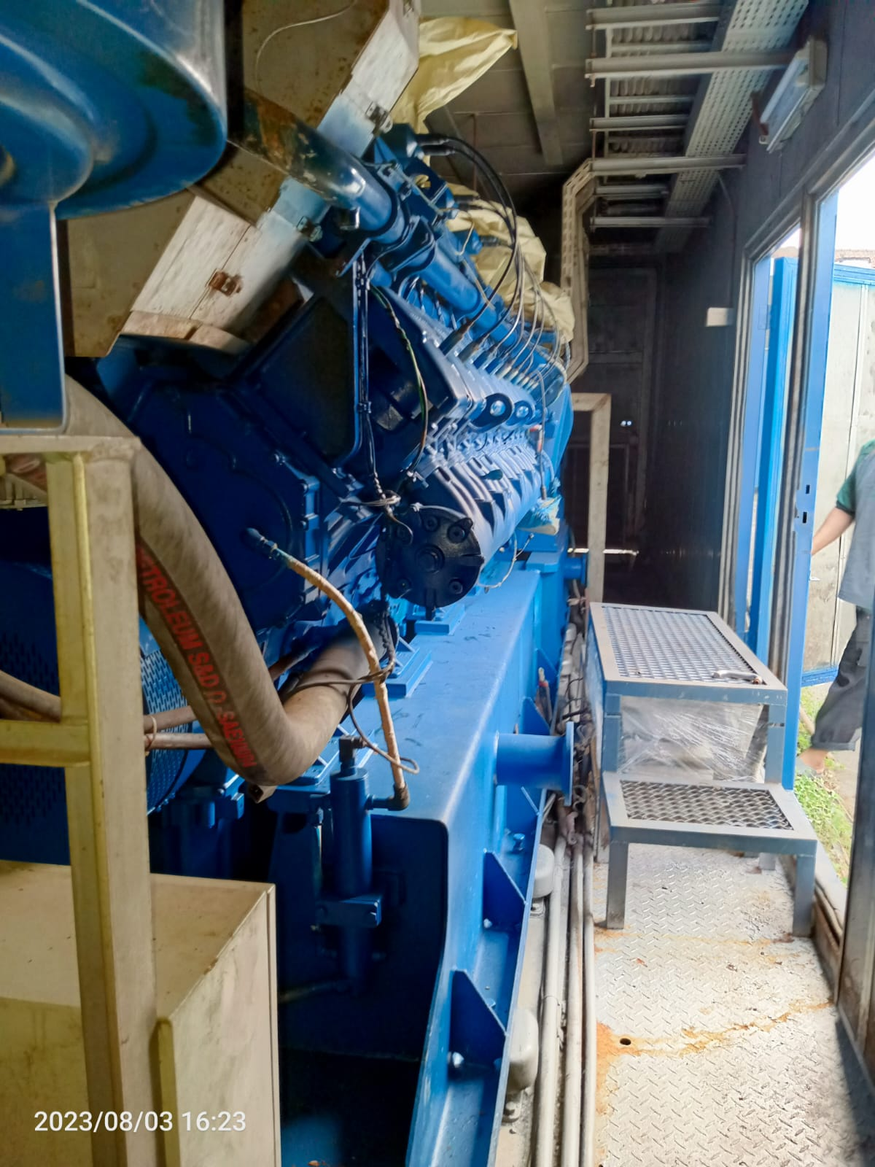

Engine type : Containerized TCG 2020 V20
Engine Serial No. : 220 9044
Generator type : Marelli MJB 560 LA4 B20
Generator Serial No. : MY16554
Installed Capacity : 2,000 (kW)

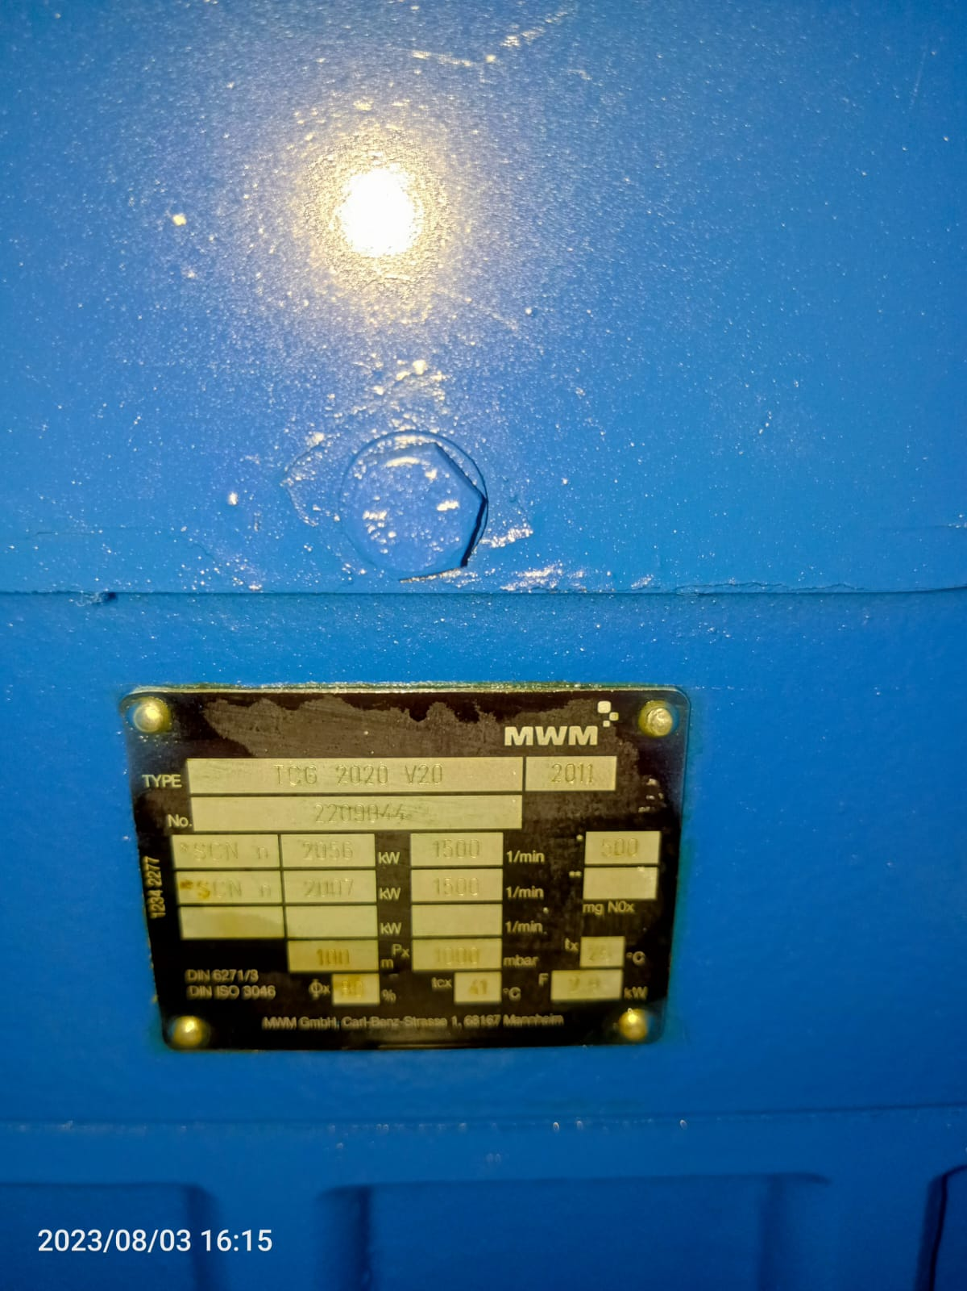 | 