Lockheed C-130 YoM 1988
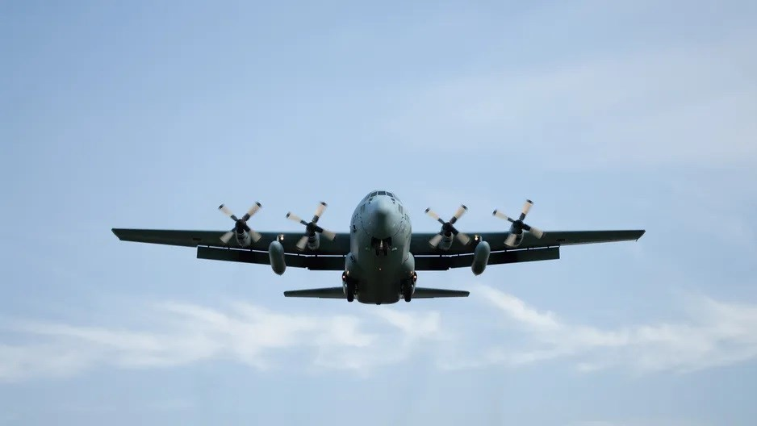

Aircraft Data Sheet

Airframe
Aircraft type | C-130 | Date of manufacture | 1988
Total airframe hours since new | 6502
Total airframe cycles since new | 1945

ENGINES | Engine 1 | Engine 2 | Engine 3 | Engine 4 | APU
Type/ model Allison | T56-A-15A | T56-A-15A | T56-A-15A | T56-A-15A
TSN / cycle | 6502 / 1945 | 6502 / 1945 | 6502 / 1945 | 6502 / 1945
Hours Since last shop visit | 272 | 272 | 272 | 272
Current Installed | 1988 | 1988 | 1988 | 1988 | 1998

Cycles Since Last Shop visit | 68 | 68 | 68 | 68

LANDING GEARS | NLG | LHLG | RHLG
Total time since new | 6502 | 6502 | 6502
Total cycles since new | 1945 | 1945 | 1945
Time since overhaul | 4Y | 4Y | 4Y
Time between overhaul | 10Y | 10Y | 10Y
Last overhaul date | 2018 | 2018 | 2018

Maximum Payload
Palletized | 21 500 kg (47 395 lbs)
Break bulk | 22 954 kg (50 600 lbs)

Weight
Maximum certified take-off weight | 70 307kg (155 000lbs)
Maximum certified landing weight | 61 235kg (135 000lbs)
Maximum certified zero fuel weight | 57 727kg (127 000lbs)
Basic empty weight | 34 545kg (76 000lbs)
Average APS weight | 35 000kg (77 000lbs)

Cargo Accommodations
- 5 standard 88” x 125” (2.24m x 3.17m) pallets or containers, plus belly compartments and a ramp container
- Mixes of 10, 20, 30 and 40 ft long (3.05 m, 6.10 m, 9.14 m, and 12.19m) 8ft x 8ft (2.44 m x 2.44 m) cross section intermodal containers up to 54 ft long (16.5 m)
- Oversize shipments up to 54 ft long, 10 ft wide and 9 ft high (16.5m x 3.05m x 2.74m)
- Up to 6,057 cu ft (171.52 cu m) cargo volume

Aircraft Equipment
- Stage III Compliant
- FM Immunity and VHF 8.33 spacing equipped
- Dual GPS
- Dual HF Radio and Selcal
- TCAS fitted
- Cargo Winch

Fuel:
Jet A
Capacity: 6,980 US Gal. (26,344L) (optional: 8,060 US Gal. (30,501L)

