17/09/25

Subject: **Supply of N. 9 Siemens Gas Turbine SGT 600 Ref.: 2509-GT600-MLEU**

Dear Sir, In reply to your request, we are pleased to present our Technical –

Commercial Proposal for the following:

# Supply of nine ( n.9) SGT 600 YOM 2005 USED

-Below in this Offer you will find the technical conditions requested.

-The information contained herein is Confidential and belongs it is given

to the customer only for information purposes and to facilitate the evaluation of this proposal.

-With the acceptance of this OFFER, the CUSTOMER agrees to keep the confidentiality of all the information supplied and AGREES not to disclose this information out of their organization.

.Prices are subject to conditions established between the parties being understood that the offer is tailored to the specifications provided by the CUSTOMER and evaluated by contractors.

-We will have the human resources, labor, equipment, goods and supplies needed to provide all service and maintenance if will be request Below in this Offer you will find the business and price conditions requested.

-Thanks in advance for the opportunity provided and waiting to see us awarded with the purchase Order to provide quality services and products.

-We are at your disposal for any additional information that may be needed in relation to this proposal.

Best regards,

# 1. SCOPE AND SUPPLY

**General description**

The Siemens SGT-600 is a powerful, robust twin-shaft gas turbine that is suitable for both:

Power generation and mechanical drive applications. These gas turbines are brand new,

Manufactured in 2005 Used

This turbine is known for its

Operating and fuel flexibility, low emissions and overall efficiency. It can burn a wide spectrum of fuel compositions and run efficiently at all loads, even at loads as low as 30%. The SGT600 offers seamless, dual-fuel capability.

# 2- TECHNICAL DATA

1. Power output: 24,5 MW(e)
2. Fuel: Dual Fuel
3. Frequency: 50/60Hz
4. Gross efficiency: 35.00%
5. Heat rate: 10,294 kJ/kWh (9,756 Btu/kWh)
6. Turbine speed: 9,500 rpm
7. Print ratio: 16.9:1
8. Exhaust mass flow: 40.0 kg/s (88.2 lb/s)
9. Exhaust gas temperature: 555°C (1,031°F)

10. NOx emissions: ≤ 15 ppmvd (NOx emissions at 15% O2 on fuel gas

with DLE)

1. Voltage: 11kV

# High fuel flexibility

The SGT-600 offers best-in-class fuel flexiblity that allows for high content of inert gases, hydrogen and heavy hydrocarbons:

* + Ethane 100%
  + Propane 100%
  + Butanes and heavy alkanes 15%
  + Hydrogen up to 75%
  + Nitrogen 40%

• H₂S ≤ 3%

**Maximized uptime**

The SGT-600 features a reliable, robust and easily maintainable design for maximized uptime

Reliability > 99%

* + On-site or off-site maintenance
  + 24-hour swap capability
  + 14 maintenance days in 17 years
  + 34,000 equivalent operating hours (EOH) between hot section inspections
  + Part load operation increases the time between overhauls
* all turbines in Europe
* all turbines can use 50
* all turbines can use multiple fuels (gas, diesel, light oil, switchable)
* built in 2005
* Operating hours ( see table)

**3.-STANDARD SOLUTION (EXAMPLE)**

**SGT-600 Power Generation**

Thanks to the compact architecture, the SGT-600 package offers you a small footprint. The package has a modular and flexible design and features single-lift capability.

The driver for both power generation and mechanical drive package is the same.

**A gas turbine package includes:**

Gas turbine, enclosure, base frame, air intake, exhaust, lubricating systems, starter system, vibration monitoring system, firefighting system, package ventilation system, instrumentation, gas detection, fuel systems,

**SGT 600 Performance data for simple cycle power generation**

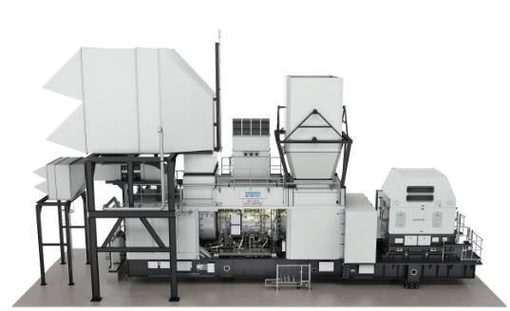

|  |  |
| --- | --- |
| Gross power output | 24.5 MW(e) |
| Fuel¹ | Natural gas, dual fuel |
| Frequency | 50/60 Hz |
| Gross efficiency | 33.6% |
| Gross heat rate | 10,720 kJ/kWh (10,161 Btu/kWh) |
| Turbine speed | 7,700 rpm |
| Pressure ratio | 14.0 : 1 |
| Exhaust mass flow | 81.3 kg/s (179.2 lb/s) |
| Exhaust temperature | 543 °C (1,009 °F) |
| NOₓ emissions² | ≤ 9 ppmvd |

# SIEMENS SGT 600 GAS TURBINES SCOPE OF SUPPLY

**1. Main GT (Gas Turbine) Generator Package on Single Skid (Includes SGT600 Gas Turbine, Auxiliary Room with the auxiliary equipment, Air intake, Gear box, ABB Generator, Lubricating Oil Tank).**

1. **Control Room Package for the respective GT.**
2. **Air Intake Package associated with the Gas Turbine**
3. **Exhaust Plenum for the respective GT.**
4. **GT and Auxiliary room Ventilation System for the respective GT.**
5. **Railings and Ladders for the respective GT.**
6. **Liquid Fuel Skid for the respective GT.**
7. **Gas Fuel Skid for the respective GT.**
8. **Lubricating Oil Cooler for the respective GT.**
9. **Respective Purging and Sealing air Cooler and associated piping to GT**
10. **One Set of Gas Turbine Manuals for the respective GT.**

**.**

see complete PICTURES in attached

**SGT 600 AVAILABLE**

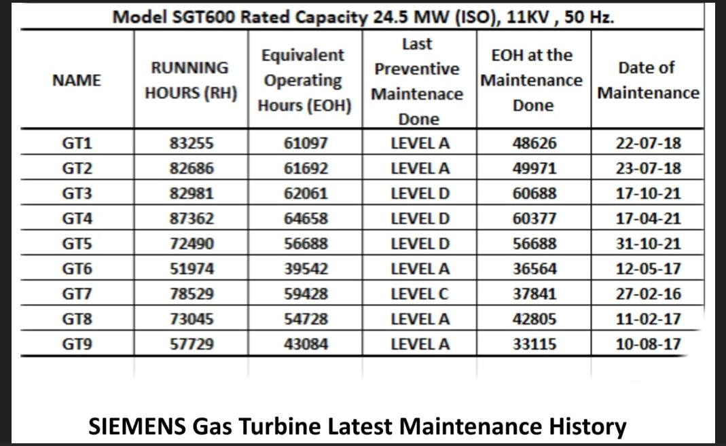

These are the Used units. We have a number of them available. They have a number of hours on them but reasonable. It you look at the chart attached, some have low hours since last maintenance. All the records are at the site.

There are no Borescope or inspection reports. We could arrange to get this done but would be cost in option

**These are installed and owner will dismantle and move to port for 10% of selling price additional.**

Some of the turbines do have 80,000 hours but some are less than that. If you look at the difference between the EOH hours now and EOH at last maintenance some have very low hours since last maintenance.

**NOTE**

The initial price is very cheap as you have seen. I would recommend your client budget $2.5 - $3.5 million USD to get a full rebuild of the turbines. Might get a little cheaper than this but if they do it right these would have many more years of service. Would also get a warranty. If you compare this with the other SGT 600 turbines on the market unused 0 hours , that almost near 17,000,000 USD each you can see how cheap these would be.

**COMMERCIAL TERMS**

**1-PRICE**

Price for one Siemens SGT 600 turbine with standard accessories ( See scope of supply )

**$ 4,850,000 each**

* The payment terms are the same for everyone

-40% deposit

* 60% upon readiness for shipping

**FOB seaport Europe**

**2.DELIVERY** 12 WEEK after the inspection and contract signed

**3-INSPECTION**

The engines can be viewed in Europa (after paying the reservation fee, which will be deducted from the purchase price upon purchase) and your representatives can check the availability and technical condition of the equipment on site, as agreed between the parties. Subject to prior sale.

**4- VALIDITY**

This offer is valid for Ten (10) calendar days from the date of delivery. This offer not included

* Any TAX
* Shipment

-Any other service, installation, equipment, device, or any additional to the scope specified in this proposal will be treated as additional to the purchase order and will be quoted separately.

A Purchase Order or contract and the respective advance payments are required.