14 MW MGTU POWERT PLANT MTU UNITS

7 X 2,000 KW UNITS

14mW MTU Package

Housto
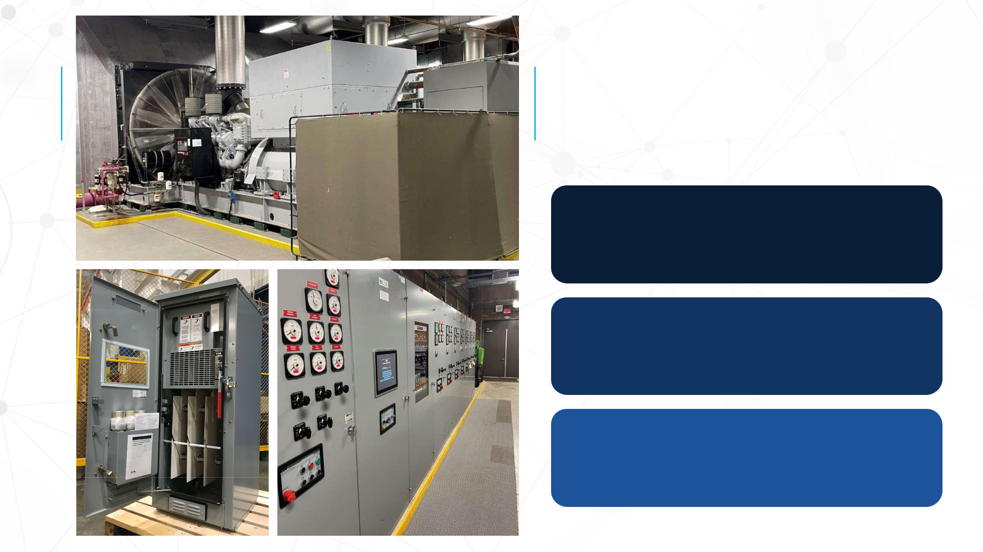

OVERVIEW

GENERATORS

DISCONNECTS

SWITCHGEAR

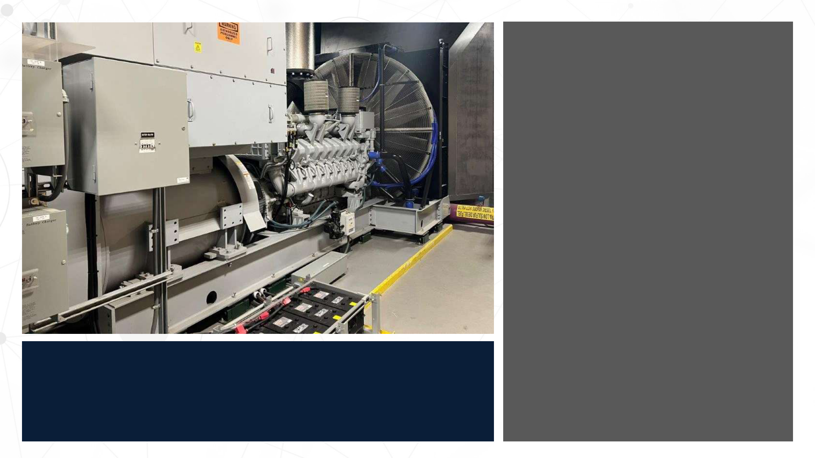

14 mW Diesel Powered Generator Package

- (7) 2 mW MTU Generators

  - (4) Tier 2, 16V4000 MTU

  - (3) Tier 1, T1637M36 MTU

- 13,800/7,970 VAC

- 3 Phase 3 Wire 60 Hz

- Short Circuit Rated 18,000 ASYM

GENERATOR
KEY FEATURES

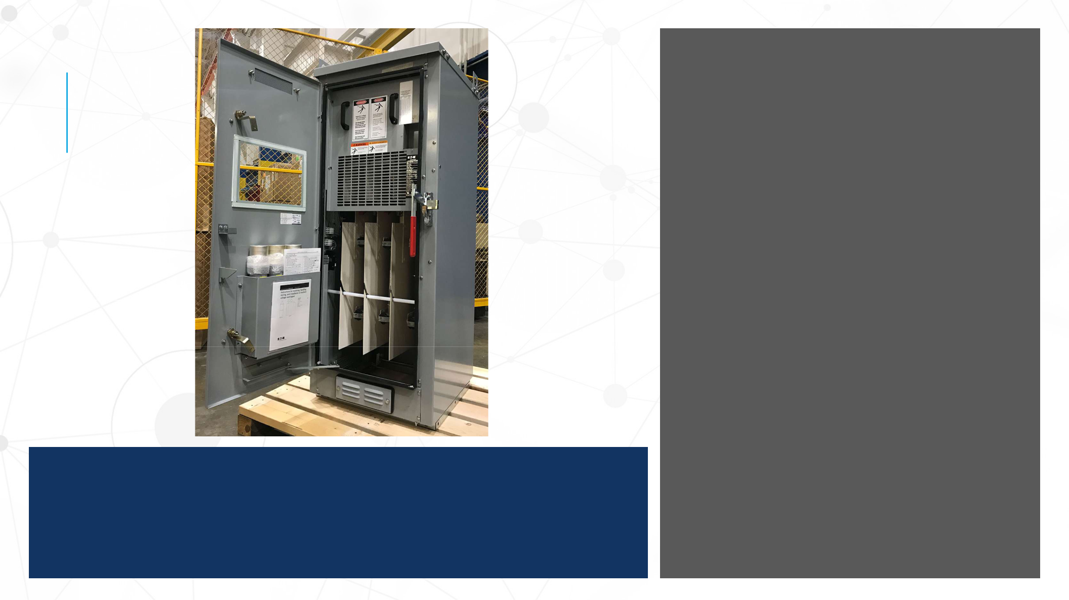

Load Break Fusible
Switches

• (7) Switches

• 15 kV Rated

• 200 amps

• NEMA 1

• Stand-alone Switches positioned at Grade on Generator Side

15 KV DISCONNECTS
KEY FEATURES

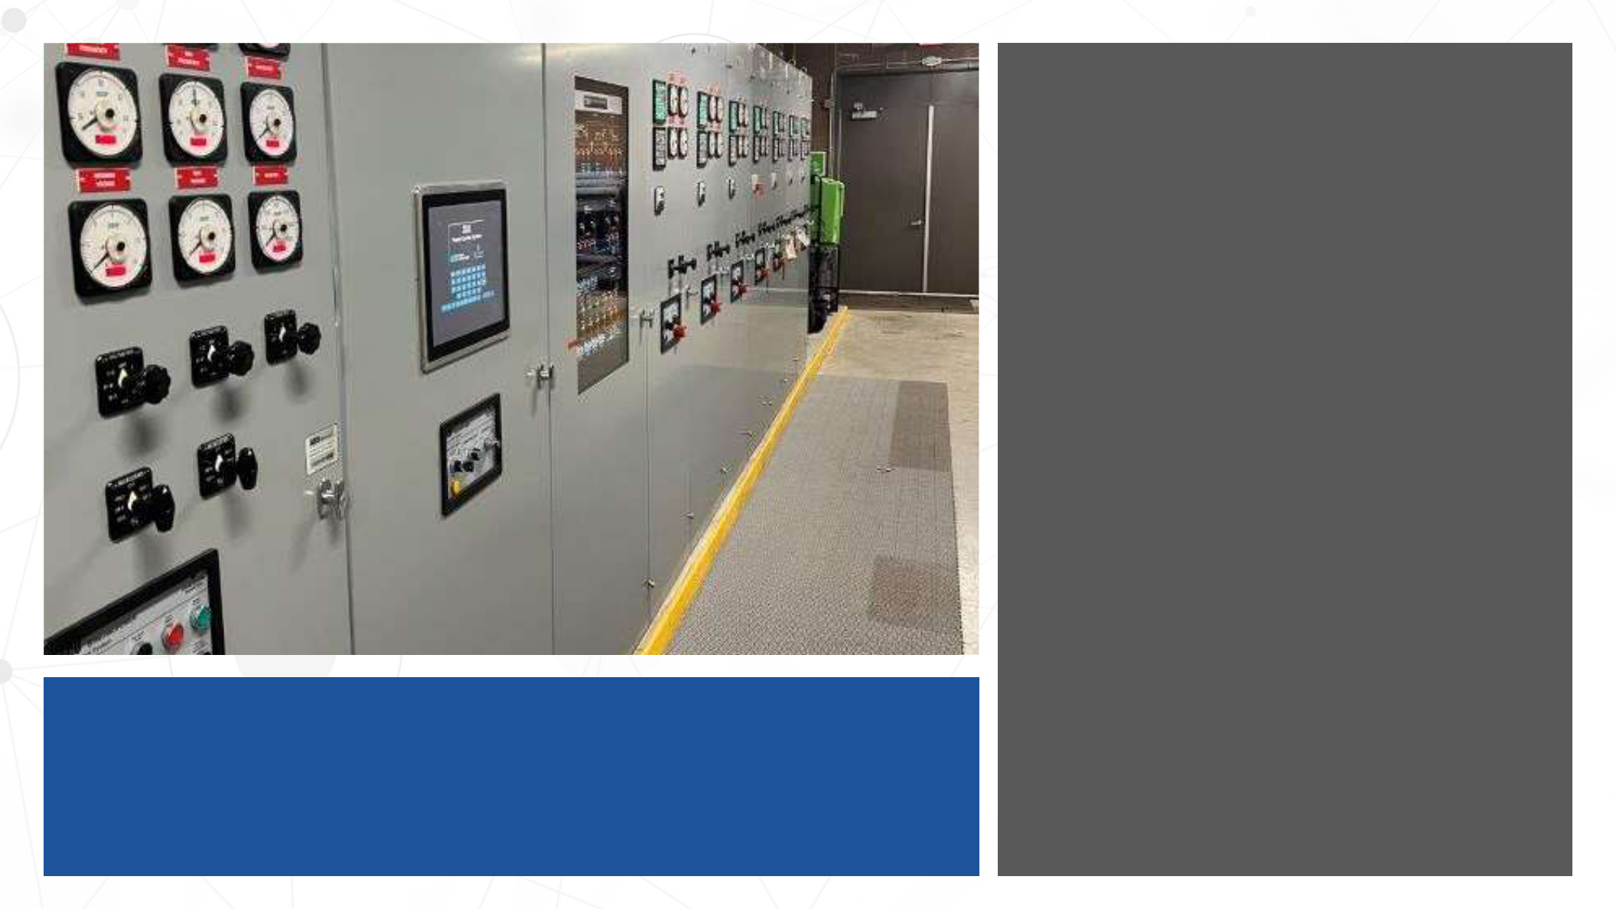

SWITCHGEAR

KEY FEATURES

ASCO Paralleling Switchgear

- Set up for (7) input Breakers from Generators to Main Buss
- (5) Output Breakers

- Square D mV Model VR Breakers

  - 1200a, 60 Hz, 500 mVA rated

  - Each fitted with GE Multilin 750 Feeder Management Relay and integrated into the ASCO System

  - DC Control, trip & charge

- Each Generator is connected to an ASCO Synchpower Controller

- Each Generator can be controlled in manual or automatic operation

- The Generator control is equipped with remoted operating panels allowing:
  - Syncing

  - Load Sharing

  - Load Shedding

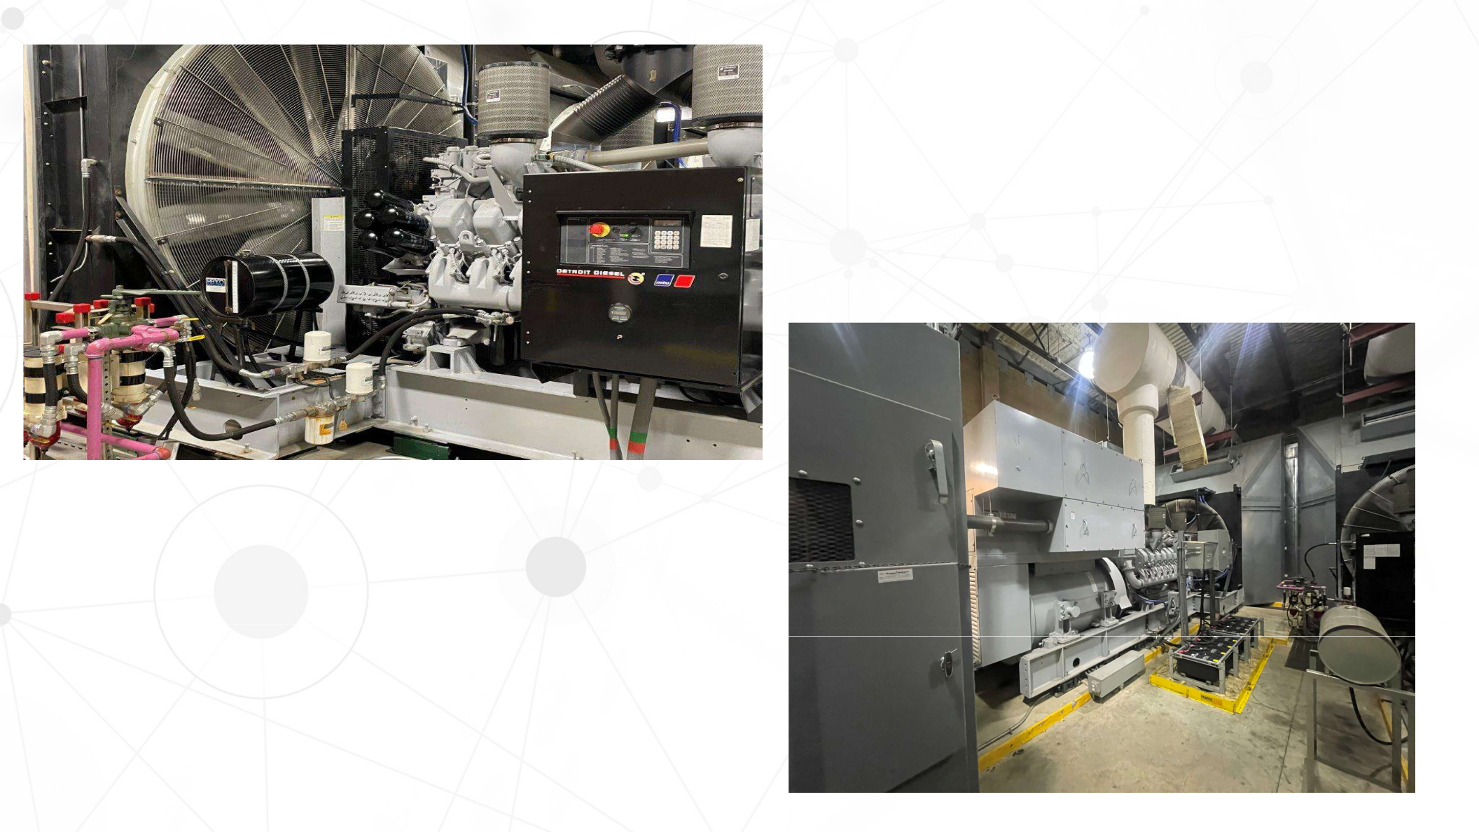
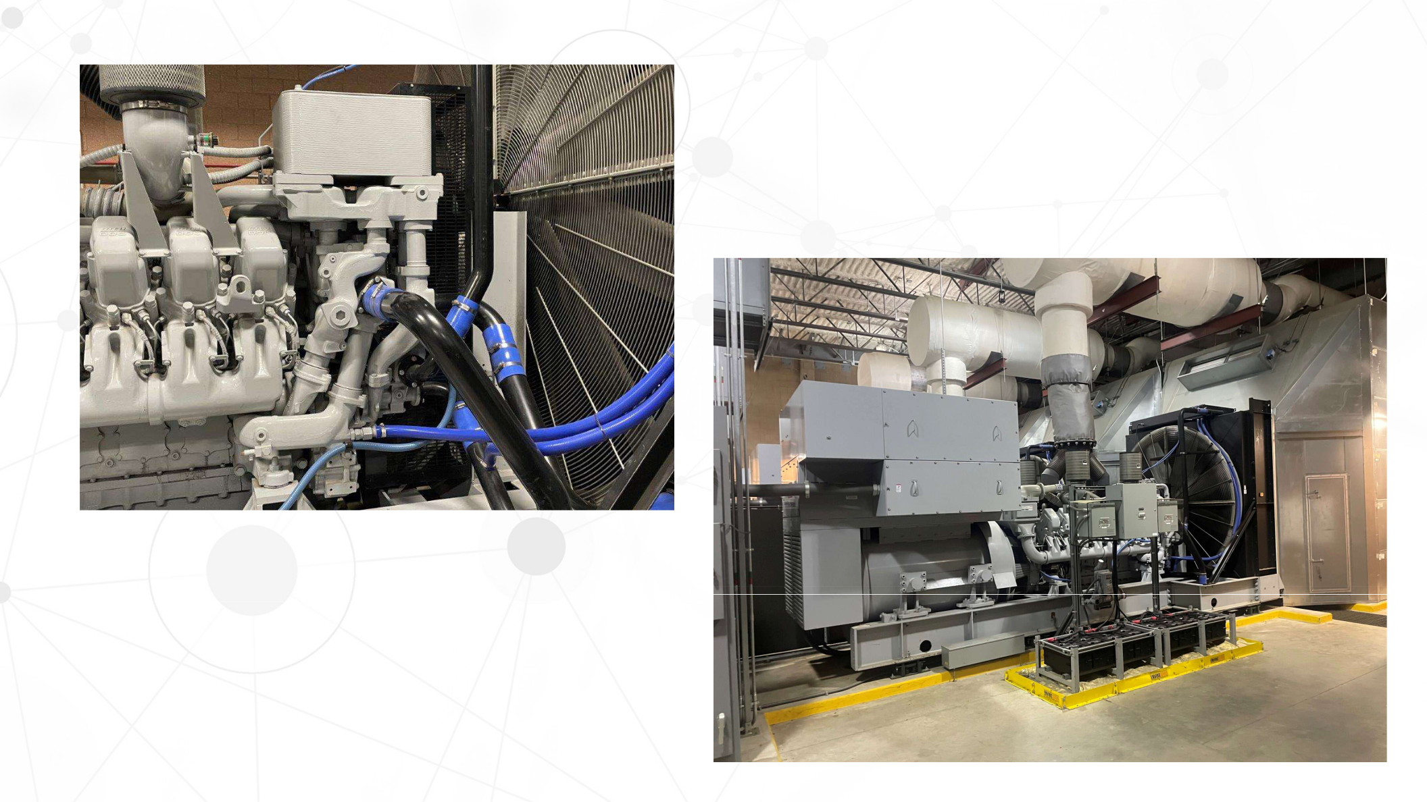
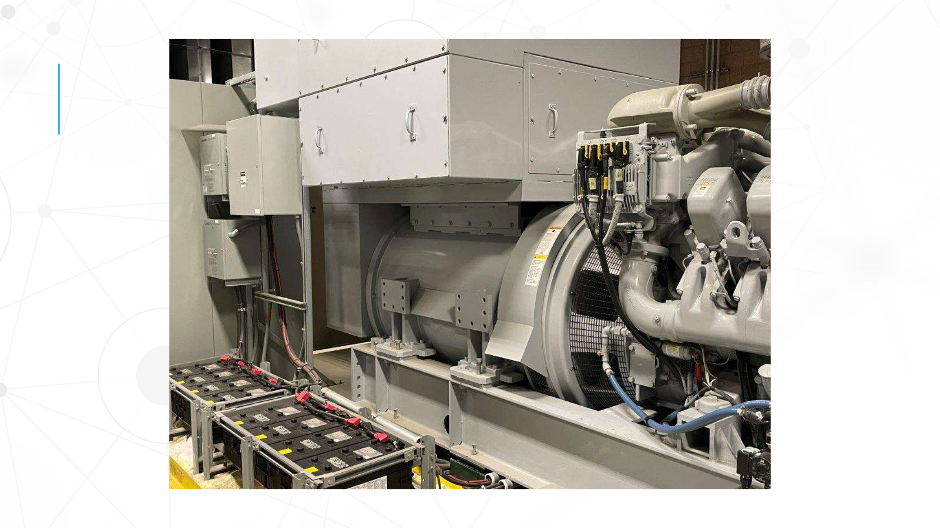
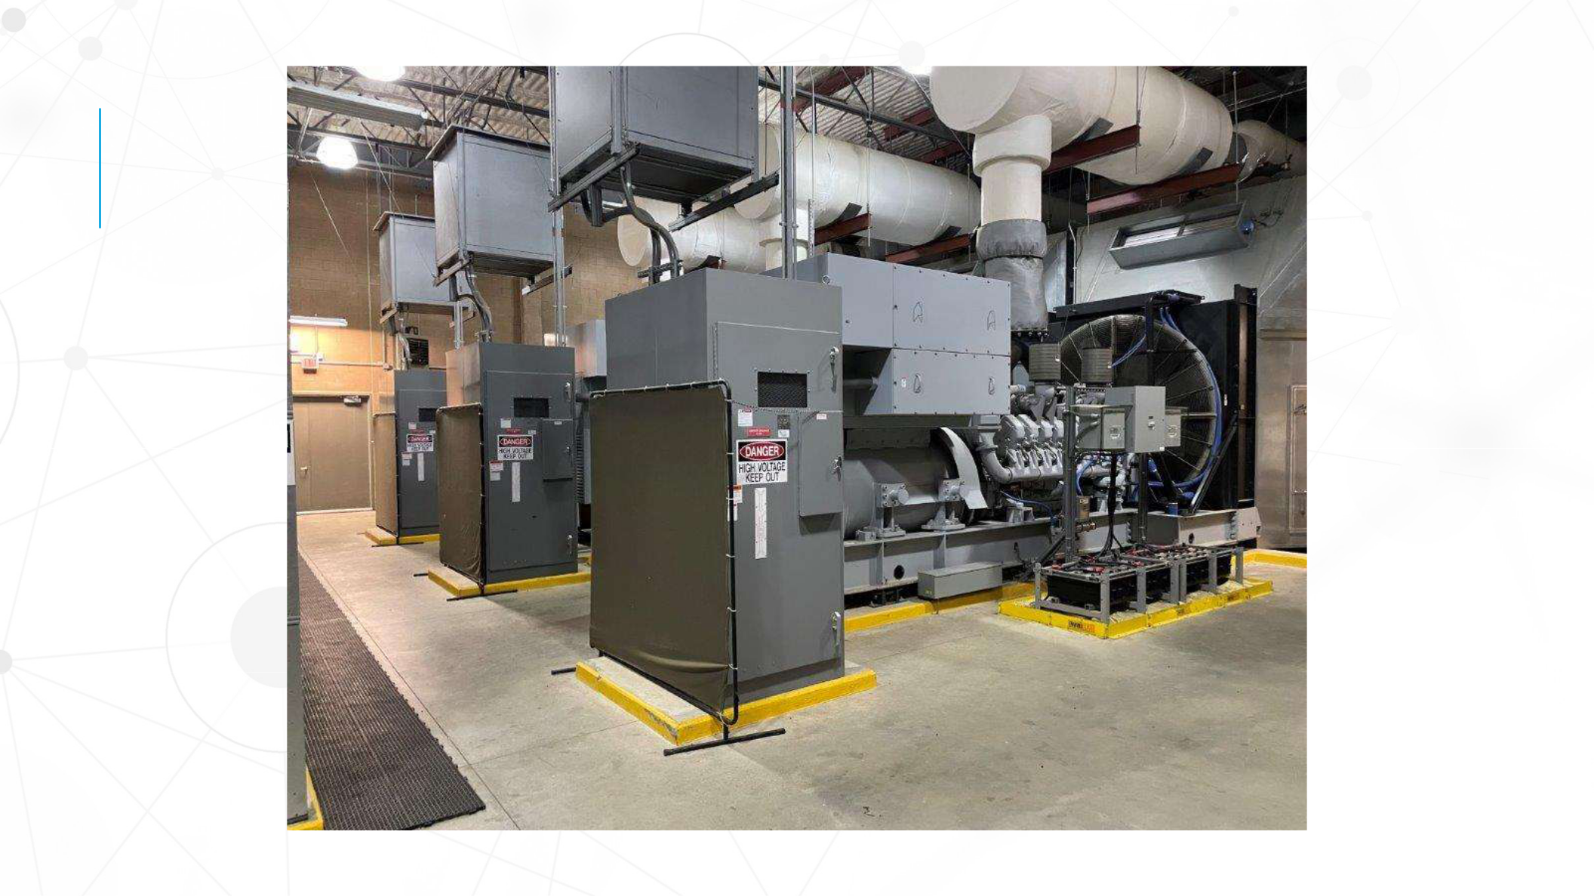
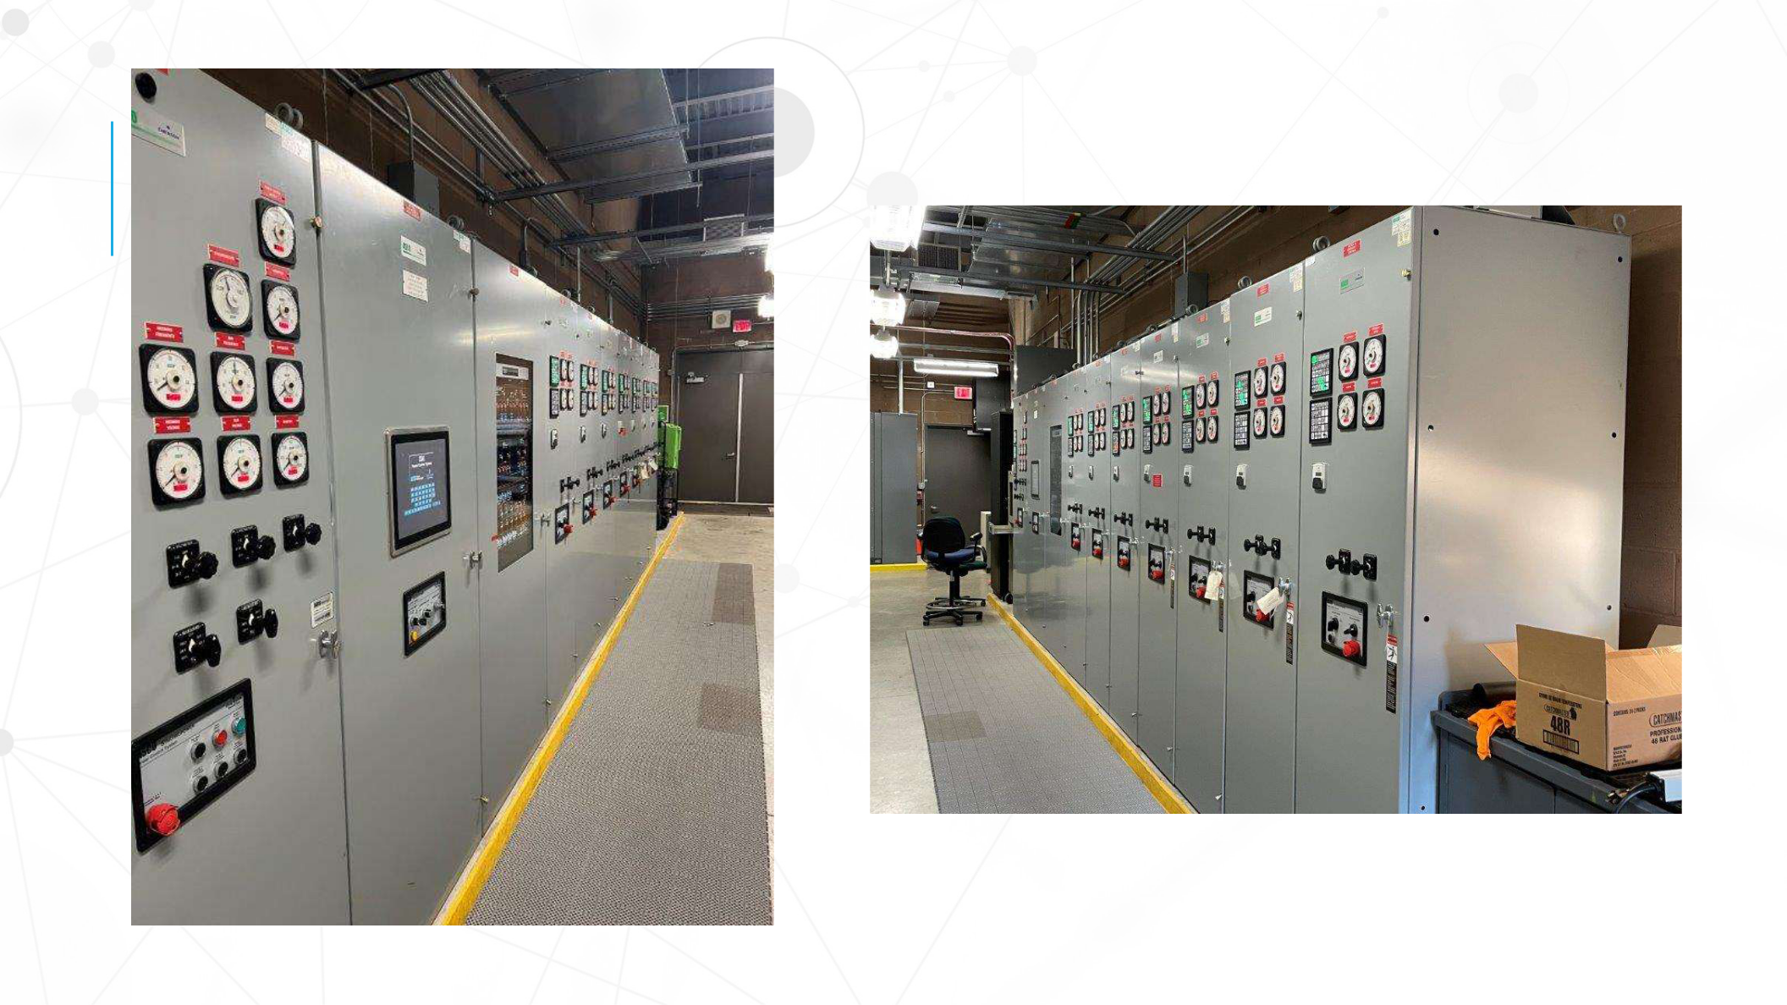
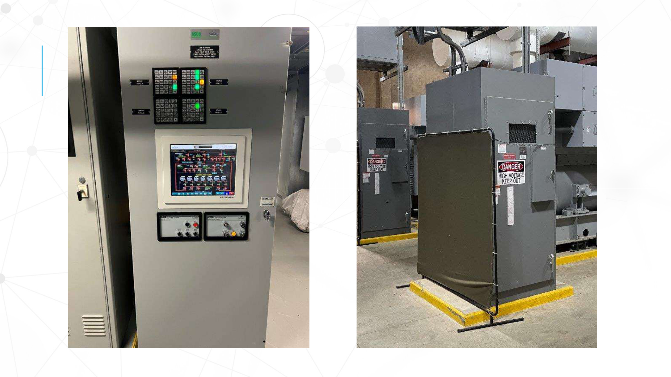


KEY FEATURES

(7) 2 mW Tier 1 & 2 Diesel Generators Rated at 13.8 kV with paralleling switchgear

Tier 1 Engine Serial #’s: 527-200-2694, 527-200-2708 & 527-200-2650

All less than 1800 hours

Tier 2 Engine Serial #’s: 527-104-245, 527-104-246, 527-104-250 & 527-104-253

All less than 1000 hours


All 7 units parallel together using ASCO switchgear

15 kV Load Break Fused Disconnects for each Generator Located in Houston, Texas.

