B757-200F Asset and Lessee Package

Asset Overview
Two (2) PW2037 engine cores One (1) B757-200F airframe
- Total Package Cost: $10,000,000
- Includes immaculate airframe (2 cycles since last C-check) and two engines cores with remaining life.

Lease Overview
- Lessee Profile: cargo specialist, coupled to contracts with Temu and historically serving NATO. Owner of 37 AOC’s and airlines.
- Lease Type: dry lease.
- Term: 5 or 7-year contract with option to buy-out.
- Base Rate: USD $185,000 per month
- Reserve: $750 per flight hour (flight hours calculated at standard 100 per month).
- Route: flight path to include goods transport, deployment UAE or Hong Kong.
- Deposit: standard arrangement, first two months and final month of the lease rate.

Outright Options for Package
- Both lessor and lessee maintain the ability to produce an outright sale during the active lease period of this aircraft.
- Lessor maintains ability to market the aircraft for external sale, providing 90 days advanced notice to the lessee of any sale potential.
- Lessee maintains first-right access to purchase the asset package, either at lease-end or in a buy-out option to be further detailed.

Technical Access

- All return-to-service work can be managed, with existing workscopes for both engines as well as the airframe.
- Spare parts support and technical management is available throughout life of the lease.
- PW2000 engine shop access is available for any future required powerplant work.

1 27OCT2025

B757-222PCF PW2037 / 37,500 lbs 04-Apr-1991
Aircraft Type/Variant
Engine Type & Purchased Thrust Rating
Date of Manufacture
First Flight
ToT from OEM
TSN @ 06-Aug-2021
CSN @ 06-Aug-2021

04-Apr-1991

19-APR-1991

70,571.41

28,991

- Aircraft Weights

 | Current | Purchased
Maximum Take-Off Weight | 256,000 lbs | 256,000 lbs
Maximum Landing Weight | 198,000 lbs | 198,000 lbs
Maximum Zero Fuel Weight | 184,000 lbs | 184,000 lbs

- Aircraft Status - Major Events

Airframe & Landing Gear

Next C Check (C17) | 29-OCT-2024
Next A2 Check (Zonal) | 331.82 hours remain
Next 1A Check (Structural) | 101 cycles remain
Next NLG Overhaul | 19-MAR-2029
Next LMLG Overhaul | 19-MAR-2029
Next RMLG Overhaul | 19-MAR-2029

Engines

Engines are being built-to-order. We have control over LLPs and future sustainment spares. Customer receives operational parts support, not just cores. We have ample PW2037 spares to ensure lifespan.

Engines are delivered fresh, 0 time since repair, with staggered cycles for operational sensibility.

Engine core candidates are final pages in the supplemental documentation. Expected lease will require 3,000 cycles. Will offer management over engine MRO.

AIRCRAFT SPECIFICATION

- Operational Features

HF Communication System | Yes (1 each installed)
ACARS | Yes
SATCOM | No
Reinforced Cockpit Door | No
Cockpit Door Video Surveillance System | No
8.33 Khz Spacing | No
FM Immunity (VHF Nav/Com) | No
Elementary Surveillance | No
Enhanced Surveillance | No
ELT 121.5/406 MHz | Yes
ELT Type | 1 Portable and 2 Personal
EGPWS/TAWS | Yes (PIP/Pegasus with EPGWS)
Quick Access Recorder | No
TCAS Standard | Honeywell 7.0
CVR Type | Solid State
DFDR Type | Solid State
FANS 1/A | No
CPDLC | No
ADS-B Out | Yes
Extended Overwater Flight | No
Fuel Tank Inerting System | No

- Interior Arrangement

Passenger/Crew Provisions

Flight Deck Galley | Yes
Door Config | A-A-A (3 door)
Cargo Configuration | 15 Pallets at 88 x 125

Autopilot / Flight Director Computer

- Avionics

ATA |  | QPA | MANUFACTURER | PART NUMBER
23 | COMPONENT DESCRIPTION | 3 | Rockwell Collins | 822-0006-105 or
23 | HF Communication Transceiver | 2 | Honeywell | 822-0006-104
23 | VHF Communication Transceiver | 3 | Honeywell | 964-0452-042
23 | SATCOM Satellite Data Unit | 0 | Not Installed | 064-50000-2000
23 | High Power Amplifier | 0 | Not Installed
23 | Selcal Decoder | 1 | Team | SL3924AA01
23 | ACARS - In AIMS ACMF | 1 | - | -
23 | ELT - Portable | 1 | ELTA | 01N65920
23 | ELT - Personal | 2 | Techtest Ltd | 500-12Y
23 | Cockpit Voice Recorder - Solid State | 1 | L3 Communications | 2100-1020-00
23 | Low Noise Amplifier / Diplexer | 0 | Not Installed
31 | Flight Data Recorder | 1 | Hawker Beechcraft | 2100-4043-00
31 | Wireless Quick Access Recorder | 0 | Not Installed

AIRCRAFT SPECIFICATION

30
ATA | COMPONENT DESCRIPTION | QPA | MANUFACTURER | PART NUMBER
34 | Air Data Inertial Reference Unit | 1 | Honeywell | HG2060AD01
34 | Secondary Attitude Air Data Reference Unit | 1 | Honeywell | HG2040AD03
34 | VOR Marker Beacon Receiver | 2 | Honeywell | 066-50012-0101
34 | ILS/GPS Multi-Mode Receiver | 3 | Honeywell | 066-50029-1201
34 | Enhanced Ground Proximity Warning Computer | 1 | Honeywell | 965-0976-003-230-2
34 | Radio Altimeter Transceiver | 3 | Thales Avionics | 9599-607-19996
34 | Weather Radar Transceiver | 2 | Rockwell Collins | 822-1710-002
34 | TCAS II Computer (7.1) | 1 | Honeywell | 940-0351-001
34 | ATC Mode S Transponder | 2 | L3 Communications | 9008000-10000
34 | DME Interrogator | 2 | Honeywell | 066-50013-0101
34 | ADF Receiver | 2 | Honeywell | 066-50014-0101
34 | Flight Management Computer - In AIMS FMCF | 1 | - | -
34 | Integrated Standby Flight Display | 1 | Thales Avionics | C16786FA02
34 | Control Display Unit | 3 | Honeywell | 4088240-901

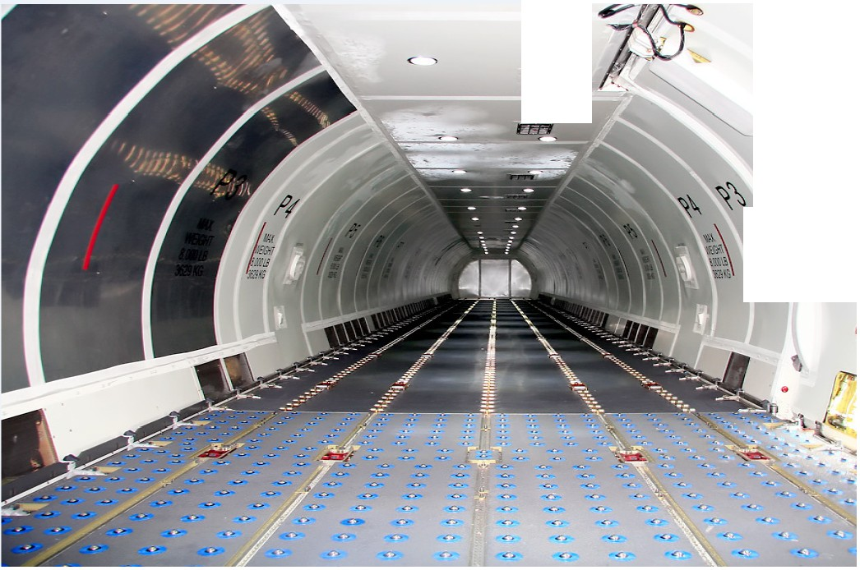

< -,.
gg

\ '
Iii\\\
H

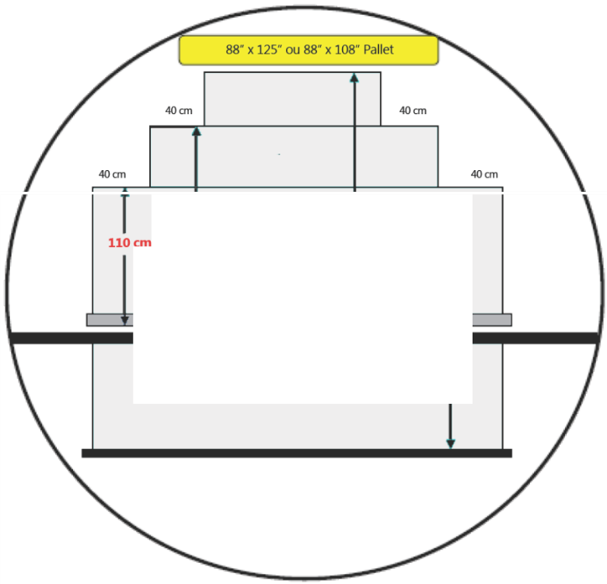

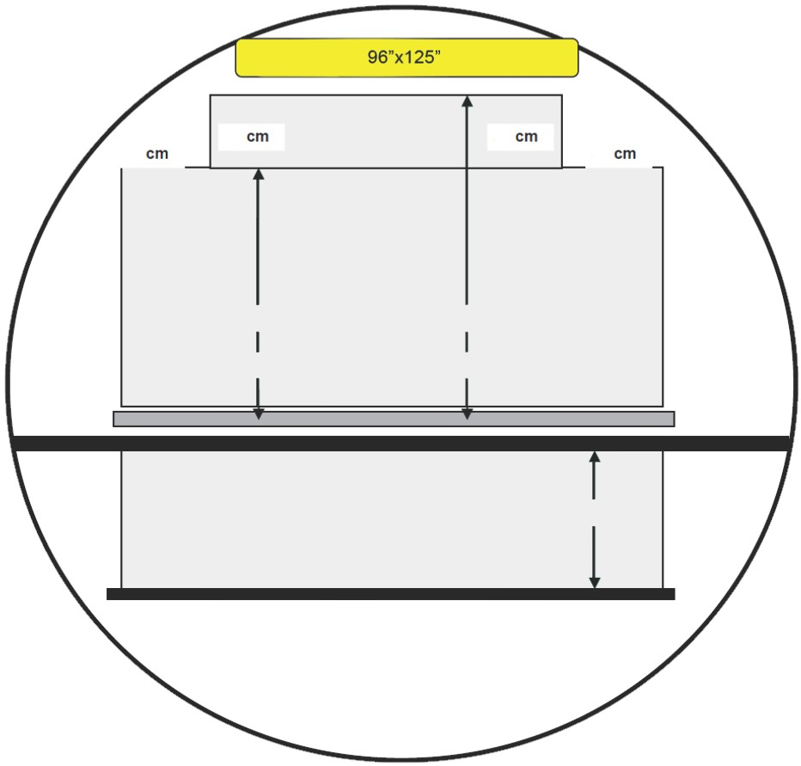
160cm 200cm
I
Este lado do Pallet de 125"(317 em) 1108" (274,32 em)

FWD Bulk
Posi<;ao BlA llOem

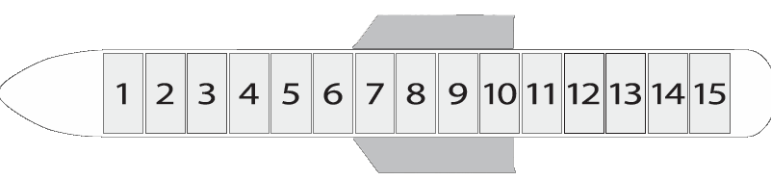

B757-200F is capable of carrying a structural load of up to 40 tons using 15 positions in the upper and lower compartments.
  - The aircraft carries the standard 88 x 125 ULD, having a range of 88x108 and
96x125.
  - Various types of cargo can be transported including live animals and perishable.
The B757-200F is capable of a flight range of 4,400 km with maximum payload.

Engines P&W - 2037 Fuel capacity 39,930
Containers, Pallets & Volume

Total Pallets Volume main deck Volume lower deck Maximum payload
15

187 m3
62 m3
40 Tons

Range (km) - 5,311 gal) 4,200

Following last C-Check (currently 2 cycles since last C-Check): Stored condition in USA:

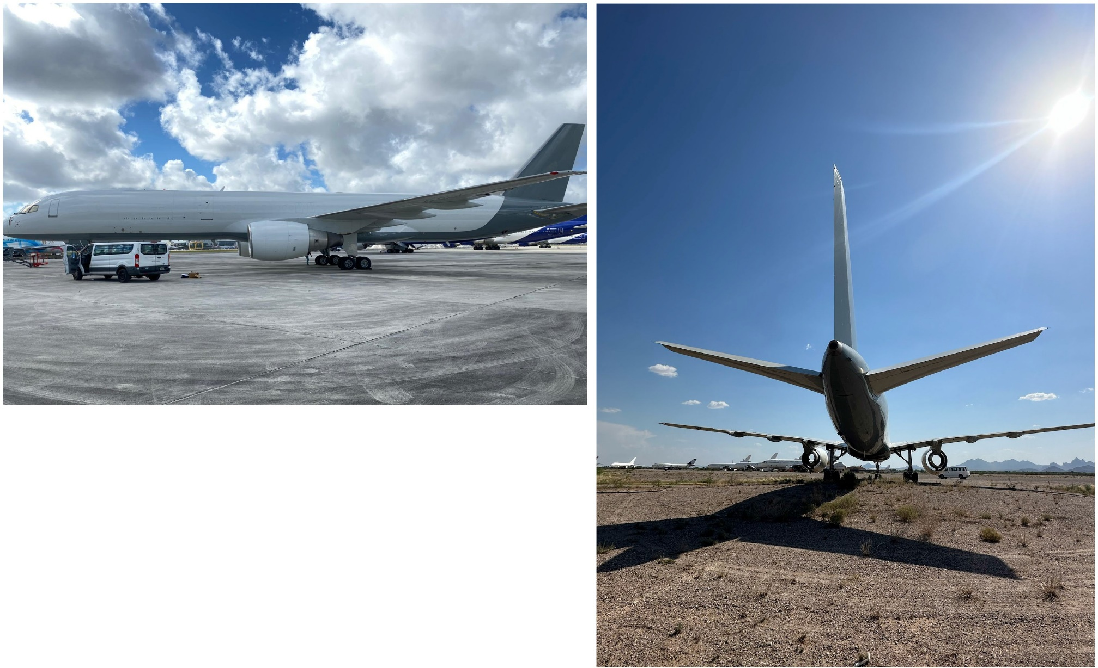

PW2037 ESN 717995 ENGINE LIFE LIMITED PART REPORT

AS OF DATE: | 20-Sep-2022 | INSTALL DATE: 04-Jan-2022 | LAST SHOP DATE: 13-May-2017 | TSLV: | 13,616.0
ENGINE TOTAL HOURS: | 82,198.9 | INSTALL ENG FH: 80,855.2 | ENG FH: 68,582.9 | CSLV: | 4,128
ENGINE TOTAL CYCLES: | 28,095 | INSTALL ENG FC: 27,777 | ENG FC: 23,967

NOMENCLATURE | PART NUMBER | SERIAL NUMBER | ENG SHOP  INSTALL DATE | LLP TOTAL  HRS AT INSTALL | LLP TOTAL  CYC AT INSTALL | ENG TOTAL  HRS AT INSTALL | ENG TOTAL  CYC AT INSTALL | LLP  TOTAL HOURS | LLP  TOTAL CYCLES | PW2037  CYCLE LIMITER | PW2037  CYCLES REM
LPC MODULE
FRONT COMPRESSOR HUB | 1A9021 | DBDUBA9803 |  | 13,842.2 | 4,126 | 80,855.2 | 27,777 | 15,185.9 | 4,444 | 20,000 | 15,556
DRUM ROTOR 2-5 DISK ASSY | 1A4032 | DBDUBA4688 |  | 13,842.2 | 4,126 | 80,855.2 | 27,777 | 15,185.9 | 4,444 | 20,000 | 15,556
DISK STG 2 LPC | 1A4602 | DBDUBA5399 |  | 13,842.2 | 4,126 | 80,855.2 | 27,777 | 15,185.9 | 4,444 | 20,000 | 15,556
DISK STG 3 LPC | 1A4603 | DBDUBA7674 |  | 13,842.2 | 4,126 | 80,855.2 | 27,777 | 15,185.9 | 4,444 | 20,000 | 15,556
DISK STG 4 LPC | 1A4504 | DBDUBA2156 |  | 13,842.2 | 4,126 | 80,855.2 | 27,777 | 15,185.9 | 4,444 | 20,000 | 15,556
DISK STG 5 LPC | 1A4505 | DBDUA75853 |  | 13,842.2 | 4,126 | 80,855.2 | 27,777 | 15,185.9 | 4,444 | 20,000 | 15,556
LPC DRIVE TURBINE SHAFT | 1B3344 | DLDLAY4610 |  | 68,648.2 | 22,795 | 80,855.2 | 27,777 | 69,991.9 | 23,113 | 30,000 | 6,887
HPC MODULE
HPC 6TH STAGE FRONT HUB | 1B3506 | DENCAU4152 |  | 36,173.2 | 12,399 | 80,855.2 | 27,777 | 37,516.9 | 12,717 | 20,000 | 7,283
HPC 17TH STAGE AIRSEAL | 1B5537 | DKLBFT8049 |  | 13,842.2 | 4,126 | 80,855.2 | 27,777 | 15,185.9 | 4,444 | 20,000 | 15,556
HPC ROTOR 7-15 STAGE | 1B7377 | DENCAX7564 |  | 36,100.2 | 10,510 | 80,855.2 | 27,777 | 37,443.9 | 10,828 | 20,000 | 9,172
DISK STG 7 | 1A9207 | DENCAX7493 |  | 36,100.2 | 10,510 | 80,855.2 | 27,777 | 37,443.9 | 10,828 | 20,000 | 9,172
DISK STG 8 | 1A3808 | DENCAX8709 |  | 36,100.2 | 10,510 | 80,855.2 | 27,777 | 37,443.9 | 10,828 | 20,000 | 9,172
DISK STG 9 | 1A3809 | DENCAX9782 |  | 36,100.2 | 10,510 | 80,855.2 | 27,777 | 37,443.9 | 10,828 | 20,000 | 9,172
DISK STG 10 | 1B2610 | DENCAX7431 |  | 36,100.2 | 10,510 | 80,855.2 | 27,777 | 37,443.9 | 10,828 | 20,000 | 9,172
DISK STG 11 | 1B2611 | DENCAX9241 |  | 36,100.2 | 10,510 | 80,855.2 | 27,777 | 37,443.9 | 10,828 | 20,000 | 9,172
DISK STG 12 | 1B7412 | DENCAX8618 |  | 36,100.2 | 10,510 | 80,855.2 | 27,777 | 37,443.9 | 10,828 | 20,000 | 9,172
DISK STG 13 | 1B3613 | DENCAX9023 |  | 36,100.2 | 10,510 | 80,855.2 | 27,777 | 37,443.9 | 10,828 | 20,000 | 9,172
DISK STG 14 | 1B4514 | DENCAX9971 |  | 36,100.2 | 10,510 | 80,855.2 | 27,777 | 37,443.9 | 10,828 | 20,000 | 9,172
DISK STG 15 | 1B3815 | DENCAX8995 |  | 36,100.2 | 10,510 | 80,855.2 | 27,777 | 37,443.9 | 10,828 | 20,000 | 9,172
HPC ROTOR (16-17) | 1B6275-01 | DENCA64612 |  | 13,842.2 | 4,126 | 80,855.2 | 27,777 | 15,185.9 | 4,444 | 20,000 | 15,556
DISK STG 16 | 1B7916 | DENCA64777 |  | 13,842.2 | 4,126 | 80,855.2 | 27,777 | 15,185.9 | 4,444 | 20,000 | 15,556
DISK STG 17 | 1B7917 | DENCA55525 |  | 13,842.2 | 4,126 | 80,855.2 | 27,777 | 15,185.9 | 4,444 | 20,000 | 15,556
SHAFT-LPC REAR | 1B7860 | DENCA57808 |  | 13,842.2 | 4,126 | 80,855.2 | 27,777 | 15,185.9 | 4,444 | 20,000 | 15,556
HPT MODULE
HPT 1ST STAGE DISK | 1B7621 | DKLBA80381 |  | 3,213.2 | 10,239 | 80,855.2 | 27,777 | 4,556.9 | 10,557 | 15,000 | 4,443
HPT FRONT TURBINE HUB | 1B8322 | DKLBCT5256 |  | 36,748.2 | 10,151 | 80,855.2 | 27,777 | 38,091.9 | 10,469 | 15,000 | 4,531
HPT 2ND STAGE PLATE | 1B7495 | DKLBEG8536 |  | 29,415.2 | 9,956 | 80,855.2 | 27,777 | 30,758.9 | 10,274 | 15,000 | 4,726
HPT 1ST STAGE AIRSEAL | 1B7499 | DKLBER8859 |  | 25,775.2 | 8,148 | 80,855.2 | 27,777 | 27,118.9 | 8,466 | 15,000 | 6,534
HPT 2ND STAGE AIRSEAL | 1A8209 | DKLBES9685 |  | 32,437.2 | 9,924 | 80,855.2 | 27,777 | 33,780.9 | 10,242 | 15,000 | 4,758
LPT MODULE
LPT 3RD STAGE DISK | 8A2135 | M30707 |  | 40,748.2 | 14,076 | 80,855.2 | 27,777 | 42,091.9 | 14,394 | 20,000 | 5,606
LPT 4TH STAGE DISK | 8A3119 | DLDLBH1134 |  | 29,914.2 | 10,122 | 80,855.2 | 27,777 | 31,257.9 | 10,440 | 20,000 | 9,560
LPT REAR HUB | 1A3619 | D416AA0504 |  | 72,592.2 | 24,835 | 80,855.2 | 27,777 | 73,935.9 | 25,153 | 30,000 | 4,847
LPT 5TH STAGE DISK | 8A3116 | DLDLBR0430 |  | 23,648.2 | 7,269 | 80,855.2 | 27,777 | 24,991.9 | 7,587 | 20,000 | 12,413
LPT 6TH STAGE DISK | 8A3058 | DLDLBR2846 |  | 21,845.2 | 7,177 | 80,855.2 | 27,777 | 23,188.9 | 7,495 | 20,000 | 12,505
LPT 3RD STAGE AIRSEAL | 8A2167 | DLDLAS7105 |  | 13,842.2 | 4,126 | 80,855.2 | 27,777 | 15,185.9 | 4,444 | 20,000 | 15,556
LPT 4TH STAGE AIRSEAL | 8A2094 | DLDLBPO484 |  | 13,842.2 | 4,126 | 80,855.2 | 27,777 | 15,185.9 | 4,444 | 20,000 | 15,556
LPT 5TH STAGE AIRSEAL | 8A2095 | DLDLBP1710 |  | 24,121.2 | 8,067 | 80,855.2 | 27,777 | 25,464.9 | 8,385 | 20,000 | 11,615
LPT 6TH STAGE AIRSEAL | 8A2806 | DKGAAH2491 |  | 23,648.2 | 7,269 | 80,855.2 | 27,777 | 24,991.9 | 7,587 | 20,000 | 12,413
LPT 7TH STAGE AIRSEAL | 8A2807 | DKGAAH3416 |  | 13,842.2 | 4,126 | 80,855.2 | 27,777 | 15,185.9 | 4,444 | 20,000 | 15,556
LPT 7TH STAGE DISK | 8A3059 | DLDLBD9559 |  | 24,402.2 | 11,462 | 80,855.2 | 27,777 | 25,745.9 | 11,780 | 20,000 | 8,220
LPT 3RD STAGE AIRSEAL SUPT | 8A2154 | DLDLAT5846 |  | 41,812.2 | 13,762 | 80,855.2 | 27,777 | 43,155.9 | 14,080 | 20,000 | 5,920

PW2037 ESN 726598 ENGINE LIFE LIMITED PART REPORT
TSLV: | 9,490.3  2,335
CSLV:

AS OF DATE: | 02-Nov-2023 | INSTALL DATE: | 06-Aug-2019 | LAST SHOP DATE: | 02-Aug-2019
ENGINE TOTAL HOURS: | 83,318.3 | INSTALL ENG FH: | 73,828.0 | ENG FH: | 73,828.0
ENGINE TOTAL CYCLES: | 28,006 | INSTALL ENG FC: | 25,671 | ENG FC: | 25,671

NOMENCLATURE | PART NUMBER | SERIAL NUMBER | ENG SHOP INSTALL DATE | LLP TOTAL HRS AT INSTALL | LLP TOTAL CYC AT INSTALL | ENG TOTAL HRS AT INSTALL | ENG TOTAL CYC AT INSTALL | LLP TOTAL HOURS | LLP TOTAL CYCLES | PW2037 CYCLE LIMITER | PW2037 CYCLES REM
LPC MODULE
FRONT COMPRESSOR HUB | 1A9021 | DBDUBA5417 |  | 15,207.0 | 4,149 | 73,828.0 | 25,671 | 24,697.3 | 6,484 | 30,000 | 23,516
DRUM ROTOR 2-5 DISK ASSY | 1A4032 | DBDUBA4679 |  | 15,207.0 | 4,149 | 73,828.0 | 25,671 | 24,697.3 | 6,484 | 20,000 | 13,516
DISK STG 2 LPC | 1A4602 | DBDUBA5396 |  | 15,207.0 | 4,149 | 73,828.0 | 25,671 | 24,697.3 | 6,484 | 20,000 | 13,516
DISK STG 3 LPC | 1A4603 | DBDUA97183 |  | 15,207.0 | 4,149 | 73,828.0 | 25,671 | 24,697.3 | 6,484 | 20,000 | 13,516
DISK STG 4 LPC | 1A4504 | DBDUA97613 |  | 15,207.0 | 4,149 | 73,828.0 | 25,671 | 24,697.3 | 6,484 | 20,000 | 13,516
DISK STG 5 LPC | 1A4505 | DBDUA97618 |  | 15,207.0 | 4,149 | 73,828.0 | 25,671 | 24,697.3 | 6,484 | 20,000 | 13,516
LPC DRIVE TURBINE SHAFT | 1B3344 | D056AA0087 |  | 66,071.0 | 23,328 | 73,828.0 | 25,671 | 75,561.3 | 25,663 | 30,000 | 4,337
HPC MODULE
HPC 6TH STAGE FRONT HUB | 1B3506 | DENCA65961 |  | 9,492.0 | 2,375 | 73,828.0 | 25,671 | 18,982.3 | 4,710 | 20,000 | 15,290
HPC 17TH STAGE AIRSEAL | 1B5537 | DKLBFJ1884 |  | 25,711.0 | 6,751 | 73,828.0 | 25,671 | 35,201.3 | 9,086 | 20,000 | 10,914
HPC ROTOR 7-15 STAGE | 1B7377 | DENCAP2154 |  | 52,314.0 | 16,003 | 73,828.0 | 25,671 | 61,804.3 | 18,338 | 20,000 | 1,662
DISK STG 7 | 1A9207 | DENCAP4168 |  | 52,314.0 | 16,003 | 73,828.0 | 25,671 | 61,804.3 | 18,338 | 20,000 | 1,662
DISK STG 8 | 1A3808 | DENCAP4407 |  | 52,314.0 | 16,003 | 73,828.0 | 25,671 | 61,804.3 | 18,338 | 20,000 | 1,662
DISK STG 9 | 1A3809 | DENCAP4121 |  | 52,314.0 | 16,003 | 73,828.0 | 25,671 | 61,804.3 | 18,338 | 20,000 | 1,662
DISK STG 10 | 1B2610 | DENCAP4283 |  | 52,314.0 | 16,003 | 73,828.0 | 25,671 | 61,804.3 | 18,338 | 20,000 | 1,662
DISK STG 11 | 1B2611 | DENCAP4539 |  | 52,314.0 | 16,003 | 73,828.0 | 25,671 | 61,804.3 | 18,338 | 20,000 | 1,662
DISK STG 12 | 1B7412 | DENCAP4292 |  | 52,314.0 | 16,003 | 73,828.0 | 25,671 | 61,804.3 | 18,338 | 20,000 | 1,662
DISK STG 13 | 1B3613 | DENCAP3727 |  | 52,314.0 | 16,003 | 73,828.0 | 25,671 | 61,804.3 | 18,338 | 20,000 | 1,662
DISK STG 14 | 1B4514 | DENCAP3820 |  | 52,314.0 | 16,003 | 73,828.0 | 25,671 | 61,804.3 | 18,338 | 20,000 | 1,662
DISK STG 15 | 1B3815 | DENCAP4674 |  | 52,314.0 | 16,003 | 73,828.0 | 25,671 | 61,804.3 | 18,338 | 20,000 | 1,662
HPC ROTOR (16-17) | 1B6275-01 | DENCA51973 |  | 25,711.0 | 6,751 | 73,828.0 | 25,671 | 35,201.3 | 9,086 | 20,000 | 10,914
DISK STG 16 | 1B7916 | DENCA52884 |  | 25,711.0 | 6,751 | 73,828.0 | 25,671 | 35,201.3 | 9,086 | 20,000 | 10,914
DISK STG 17 | 1B7917 | DENCA52925 |  | 25,711.0 | 6,751 | 73,828.0 | 25,671 | 35,201.3 | 9,086 | 20,000 | 10,914
SHAFT-LPC REAR | 1B7860 | DENCA44145 |  | 25,711.0 | 6,751 | 73,828.0 | 25,671 | 35,201.3 | 9,086 | 20,000 | 10,914
HPT MODULE
HPT 1ST STAGE DISK | 1B7621 | DKLBA80335 |  | 30,365.0 | 10,206 | 73,828.0 | 25,671 | 39,855.3 | 12,541 | 15,000 | 2,459
HPT FRONT TURBINE HUB | 1B8322 | DKLBCT5293 |  | 40,752.0 | 11,319 | 73,828.0 | 25,671 | 50,242.3 | 13,654 | 15,000 | 1,346
HPT 2ND STAGE PLATE | 1B7495 | DKLBA76817 |  | 27,703.0 | 11,529 | 73,828.0 | 25,671 | 37,193.3 | 13,864 | 15,000 | 1,136
HPT 1ST STAGE AIRSEAL | 1B7499 | DKLBFG9657 |  | 23,424.0 | 7,122 | 73,828.0 | 25,671 | 32,914.3 | 9,457 | 15,000 | 5,543
HPT 2ND STAGE AIRSEAL | 1A8209 | DKLBEG8162 |  | 33,833.0 | 10,639 | 73,828.0 | 25,671 | 43,323.3 | 12,974 | 15,000 | 2,026
LPT MODULE
LPT 3RD STAGE DISK | 8A3115 | DLDLBP4548 |  | 32,289.0 | 9,620 | 73,828.0 | 25,671 | 41,779.3 | 11,955 | 20,000 | 8,045
LPT 4TH STAGE DISK | 8A3119 | DLDLBH1218 |  | 19,936.0 | 6,646 | 73,828.0 | 25,671 | 29,426.3 | 8,981 | 15,000 | 6,019
LPT REAR HUB | 1A3619 | S24381 |  | 79,244.0 | 25,083 | 73,828.0 | 25,671 | 88,734.3 | 27,418 | 30,000 | 2,582
LPT 5TH STAGE DISK | 8A3116 | DLDLBH0387 |  | 31,913.0 | 10,938 | 73,828.0 | 25,671 | 41,403.3 | 13,273 | 20,000 | 6,727
LPT 6TH STAGE DISK | 8A1046 | DLDLAT2237 |  | 46,319.0 | 16,709 | 73,828.0 | 25,671 | 55,809.3 | 19,044 | 20,000 | 956
LPT 3RD STAGE AIRSEAL | 8A2167 | DLDLAS6459 |  | 47,775.0 | 16,547 | 73,828.0 | 25,671 | 57,265.3 | 18,882 | 20,000 | 1,118
LPT 4TH STAGE AIRSEAL | 8A2094 | DLDLBH7894 |  | 29,447.0 | 8,923 | 73,828.0 | 25,671 | 38,937.3 | 11,258 | 20,000 | 8,742
LPT 5TH STAGE AIRSEAL | 8A2095 | DLDLAS8310 |  | 51,978.0 | 15,989 | 73,828.0 | 25,671 | 61,468.3 | 18,324 | 20,000 | 1,676
LPT 6TH STAGE AIRSEAL | 8A2806 | DKGAAH0325 |  | 49,874.0 | 16,816 | 73,828.0 | 25,671 | 59,364.3 | 19,151 | 20,000 | 849
LPT 7TH STAGE AIRSEAL | 8A2807 | DKGAAH3073 |  | 21,004.0 | 6,493 | 73,828.0 | 25,671 | 30,494.3 | 8,828 | 20,000 | 11,172
LPT 7TH STAGE DISK | 8A3059 | DLDLBP6430 |  | 26,130.0 | 5,835 | 73,828.0 | 25,671 | 35,620.3 | 8,170 | 20,000 | 11,830
LPT 3RD STAGE AIRSEAL SUPT | 8A2154 | DLDLBS1649 |  | 25,771.0 | 7,250 | 73,828.0 | 25,671 | 35,261.3 | 9,585 | 20,000 | 10,415

Page 1 of 1

PW2037 ESN 727201 ENGINE LIFE LIMITED PART REPORT

REMOVAL DATE: 11-Dec-2024
ENGINE TOTAL HOURS: 74,079.7
INSTALL DATE: 01-Oct-2024 LAST SHOP DATE: 01-Oct-2019
INSTALL ENG FH: 73,734.0 ENG FH: 62,637.0
TSLV: | 11,442.7  2,637
CSLV:

ENGINE TOTAL CYCLES: 23,425 INSTALL ENG FC: 23,343 ENG FC: 20,788

NOMENCLATURE | PART NUMBER | SERIAL NUMBER | ENG SHOP  INSTALL DATE | LLP TOTAL  HRS AT INSTALL | LLP TOTAL  CYC AT INSTALL | ENG TOTAL  HRS AT INSTALL | ENG TOTAL  CYC AT INSTALL | LLP  TOTAL HOURS | LLP  TOTAL CYCLES | PW2037  CYCLE LIMITER | PW2037  CYCLES REM
LPC MODULE
FRONT COMPRESSOR HUB | 1A9021 | DBDUAY4570 |  | 39,399.0 | 14,792 | 73,734.0 | 23,343 | 39,744.7 | 14,874 | 20,000 | 5,126
DRUM ROTOR 2-5 DISK ASSY | 1B6503 | DBDUAS7202 |  | 70,790.0 | 19,057 | 73,734.0 | 23,343 | 71,135.7 | 19,139 | 20,000 | 861
DISK STG 2 LPC | 1B6503-02 | DBDUAS7684 |  | 67,790.0 | 19,057 | 73,734.0 | 23,343 | 68,135.7 | 19,139 | 20,000 | 861
DISK STG 3 LPC | 1B6503-03 | DBDUAS7640 |  | 70,790.0 | 19,057 | 73,734.0 | 23,343 | 71,135.7 | 19,139 | 20,000 | 861
DISK STG 4 LPC | 1B6503-04 | DBDUAS7760 |  | 70,790.0 | 19,057 | 73,734.0 | 23,343 | 71,135.7 | 19,139 | 20,000 | 861
DISK STG 5 LOC | 1B6503-05 | DBDUAS5199 |  | 70,790.0 | 19,057 | 73,734.0 | 23,343 | 71,135.7 | 19,139 | 20,000 | 861
LPC DRIVE TURBINE SHAFT | 1B6326 | SLSLBH4239 |  | 57,240.0 | 16,302 | 73,734.0 | 23,343 | 57,585.7 | 16,384 | 30,000 | 13,616
HPC MODULE
HPC 6TH STAGE FRONT HUB | 1B3506 | S69979 |  | 61,385.0 | 19,096 | 73,734.0 | 23,343 | 61,730.7 | 19,178 | 20,000 | 822
HPC 17TH STAGE AIRSEAL | 1B5537 | DKLBCK2027 |  | 61,838.0 | 18,546 | 73,734.0 | 23,343 | 62,183.7 | 18,628 | 20,000 | 1,372
HPC ROTOR 7-15 STAGE | 1B3702 | DENCAJ4939 |  | 60,652.0 | 19,916 | 73,734.0 | 23,343 | 60,997.7 | 19,998 | 20,000 | 2
DISK STAGE 7 | 1A8207 | DENCAH8972 |  | 60,652.0 | 19,916 | 73,734.0 | 23,343 | 60,997.7 | 19,998 | 20,000 | 2
DISK SATGE 8 | 1A3808 | DENCAH7706 |  | 60,652.0 | 19,916 | 73,734.0 | 23,343 | 60,997.7 | 19,998 | 20,000 | 2
DISK STAGE 9 | 1A3809 | DANCAH8624 |  | 60,652.0 | 19,916 | 73,734.0 | 23,343 | 60,997.7 | 19,998 | 20,000 | 2
DISK SATGE 10 | 1B2610 | DENCAH9824 |  | 60,652.0 | 19,916 | 73,734.0 | 23,343 | 60,997.7 | 19,998 | 20,000 | 2
DISK STAGE 11 | 1B2611 | DENCAH0775 |  | 60,652.0 | 19,916 | 73,734.0 | 23,343 | 60,997.7 | 19,998 | 20,000 | 2
DISK STAGE 12 | 1B2612 | DENCAH9638 |  | 60,652.0 | 19,916 | 73,734.0 | 23,343 | 60,997.7 | 19,998 | 20,000 | 2
DISK STAGE 13 | 1B3613 | DENCAH9151 |  | 60,652.0 | 19,916 | 73,734.0 | 23,343 | 60,997.7 | 19,998 | 20,000 | 2
DISK STAGE 14 | 1B4514 | DENCAH8932 |  | 60,652.0 | 19,916 | 73,734.0 | 23,343 | 60,997.7 | 19,998 | 20,000 | 2
DISK STAGE 15 | 1B3815 | DENCAJ1151 |  | 60,652.0 | 19,916 | 73,734.0 | 23,343 | 60,997.7 | 19,998 | 20,000 | 2
HPC ROTOR (16-17) | 1B6275-01 | DENCAR4864 |  | 48,136.0 | 17,345 | 73,734.0 | 23,343 | 48,481.7 | 17,427 | 20,000 | 2,573
DISK - 16TH STAGE | 1B1700-02 | DENCAR5026 |  | 48,136.0 | 17,345 | 73,734.0 | 23,343 | 48,481.7 | 17,427 | 20,000 | 2,573
DISK - 17TH STAGE | 1B1700-03 | DENCAR5109 |  | 48,136.0 | 17,345 | 73,734.0 | 23,343 | 48,481.7 | 17,427 | 20,000 | 2,573
SHAFT - HPC REAR | 1B5100-02 | DENCAR4990 |  | 48,136.0 | 17,345 | 73,734.0 | 23,343 | 48,481.7 | 17,427 | 20,000 | 2,573
HPT MODULE
HPT 1ST STAGE DISK | 1B7621 | DKLBFH5637 |  | 31,064.0 | 8,145 | 73,734.0 | 23,343 | 31,409.7 | 8,227 | 15,000 | 6,773
HPT FRONT TURBINE HUB | 1B8322 | DKLBD19353 |  | 35,292.0 | 12,826 | 73,734.0 | 23,343 | 35,637.7 | 12,908 | 15,000 | 2,092
HPT 2ND STAGE PLATE | 1B0947 | DKLBA76713 |  | 38,349.0 | 14,439 | 73,734.0 | 23,343 | 38,694.7 | 14,521 | 15,000 | 479
HPT 1ST STAGE AIRSEAL | 1B7499 | DKLBGS9150 |  | 11,097.0 | 2,855 | 73,734.0 | 23,343 | 11,442.7 | 2,937 | 15,000 | 12,063
HPT 2ND STAGE AIRSEAL | 1A8209 | DKLBED0524 |  | 43,502.0 | 11,545 | 73,734.0 | 23,343 | 43,847.7 | 11,627 | 15,000 | 3,373
LPT MODULE
LPT 3RD STAGE DISK | 8A3115 | DLDLBP4576 |  | 39,860.0 | 10,453 | 73,734.0 | 23,343 | 40,205.7 | 10,535 | 20,000 | 9,465
LPT 4TH STAGE DISK | 8A3119 | DLDLBN7222 |  | 39,425.0 | 11,473 | 73,734.0 | 23,343 | 39,770.7 | 11,555 | 15,000 | 3,445
LPT REAR HUB | 1A3619 | D416AA0021 |  | 82,535.0 | 26,383 | 73,734.0 | 23,343 | 82,880.7 | 26,465 | 30,000 | 3,535
LPT 5TH STAGE DISK | 8A3116 | DLDLBR0367 |  | 36,534.0 | 10,423 | 73,734.0 | 23,343 | 36,879.7 | 10,505 | 20,000 | 9,495
LPT 6TH STAGE DISK | 8A3058 | DLDLBG9137 |  | 36,854.0 | 10,449 | 73,734.0 | 23,343 | 37,199.7 | 10,531 | 20,000 | 9,469
LPT 3RD STAGE AIRSEAL | 8A2167 | DLDLBP2147 |  | 36,702.0 | 10,426 | 73,734.0 | 23,343 | 37,047.7 | 10,508 | 20,000 | 9,492
LPT 4TH STAGE AIRSEAL | 8A2094 | DLDLBH7884 |  | 36,702.0 | 10,426 | 73,734.0 | 23,343 | 37,047.7 | 10,508 | 20,000 | 9,492
LPT 5TH STAGE AIRSEAL | 8A2095 | DLDLBP1678 |  | 36,702.0 | 10,426 | 73,734.0 | 23,343 | 37,047.7 | 10,508 | 20,000 | 9,492
LPT 6TH STAGE AIRSEAL | 8A2806 | DKGAAH3554 |  | 36,679.0 | 10,399 | 73,734.0 | 23,343 | 37,024.7 | 10,481 | 20,000 | 9,519
LPT 7TH STAGE AIRSEAL | 8A2807 | DKGAAH3052 |  | 34,214.0 | 9,485 | 73,734.0 | 23,343 | 34,559.7 | 9,567 | 20,000 | 10,433
LPT 7TH STAGE DISK | 8A3059 | DLDLBP6313 |  | 37,857.0 | 10,904 | 73,734.0 | 23,343 | 38,202.7 | 10,986 | 20,000 | 9,014
LPT 3RD STAGE AIRSEAL SUPT | 8A2154 | DLDLBP4772 |  | 39,860.0 | 10,453 | 73,734.0 | 23,343 | 40,205.7 | 10,535 | 20,000 | 9,465

