Subject: Urgent Sale Opportunity: 1976 BOEING 727-200 SUPER27 Aircraft

PROPOSAL HIGHLIGHT: A UNIQUELY PRESERVED AVIATION ASSET AT A FRACTION OF ITS INVESTED COST

- Executive Summary

On behalf of the motivated owner, presents an exceptional and time-sensitive opportunity to acquire a remarkably maintained 1976 Boeing 727-200 SUPER27. This aircraft is not a typical example; it is a low-time, high-investment airframe with over $14,000,000 in recent upgrades and conversions, yet is offered at an asking price of USD $3,000,000 to secure an immediate sale.

With extremely low total hours and cycles since new, a recent multi-million-dollar maintenance event in 2017, and a like-new two-class airline interior with under 100 flight hours, this aircraft represents unparalleled value. The owner's urgent requirement for a sale makes this the ideal moment for a decisive buyer to acquire a premium asset at a liquidation price.

Aircraft Overview & Key Selling Points

  - Aircraft: 1976 Boeing 727-200 ADVANCED VALSAN SUPER27
  - Location: California, USA

• Price: USD $3,000,000
  - Condition: Excellent, well-maintained, and recently operated

Highlight Features:
    - VALSAN SUPER27 Conversion: Includes performance-enhancing winglets and JT8D-217C engine upgrades—a $10,000,000+ investment that improves fuel efficiency, thrust, and payload.
    - Extremely Low Utilization: Only 13,135 Total Airframe Hours | 6,259 Landings.
    - Recent Major Investment (2017): Approximately $4,000,000 spent on inspections, interior refurbishment, and system overhauls.
    - Like-New Interior: A 113-passenger, two-class (Business & Coach) cabin installed in 2017 with less than 100 hours of use.
    - Comprehensive Spares Package: Included to ensure operational readiness and reduce future costs.
    - VIP Conversion Potential: The original full VIP interior (with stateroom & private bath) and long-range auxiliary tanks are preserved in storage and available for re-installation.

Investment & Value Proposition

This aircraft's history is defined by significant capital investment, far exceeding its current asking price. The owner's motivation allows you to capitalize on this disparity.

Investment Feature | Value Add
VALSAN SUPER27 Conversion & Winglets | > $10,000,000
2017 Maintenance Event (C Checks, CPCP, Corrosion Inspections, Landing Gear Overhauls) | ~ $4,000,000
Total Recent Capital Invested | ~  $14,000,000+
Price | $3,000,000

You are acquiring an asset with the operational capabilities and maintenance pedigree of a multi-million-dollar aircraft for a fraction of the cost.

Critical Technical & Maintenance Summary

  - Airframe: 13,135 Hours | 6,259 Landings. Recent C Inspections and CPCP completed ~5 years ago.

Engines (3x Pratt & Whitney JT8D-217C):
    - Engine 1 & 3: 3,412 TTSN | 1,102 TCSN | Fresh Corrosion Inspection (2017)
    - Engine 2: 11,147 TTSN | 5,917 TCSN | Fresh Corrosion Inspection (2017)
  - Landing Gear: Overhauled ~5 years ago, with only 30 cycles since.
• APU: 13,090 TTSN | 6,231 TCSN
  - Avionics: Fully modernized suite including 8.33 spacing, FM Immunity, RVSM, TCAS II, Dual FMS/GPS, and SATCOM.

Note on Inspection Status: A C-check is now due; however, given the extensive work completed in 2017 and the minimal flight hours since, this is anticipated to be a light and cost-effective inspection.

Terms of Sale

• Price: USD $3,000,000.
  - Payment: Immediate
  - Availability: Immediate.
  - Condition: Sold "AS-IS / WHERE-IS" in California.
  - Included: The aircraft and the large spare parts package.

Call to Action: Seize This Opportunity

This is not a routine aircraft listing. The combination of its pristine condition, immense prior investment, and the owner's urgent need for a sale creates a finite window of opportunity. $1,000,000 deposit into escrow will reserve the aircraft now.

We invite qualified buyers to act quickly. Full specifications, detailed maintenance records, and a comprehensive photo library are ready for your immediate review.

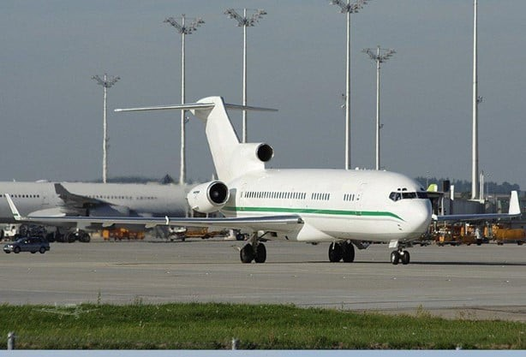

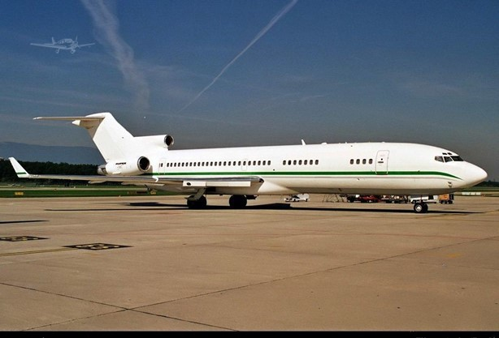

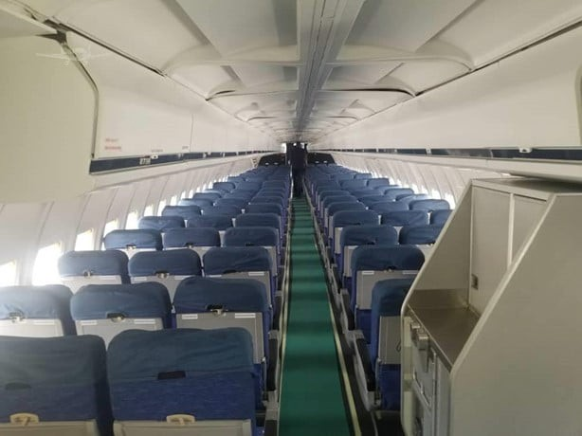

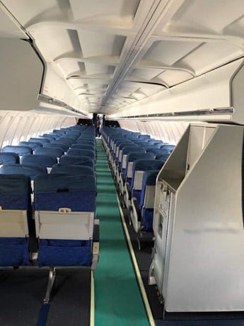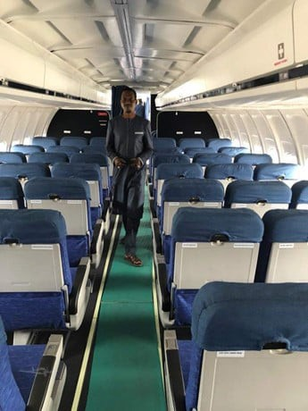4 | P a g e

